NOTE: No where does this list IRS TAX Cases or forms to use: Therefore it must be Lack of Jurisdiction:

https://www.uscourts.gov/about-federal-courts/types-cases

Types of Cases
The U.S. Courts hear cases over which they have jurisdiction granted by the U.S. Constitution or Congress. Learn more about the cases heard in federal courts in this section.
The federal courts have jurisdiction over
- Cases that raise a "federal question" involving the United States Government , the U.S. Constitution, or other federal laws; and
- Cases involving “diversity of citizenship," which are disputes between two parties not from the same state or country, and where the claim meets a set dollar threshold for damages.

More specifically, federal courts hear criminal, civil, and bankruptcy cases. And once a case is decided, it can often be appealed.

Services & Forms
The U.S. Courts are an independent national judiciary providing fair and impartial justice within the jurisdiction conferred by the Constitution and Congress. As an equal branch of government, the federal Judiciary preserves and enhances its core values as the courts meet changing national and local needs.

Forms
- Attorney Forms
- Bankruptcy Forms
- Superseded Bankruptcy Forms
- Civil Forms
- Criminal Forms
- Court Reporter Forms
- CJA Forms
- Human Resources Forms
- Jury Forms
- Other Forms

Bankruptcy
- Bankruptcy Basics
- Filing Without an Attorney
- Credit Counseling and Debtor Education
- Trustees and Administrators
- Approved Bankruptcy Notice Providers
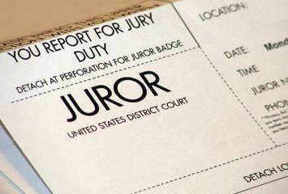

Jury Service
- National eJuror Program
- Learn About Jury Service
- Types of Juries
- Juror Qualifications
- Juror Pay
- Juror Scams
- FAQs: Juror Information

