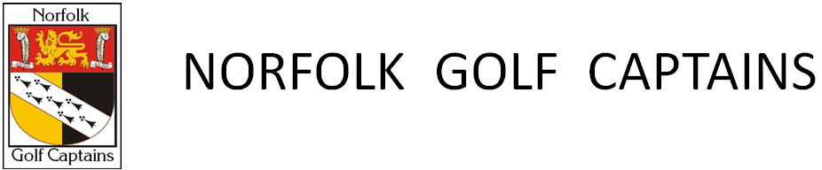
The Norfolk Golf Captains Annual Renewal Form 2026
Date completed:
Name: Mr/Mrs/Miss/Other
Current Golf Club: Year of Captaincy and Golf Club:
Email address:
Telephone numbers, please indicate preferred:
Home Address:

Post code:
Lifetime SNGC reference number: NC
I (name) have read the Norfolk Golf Captains Data Protection Policy Statement. I am happy for my data to be stored and used as described in the policy.
DOB or age:
If you were born before 1946, in accordance with the NGC constitution, you are eligible for free Honorary membership. Many members that qualify for Honorary Membership continue to pay the subscriptions, but this is by choice.
The 2026 Annual Subscription rate is £38.00
Method of Payment (Please indicate which applies)

Cheque (made payable to The Society of Norfolk Golf Captains):

Electronic transfer: Please use the following, NatWest Bank. Account name SNGC: Sort Code 51:70:02, Account No 76124258. You must quote your Lifetime SNGC reference number with your payment.

Either return this form by post with your cheque or you can email if you are paying by electronic transfer. Please note, even if you are eligible for free honorary membership you should still return this form. This is a GDPR requirement.
Send to:
Jack Norton, Honorary Treasurer, 18 Colossus Way, Costessey, Norwich, NR5 0UX
Tel: 01603 560498 E mail: jacknorton55@hotmail.com

