The Lions Tale
July 2025

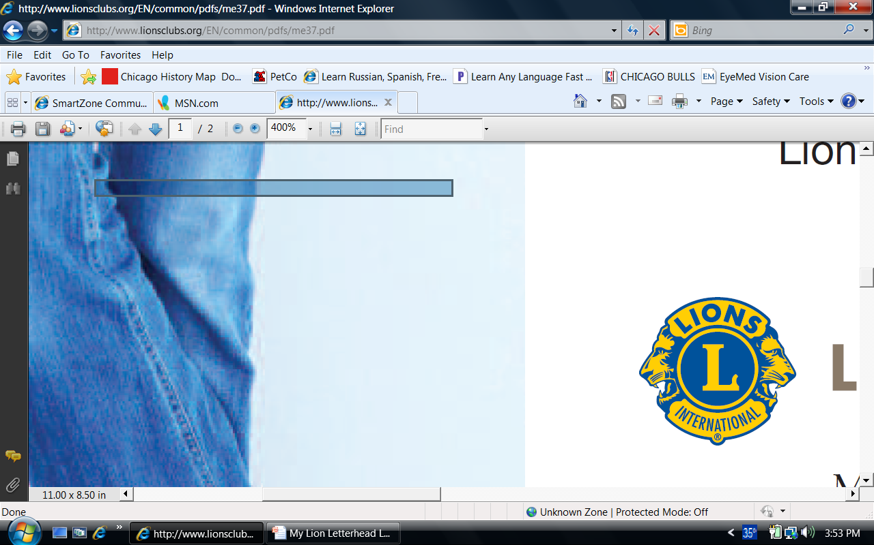 | A Publication of the Elgin Lions Club  PO Box 276, Elgin, Illinois 60121
Message From the President:  “Optimism is the faith that leads to Achievement. Nothing can be done without Hope and Confidence” – Helen Keller  Come to the July 4th Elgin parade, mingle with your fellow Lions, walk down the streets passing out beads, candy and other goodies. Be visual and inspire others to become members of the Elgin Lions Club.  Jorja and I will be attending the 107th Lions International Convention in Orlando from July 13-17, 2025. Hopefully we will be posting some from the show on the Elgin Lions Club Facebook page.  Please get involved with the club, we have many events coming up and we could use your help.  Again, we are here “TO SERVE”.  President Gary Hearn  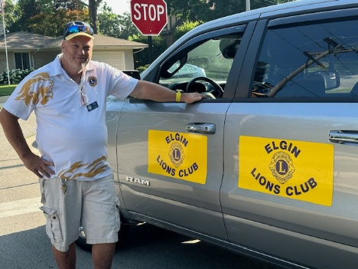  SERVICE INITIATIVES  Eyeglasses Program - Our Eyeglasses Program has been active for many years and is arguably our primary service activity in Elgin. There are many students and individuals in Elgin that cannot afford to buy their own eyeglasses. We work with the U46 School District nursing staff and the Elgin Crisis Center to provide eye examinations and glasses based on an individual’s financial needs. For year ending June 30, 2025, we have provided 61 adults and 90 children with eye exams and glasses.  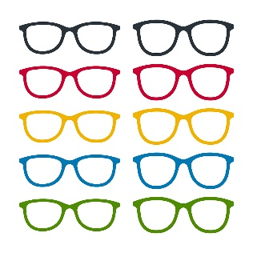  Food Drives – Our members continue to work with the Northern Illinois Food Bank at their food distribution events. In addition, we have food collection bins for nonperishable food items at a number of Elgin schools during the school year. The food collected at the schools is donated to the Elgin Crisis Center in support of their food distribution program.  Regular Meeting  Our next dinner meeting will be held on Tuesday, September 2, 2025, at 0600 pm at the American Legion Post 57 located at 820 N. Liberty Street, Elgin, IL.  LET’S CELEBRATE    July Anniversaries  Bill Klawitter – 15 years (Elgin Club)  Sue Bruneau – 10 years  Mario Martinez – 6 years  July Birthdays  Bonnie Kleinmark – July 21  OUT AND ABOUT  June 1, 2025 – Fox Trot  Over 1,000 runners participated  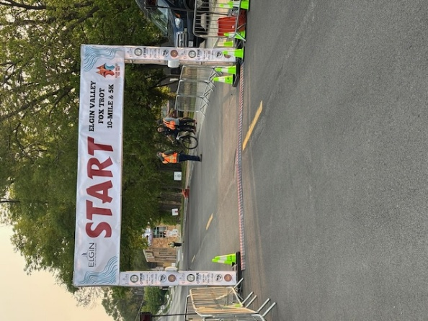  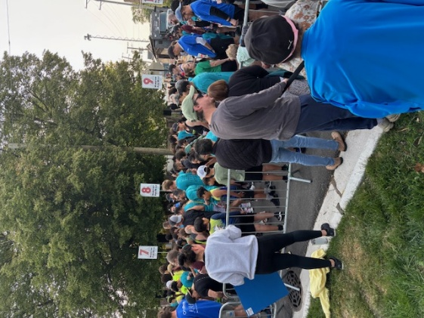  June 21, 2025 – Charitable Gaming  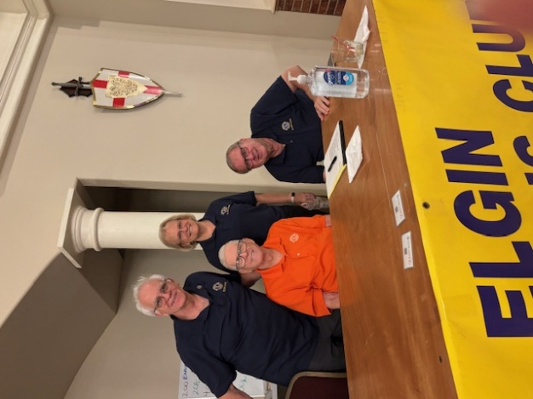  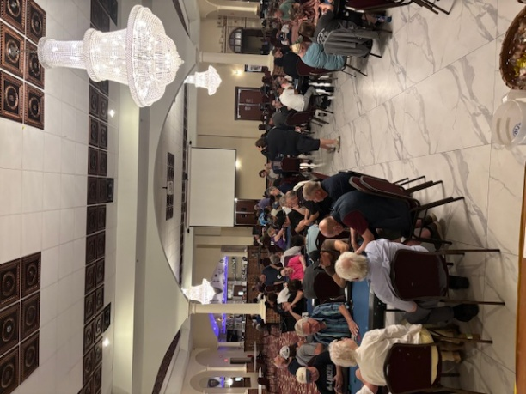  A big thanks to Lions Bill Klawitter, Bonnie Kleinmark, Sue Bruneau, John Sheehan and Bob Fowler for their help!!!  July Fun Facts  For people in the northern hemisphere, July is a time to soak up the sun, go on vacation, and spend time outdoors with family and friends.  There is a sense of balance about July. That may be because the exact middle of each year occurs on July 2nd.  July is also the month of Cancers and Leos. The Zodiac smiles down upon all the July babies during this time of year. The best part of being born in July? No school!  We also love to relax in July. The lazy dog days of summer wash over us and we can rest by the pool or lake. In July, we laugh with each other and take life a little less seriously.  Did you know July is the month of junk food?  The month of July is named after Roman leader Julius Caesar. Before the name change, July was known as Quintilis. Quintilis, the Latin word for five, was the fifth month on the Gregorian calendar.  If you were born between July 1st and July 22nd you were born under the Zodiac sign of Cancer. Cancers are known to be emotionally intelligent and caring.  If you were born between July 23rd and July 31st you were born under the Zodiac sign of Leo. Leos are known to be outgoing and confident.  06/29/25  Doings At Other Clubs – please see the District IJ Journal for upcoming events  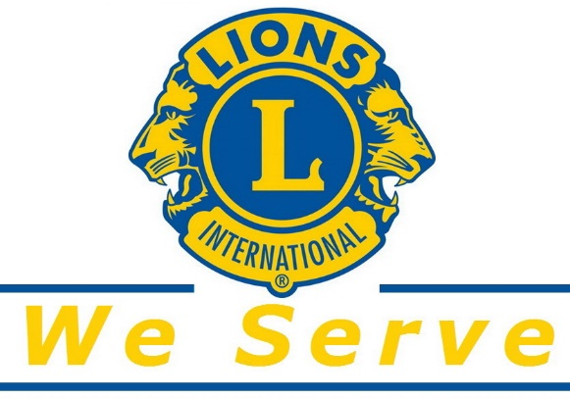 |  |  | Board Meeting  Our next Board Meeting will be held on  Tuesday, July 22, 2025, at 0600 pm. The meeting will be held at Lion Bob Fowler’s house – 11807 Borhart Drive, Huntley, IL 60142.  Membership - Attention all Elgin Lions! The number of charitable endeavors we can become involved in as a club depends on how many active members we have in our club. Many non-profit organizations are having a challenging time regarding the recruitment of new members. We are no different but, as Elgin Lions, we have a responsibility to do what we can to recruit new members.  Miscellaneous Items - Appropriate Lions clothing and insignia are required at our monthly meetings. The vest is always appropriate as is the Lions lapel pin. Our Tail Twister has been advised to fine all offenders.  Members are also reminded to keep the housing committee chairperson advised of their plans to attend the monthly dinner meeting to ensure that food is available for all attendees and that no food is wasted.  Fox Trot – cont’d  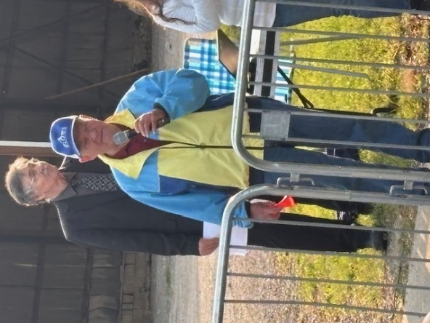  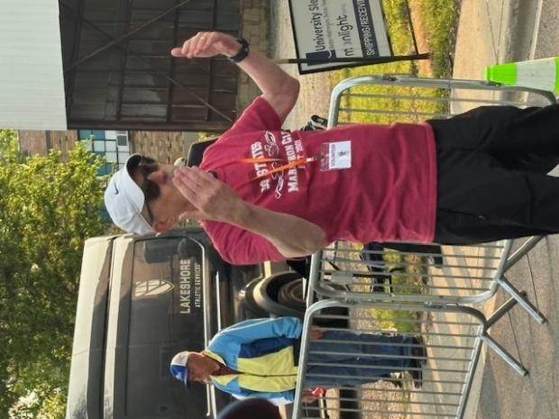  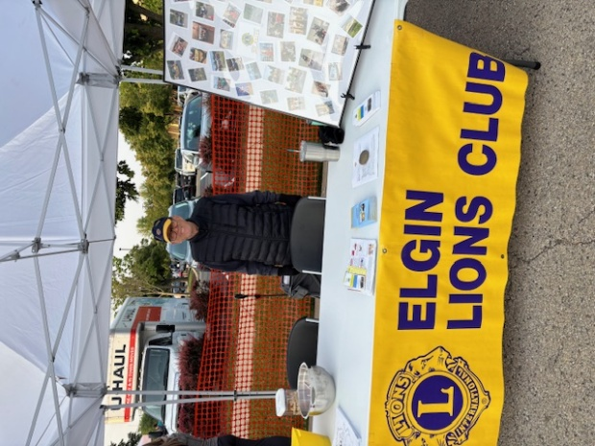  Important Dates  - July 4, 2025 – 4th of July Parade  - July 12, 2025 – Back to School Event - Library  - August 12, 2025 – 3rd Annual Lions Club Picnic at Wing Park  - August – What Makes Elgin Tick  - October – Heal Elgin  If there is something that you would be interested in doing as a service project, let one of the Board members know.

