The Lions Tale
January 2026

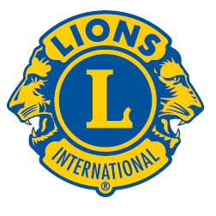 | A Publication of the Elgin Lions Club  PO Box 276, Elgin, Illinois 60121
Message From the President:  HAPPY NEW YEAR!!!!! Welcome to 2026; hopefully this year will be healthy, blessed, and profitable. Hope everybody had a safe and fantastic Christmas holiday, you all got a  chance to spend time with family and friends. Relax and rejuvenate.  Looking in the rearview mirror; I think we had a very successful 2025, thanks to all our volunteers and Lion Sue B. (2024-25 President). Thank you for participating in all our events and hopefully you all will continue throughout 2026.  On Schedule for 2026: Rose Day (week), Charitable Gaming (three more events), Elgin Valley Fox Trot, Candy day, and maybe a carnival, along with other special events in the Elgin area.  My New Year resolution is to bring volunteers to our events, friends, family members, and co-workers. We need a lot of volunteers, let these people see how our operation works, then they might become members.  SERVICE INITIATIVES  Eyeglasses Program - Our Eyeglasses Program has been active for many years and is arguably our primary service activity in Elgin. There are many students and individuals in Elgin that cannot afford to buy their own eyeglasses. We work with the U46 School District nursing staff and the Elgin Crisis Center to provide eye examinations and glasses based on an individual’s financial needs. To date we have approved 17 adults and 54 children with eye exams and glasses. We have also collected over 1,800 pairs of used glasses.    Recycling – We have collected and recycled 8 pounds to pull tabs, 17 cell phones, 72 ink cartridges and 38 hearing aids.  Food Drives – Our members continue to work with the Northern Illinois Food Bank at their food distribution events. In addition, we have food collection bins for nonperishable food items at a number of Elgin schools during the school year. The food collected at the schools is donated to the Elgin Crisis Center in support of their food distribution program.  Regular Meeting  Our next dinner meeting will be held on Tuesday, January 6, 2026, at 0600 pm at the American Legion Post 57 located at 820 N. Liberty Street, Elgin, IL.  OUT AND ABOUT  December 9, 2025 – Holiday Party  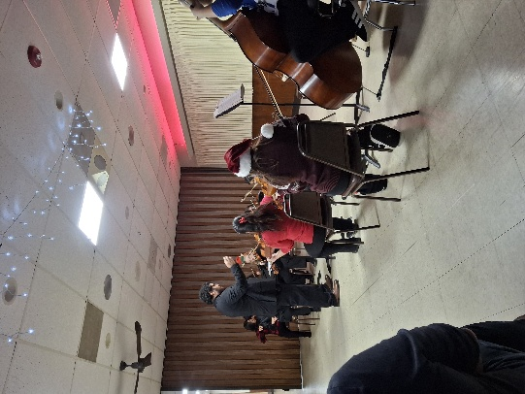  Larkin Orchestra  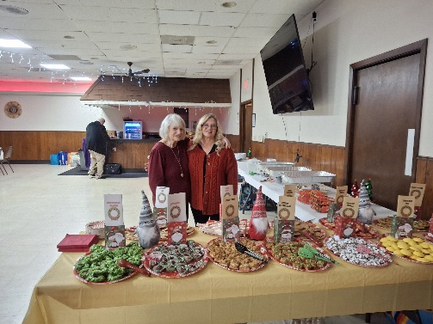  Our wonderful bakers – Janet Deal  and her wonderful mom  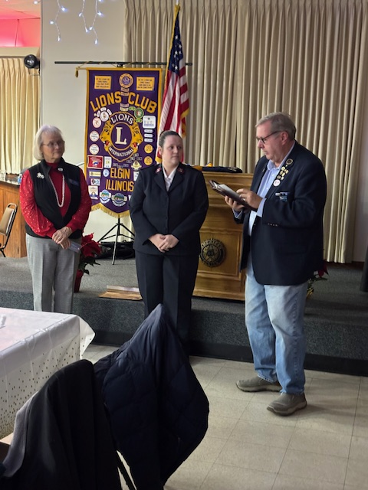  Induction of Allison Rodriguez  OUT AND ABOUT (cont’d)  December 20, 2025 – Food Distribution at ECC  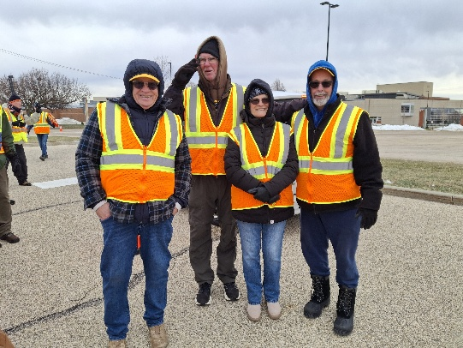  Frozen Lions John Sheehan, Wes Tredup,  Sue Bruneau and Ed Deal  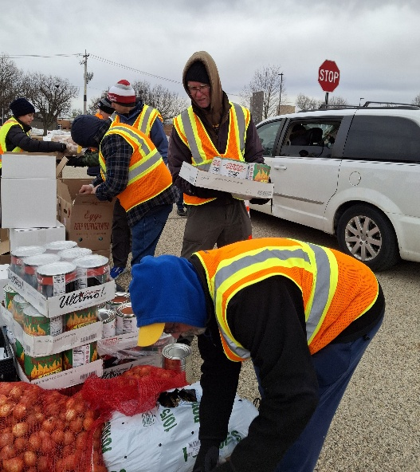  December 20, 2025 – Charitable Gaming  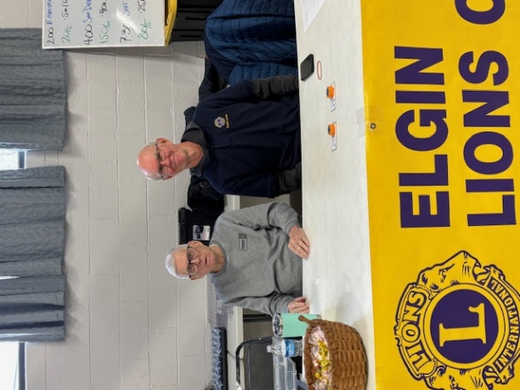  Lions Bill Klawitter and Wes Tredup  Important Dates  - January 18, 2026 – Lions Bowling  - February 28, 2026 – Charitable Gaming  If there is something that you would be interested in doing as a service project, let one of the Board members know.  Fun Facts About January  January is the 1st month of the year!!  January is known to be the coldest month in the northern hemisphere and the warmest in the southern hemisphere  The first New Year’s ball drop in New York City in 1908  The History Channel was launched in 1995  In 1959, Alaska became the 49th state of the United States  Ellis Island opened on January 1, 1892 allowing more than 20 million immigrants to enter the United States  In 1946, the first United States computer was built in Pennsylvania at the Moore School of Engineering |  |  | We are here “TO SERVE” our community, please help.  President Gary Hearn  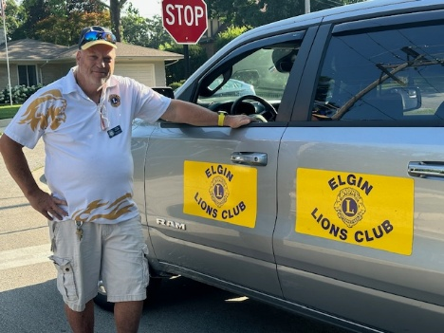  Board Meeting  Our next Board Meeting will be held on  Tuesday, January 20, 2026 at 0600 pm. The meeting will be held at the American Legion at 820 N. Liberty Street, Elgin.  Membership - Attention all Elgin Lions! The number of charitable endeavors we can become involved in as a club depends on how many active members we have in our club. Many non-profit organizations are having a challenging time regarding the recruitment of new members. We are no different but, as Elgin Lions, we have a responsibility to do what we can to recruit new members.  Miscellaneous Items - Appropriate Lions clothing and insignia are required at our monthly meetings. The vest is always appropriate as is the Lions lapel pin. Our Tail Twister has been advised to fine all offenders.  Members are also reminded to keep the housing committee chairperson advised of their plans to attend the monthly dinner meeting to ensure that food is available for all attendees and that no food is wasted.  LET’S CELEBRATE    January Anniversaries  Dan Symonds – 20 years  January Birthdays  Sandy Fidanzia – 01/23  Ron Heider – 01/01  Nadine Lipp – 01/05  Bob O’Connor – 01/01  Rickey Sparks – 01/21  Heike Spayne – 01/16  Dan Symonds – 01/01  December 13, 2025 - Bell Ringing at Sam’s Club – Our Club collected $519.14, a little lower than last year.  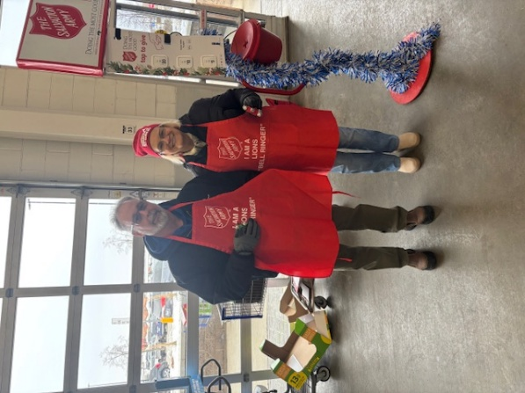  Lions Ed Deal and Sue Bruneau  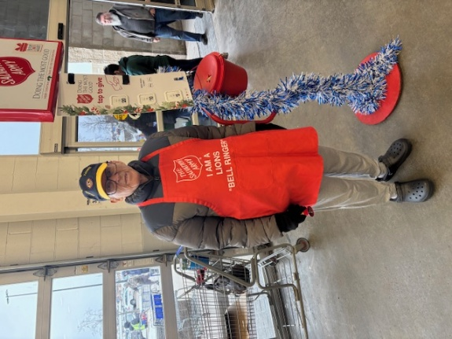  Lion Bill Klawitter  December 20, 2025 – Charitable Gaming  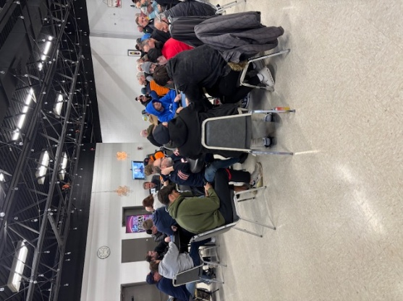  Special Appearance  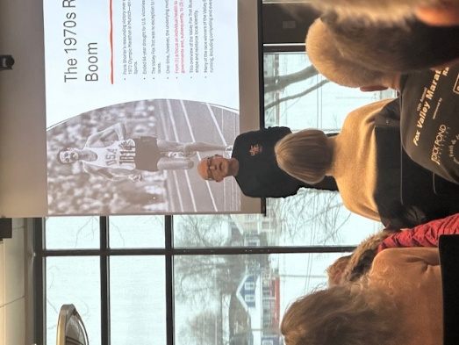  Lion/Author Ed Bates – The History of the Foxtrot  Doings At Other Clubs – please see the District IJ Journal for upcoming events  

