The Lions Tale
May/June 2026

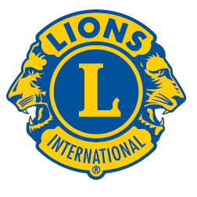 | A Publication of the Elgin Lions Club  PO Box 276, Elgin, Illinois 60121
Message From the President:  Dear Lions,  “The only thing worse than being blind is having sight but no vision.” – Helen Keller  As my term comes to a successful end; I want to thank all the Lions members for their support, their actions in being involved with Lion’s events in serving our community and your dedication and input at all our meetings. Thank you for making my Presidency painless and enjoyable, I will have many memories from this past year.  Please continue that same compassion and desire to serve our community the best way we can under our 1st time Lions President Bonnie Kleinmark. She will lean on all of us for support and direction. Congratulations to Lion Bonnie and our new officers for 2026-27. Looking forward to new bright ideas, new members, and a banner year.  SERVICE INITIATIVES  Eyeglasses Program - Our Eyeglasses Program has been active for many years and is arguably our primary service activity in Elgin. There are many students and individuals in Elgin that cannot afford to buy their own eyeglasses. We work with the U46 School District nursing staff and the Elgin Crisis Center to provide eye examinations and glasses based on an individual’s financial needs. To date we have approved 33 adults and 100+ children with eye exams and glasses. We have also collected over 2,500 pairs of used glasses.    Recycling – Don’t forget our Club also collects pull tabs, ink cartridges, hearing aids, cell phones and sneakers.  Food Drives – Our members continue to work with the Northern Illinois Food Bank at their food distribution events. In addition, we have food collection bins for nonperishable food items at a number of Elgin schools during the school year. The food collected at the schools is donated to the Elgin Crisis Center in support of their food distribution program.  Regular Meeting  Our next dinner meeting will be held on Tuesday, June 16, 2026, at 0600 pm at the American Legion Post 57 located at 820 N. Liberty Street, Elgin, IL.  OUT AND ABOUT  May 1, 2026 – Charitable Gaming  Downers Grove  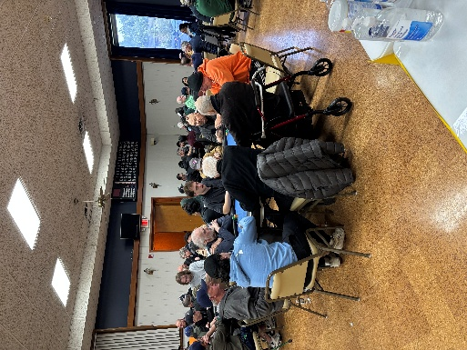  A BIG Thanks to Lions Lynne Dusel, Sue Bruneau, John Sheehan and Bonnie Kleinmark for manning the table  *****  May 2, 2026 – Bob Olender District Governor Roar  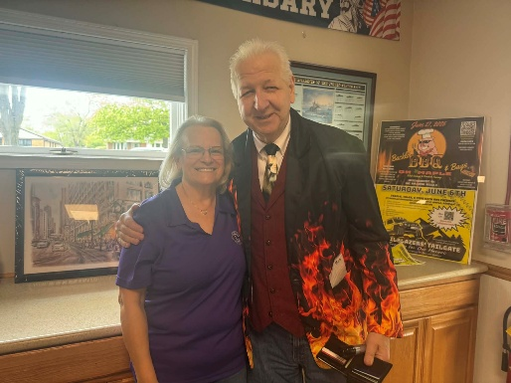  Lion Sue Bruneau and New District  Governor Bob Olender  *****  May 2, 2026 District Convention  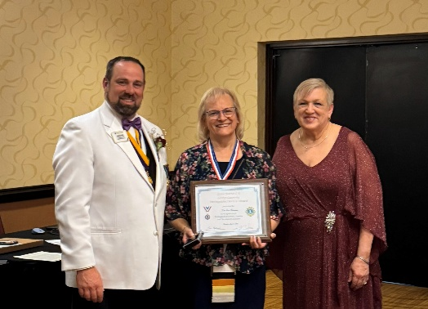  Lion Sue Bruneau (center) is awarded the George Lazansky Award  .  Awards  NA  This and That  Golf Balls are like eggs. They’re white, sold by the dozen, and a week later you have to buy more.  Kindness is free, but its impact is priceless.  When one door closes another one opens, other than that it’s a pretty good car.  A perfect metaphor for life would be “someone trying to stand up in a hammock”.  Welcome to the Chair. Clothes too dirty for the closet but too clean for the laundry.  Facetious – is the only word in the English language that uses all of the vowels in order.  In the cookie of life, friends are the chocolate chips.  When people give me directions and say “you can’t miss it.” You have no idea what I’m capable of.  Be Decisive….The road of life is paved with flat squirrels who couldn’t make a decision.  Today is a good day for a good day!!  Doings At Other Clubs – please see the District IJ Journal for upcoming events   |  |  | I will leave you one more quote from Helen Keller since her birthday is June 27 – “The best and most beautiful things in the world cannot be seen or even touched – they must be felt with the heart.”  “WE SERVE”  President Gary Hearn  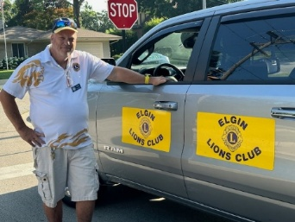  Board Meeting  Our next Board Meeting will be held on  Tuesday, July 21, 2026 at 0600 pm. Location to be determined.  Membership - Attention all Elgin Lions! The number of charitable endeavors we can become involved in as a club depends on how many active members we have in our club. Many non-profit organizations are having a challenging time regarding the recruitment of new members. We are no different but, as Elgin Lions, we have a responsibility to do what we can to recruit new members.  Miscellaneous Items - Appropriate Lions clothing and insignia are required at our monthly meetings. The vest is always appropriate as is the Lions lapel pin. Our Tail Twister has been advised to fine all offenders.  Meeting Etiquette - Please no side discussions during meetings, offenders will be fined!!  Members are also reminded to keep the housing committee chairperson advised of their plans to attend the monthly dinner meeting to ensure that food is available for all attendees and that no food is wasted.  LET’S CELEBRATE    May/June Anniversaries  May – NA  Jose Cuevas – 4 years  Ed Deal – 8 years  Janet Deal – 8 years  Heike Spayne – 3 years  May/June Birthdays  Wes Tredup – 06/11  Bob Fowler – 06/22  OUT AND ABOUT (cont’d)  Scholarships  May 12, 2026 – Elgin High School  Scholarships presented to Alexa Orozco and Margaret Ingents by Lion Sue Bruneau.  May 20, 2026 – Larkin High School Scholarship presented to Yesina Escobar by Lion Bonnie Kleinmark.  June 1, 2026 – Burlington High Scholarship presented to Allison Kowall by Lion Sue Bruneau.  *****  May 31, 2026 – Elgin Valley Fox Trot  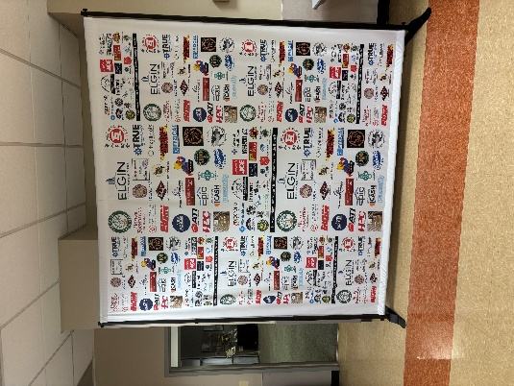  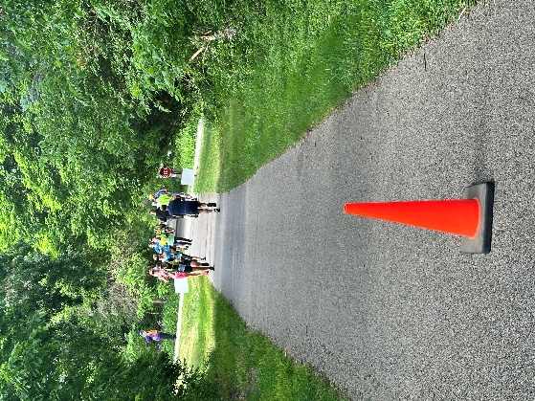  A BIG THANKS to everyone who volunteered to make this a very successful event!! A Special Thanks to the Dundee Township Lions who were a big help!!!  Fundraising  The Club is currently thinking of some fundraising ideas. All ideas are welcome!!!  If there is something that you would be interested in doing as a service project, let one of the Board members know

