The Lions Tale
February/March 2026

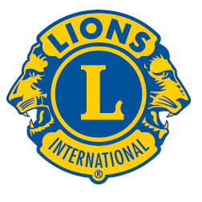 | A Publication of the Elgin Lions Club  PO Box 276, Elgin, Illinois 60121
Message From the President:  An Irish saying “Don’t miss all the beautiful colours of the rainbow looking for the pot of gold”. Happy St. Patrick’s Day!! March is upon us and hopefully Spring is just around the corner unless you believe in the groundhog.  We have a guest speaker for our monthly dinner meeting, Jerry Turnquist – local historian. Bring a spouse, significant other and/or friends.  Rose Day is upon us at the end of month and early April; we need volunteers and we need drivers. Contact Lion Sue or myself if you can help, highly appreciated. Get your orders in as soon as possible - $20.00/dozen. Thank you.  Looking for officers for the upcoming new year of 2026-27, need a new President – any volunteers? There will be a nominating committee to discuss these positions, it’s very rewarding. Please become an officer and get involved, your say makes a difference.  “WE SERVE”  President Gary Hearn  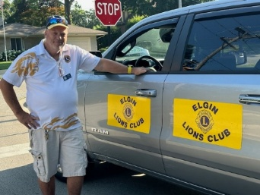  SERVICE INITIATIVES  Eyeglasses Program - Our Eyeglasses Program has been active for many years and is arguably our primary service activity in Elgin. There are many students and individuals in Elgin that cannot afford to buy their own eyeglasses. We work with the U46 School District nursing staff and the Elgin Crisis Center to provide eye examinations and glasses based on an individual’s financial needs. To date we have approved 21 adults and 65 children with eye exams and glasses. We have also collected over 1,800 pairs of used glasses.    Recycling – We have collected and recycled 8 pounds to pull tabs, 17 cell phones, 72 ink cartridges and 38 hearing aids.  Food Drives – Our members continue to work with the Northern Illinois Food Bank at their food distribution events. In addition, we have food collection bins for nonperishable food items at a number of Elgin schools during the school year. The food collected at the schools is donated to the Elgin Crisis Center in support of their food distribution program.  Regular Meeting  Our next dinner meeting will be held on Tuesday, April 7, 2026, at 0600 pm at the American Legion Post 57 located at 820 N. Liberty Street, Elgin, IL.  OUT AND ABOUT  January 18, 2026  District 1J Bowling  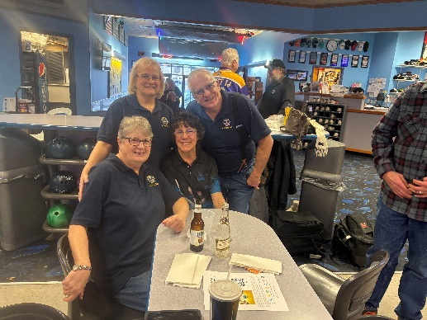  February 25, 2026  District 1J Meeting hosted by Island Lakes Lions  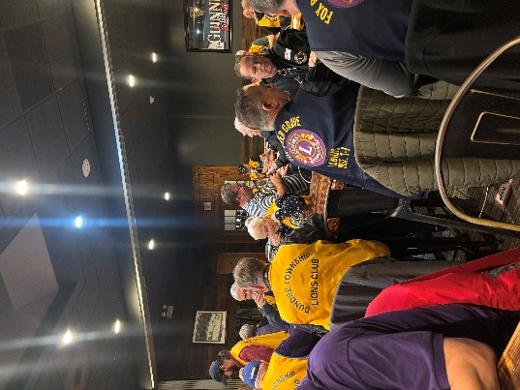  February 28, 2026  Charitable Gaming  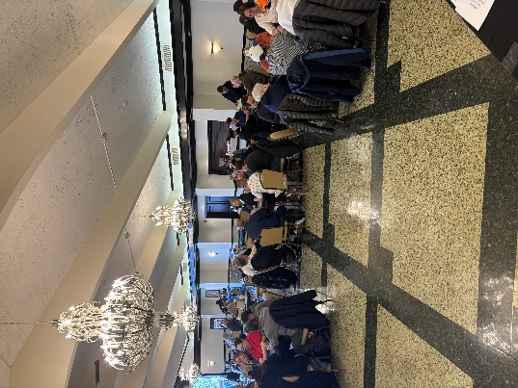  Thanks to Lions Bill Klawitter, Gary Hearn,  Bob Fowler and Bonnie Kleinmark for  helping out  Important Dates  April 10-11 – Convention  If there is something that you would be interested in doing as a service project, let one of the Board members know.  Thoughts  We are a generation that will  never comeback  A generation that walked to school and then walked back.  A generation that did homework, also to get out asap to play in the street.  A generation that spent all their free time on the street with their friends.  A generation that made mud cakes.  A generation that found, collected, washed and returned empty Coke bottles to the local grocery store for 5 cents each, then bought a Mountain Dew and candy bar with the money.  A generation that made paper toys with their bare hands.  A generation who bought vinyl albums to play on the record player.  A generation that played board games and cards on rainy days.  A generation whose TV went off at midnight after playing the National Anthem.  A generation that laughed under the covers in bed so parents didn’t know we were still awake.  A generation that will never return and I loved growing up when I did. |  |  | Board Meeting  Our next Board Meeting will be held on  Tuesday, March 17, 2026 at 0600 pm. The meeting will be held at the American Legion at 820 N. Liberty Street, Elgin.  Membership - Attention all Elgin Lions! The number of charitable endeavors we can become involved in as a club depends on how many active members we have in our club. Many non-profit organizations are having a challenging time regarding the recruitment of new members. We are no different but, as Elgin Lions, we have a responsibility to do what we can to recruit new members.  Miscellaneous Items - Appropriate Lions clothing and insignia are required at our monthly meetings. The vest is always appropriate as is the Lions lapel pin. Our Tail Twister has been advised to fine all offenders.  Members are also reminded to keep the housing committee chairperson advised of their plans to attend the monthly dinner meeting to ensure that food is available for all attendees and that no food is wasted.  LET’S CELEBRATE    March Anniversaries  Sharry Blazier – 4 years  Nadine Lipp – 2 years  February/March Birthdays  Mario Martinez – 02/20  Sharry Blazier – 03/01  Fundraising  Rose Day - One our largest fundraising events is taking place in March – Rose Day!!! See attached brochure for details. Also, Lion Sue Bruneau will be looking for drivers to help deliver the roses.  District Governor Terri Pasternik has a service project she would like all Lions in her district to participate in – “Change for a Cure” to fight childhood cancer. The below piggy bank will attend all of our meetings. Please throw in any extra change you may have in your wallets or purses. At the end of the Lion year, each club will donate the collected change to a group supporting finding a cure for childhood cancer.  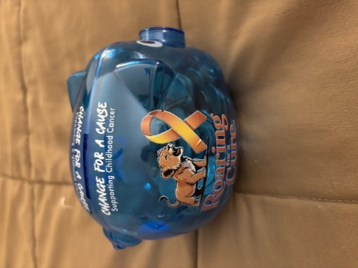  Doings At Other Clubs – please see the District IJ Journal for upcoming events  

