The Lions Tale
November/December 2025

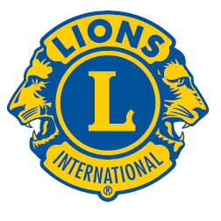 | A Publication of the Elgin Lions Club  PO Box 276, Elgin, Illinois 60121
Message From the President:  HAPPY HOLIDAYS, MERRY CHRISTMAS & A JOYOUS NEW YEAR!!!!!!  Hoping that your Thanksgiving was blissful, entertaining, and rewarding. December 9th is our annual Holiday dinner at American Legion Hall with music provided by Larkin High School. Bring your significant other and family, hopefully you all can attend a spiritual and uplifting evening.  Please purchase Poinsettias from Lion Sue for $15.00; proceeds help fund the eye glass program. December 13th at Sam’s on Randall Road in cooperation with the Elgin Salvation Army, ringing the Bell – Red Kettle for donations from 10:00 am to 6:00 pm. Need volunteers. Charitable gaming on December 20, See Lion Bonnie if you like Poker.  SERVICE INITIATIVES  Eyeglasses Program - Our Eyeglasses Program has been active for many years and is arguably our primary service activity in Elgin. There are many students and individuals in Elgin that cannot afford to buy their own eyeglasses. We work with the U46 School District nursing staff and the Elgin Crisis Center to provide eye examinations and glasses based on an individual’s financial needs. To date we have approved 12 adults and 43 children with eye exams and glasses. We have also collected over 1,800 pairs of used glasses.    Food Drives – Our members continue to work with the Northern Illinois Food Bank at their food distribution events. In addition, we have food collection bins for nonperishable food items at a number of Elgin schools during the school year. The food collected at the schools is donated to the Elgin Crisis Center in support of their food distribution program.  Regular Meeting  Our next dinner meeting will be held on Tuesday, December 9, 2025, at 0600 pm at the American Legion Post 57 located at 820 N. Liberty Street, Elgin, IL.  A big thank you to Rick Reigner of the Salvation Army. Rick was our October guest speaker.  A big thank you to Ruth Peterson of the Crisis Center. Ruth was our November Speaker.  OUT AND ABOUT  Candy Day – 10/03/25  Jewel/Osco  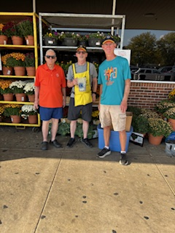  Candy Day – 10/04/25    Candy Day – 10/11/12/25  Country Donuts  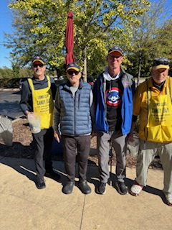  Awards  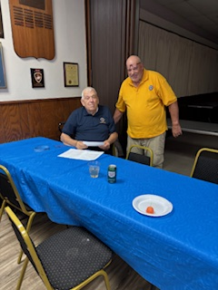  Lion Bob O’Connor received 40-year  recognition from President Gary Hearn  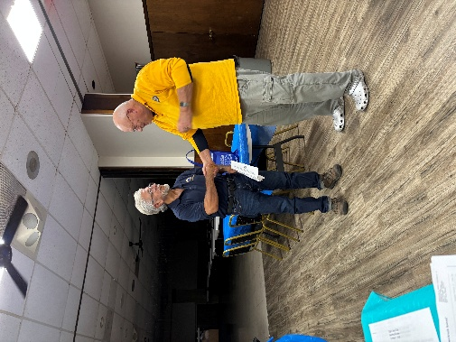  Lion Mario Martinez receiving award from  President Gary Hearn for membership additions  Important Dates  - December 9, 2025 – Holiday Party  - December 13, 2025 – Bell Ringing  - December 20, 2025 – Charitable Gaming  Poinsettias for Sale  See Lion Sue for information regarding the poinsettias.  If there is something that you would be interested in doing as a service project, let one of the Board members know.  Doings At Other Clubs – please see the District IJ Journal for upcoming events   |  |  | The theme for next year is to encourage volunteers to help us at special events, hopefully that will lead to being a member.  Enjoy the holidays; be with family and friends, enjoy the journey, be safe and stay healthy.  Please get involved – Again, we are here “TO SERVE”  President Gary Hearn  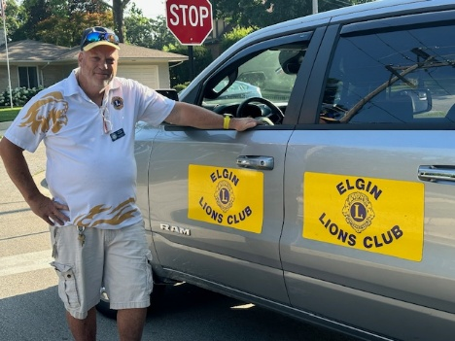  Board Meeting  Our next Board Meeting will be held on  Tuesday, December 16, 2025, at 0600 pm. The meeting will be held at the American Legion at 820 N. Liberty Street, Elgin.  Membership - Attention all Elgin Lions! The number of charitable endeavors we can become involved in as a club depends on how many active members we have in our club. Many non-profit organizations are having a challenging time regarding the recruitment of new members. We are no different but, as Elgin Lions, we have a responsibility to do what we can to recruit new members.  Miscellaneous Items - Appropriate Lions clothing and insignia are required at our monthly meetings. The vest is always appropriate as is the Lions lapel pin. Our Tail Twister has been advised to fine all offenders.  Members are also reminded to keep the housing committee chairperson advised of their plans to attend the monthly dinner meeting to ensure that food is available for all attendees and that no food is wasted.  LET’S CELEBRATE    November Anniversaries  Bob Fowler – 28 years  December Anniversaries  Wes Tredup – 8 years  November Birthdays  Sue Bruneau – 11/11  December Birthdays  Rosa Guerra – 12/01  Bill Klawitter – 12/16  Allison Rodriguez – 12/24  Heal Elgin – 10/18-19/25    October 29, 2025  Lions District Meeting  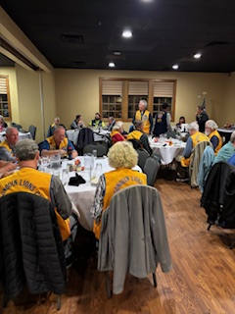  Attended by Lions Bob Fowler, Gary Hearn,  Bill Klawitter and Bonnie Kleinmark  Welcome Aboard!!!  Allsion Rodriguez has joined the Elgin Lions Club. Allsion comes to us from the Salvation Army.  Hidden Facts About December  Christmas wasn’t always on December 25th – early Christians celebrated it at different times of the year and date was officially set in the 4th century.  The first Christmas tree was decorated in Germany in the 16th century.  Santa Claus wasn’t always jolly – early depiction show him as stern or even scary.  Candy canes were invented in the 17th century to keep children quiet during the church services.

