The Lions Tale
A Publication of the Elgin Lions Club
Elgin Lions Club PO Box 276, Elgin, Illinois 60121

July/August 2026

A Note from the President  First of all, I want to say congratulations to our new officers and board members.  July and August have been very busy months for our Club. A lot of public events and more to come in the next months.  I know if we work together, we can have another successful year  Thanks to everyone who participated in our summer events.  Thanks,  Bonnie Kleinmark  President  July Events  July was a fun, eventful month!  The Elgin Lions participated in the July 4th parade. We handed out purple and gold beads and candy to the 1,000’s of kids and adults.  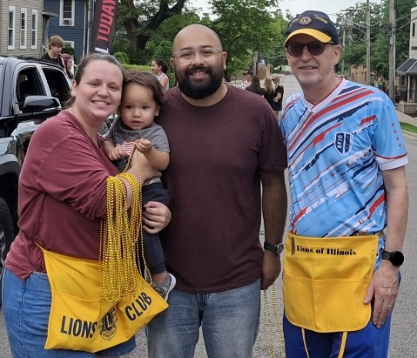  Alison, Henry, Scott, Lion Ed  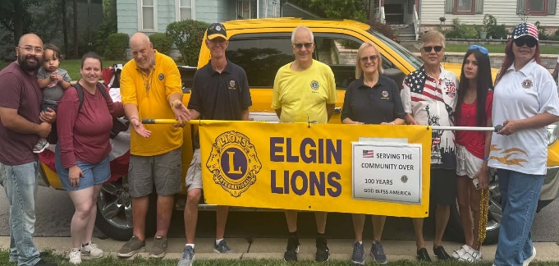  Left to right: Scott, Henry, Alison, Gary, Wes, John, Sue, Alex & Janna (friends of Jorja), Jorja  Xilin Health Fair  We tested 19 children & adults  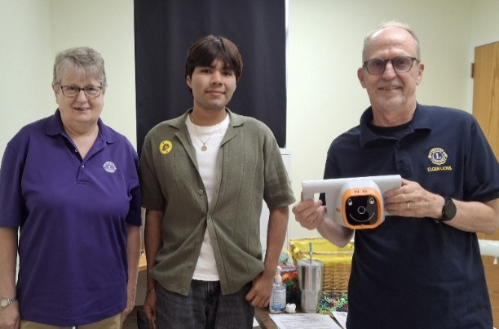  Lion Bonnie, Juan (translator), Lion Ed  District 1J Golf Outing  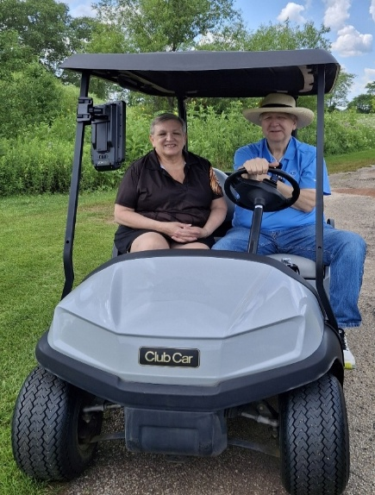  Past District Governor Terri Pasternik & Current District 1J Governor Bob Olender  Xilin Health Fair  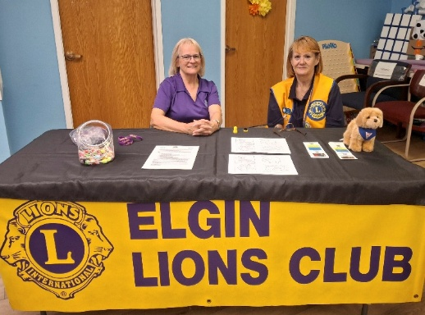  Lions Sue and Rosa  SERVICE INITIATIVES  Eyeglasses Program - Our Eyeglasses Program has been active for many years and is our primary service activity in Elgin. There are many students and individuals in Elgin that cannot afford to buy their own eyeglasses. We work with the U-46 School District nursing staff and the Elgin Crisis Center to provide eye examinations and glasses based on an individual’s financial needs. Approved 2026 approved 33 adults and 105 children with eye exams and glasses.  Regular Meeting  No meeting on 8/4 due to the picnic on 8/11  Picnic August 11, 6:00 – 8:00 P.M.  Sept. dinner meeting will be held on Tuesday, Sept. 1, 2026, at 06:15 pm at the American Legion Post 57 located at 820 N. Liberty Street, Elgin, IL.  Board Meeting  Our next Board Meeting will be held on  Tuesday, August 18, 2026 at 0600 pm. Sue & John’s house, 886 N Shady Oaks Dr. Elgin  Doings At Other Clubs – please copy & past the link below for upcoming events. Elmhurst Lions Reverse Raffle / Aurora Carillon Lions New   |  |  | July Events (cont’d)  The Elgin Classic Bike Race was hosted by the Northeast Neighborhood Association of Elgin (NENA). We had 10 volunteers for 40 hours of service. It was interesting seeing all the racers from all over the world.  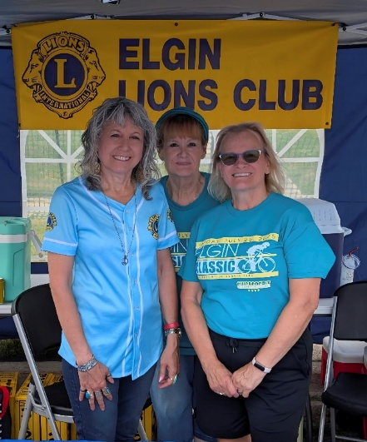  Lion Kari Freeman (Huntley Lions) Lions Rose & Sue  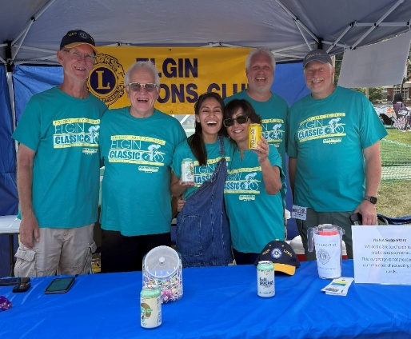  Lions Wes, John Volunteers: Cecilia, Teresa, NENA members Tom & Eric  District 1J Golf Outing in July  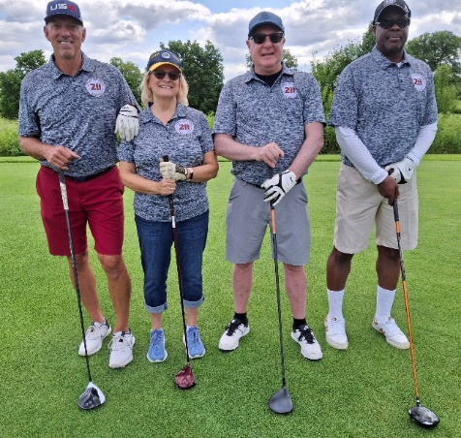  Bob, Lion Sue, Dave, Lion Rickey  LET’S CELEBRATE    July/August Anniversaries  07/01/18 – Mario Martinez – 8 years  07/23/15 – Sue Bruneau – 11 years  08/13/24 – Rose Guerra – 2 years  July/August Birthdays  0721 – Bonnie Kleinmark  8/7 – Gary Hearn  Fundraising  All ideas are welcome!!!  If there is something that you would be interested in doing as a service project, let one of the Board members know  Recycling  Reminder: our Club also collects pull tabs, ink cartridges, hearing aids, cell phones, sneakers and eyeglasses. We take all of these items to the Foundation office and they are sent out from there. We collected over 2,300 pairs of glasses in 2026.  So far in August we collected and took to the District 67 pairs of tennis shoes, 1385 pairs of glasses, 28 cell phones, 29 hearing aids, 25 ink cartridges, and 5 lbs. of tabs

