The Lions Tale
A Publication of the Elgin Lions Club

September 2026

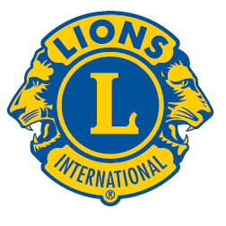
Message From the President:  Lions –  Summer is over!! We were a busy group this summer, i.e., Fox Trot support, 4th of July Parade, multiple vision screenings, Elgin bike race support, and charitable gaming to mention a few.  Let’s keep the momentum going as we enter our new Lions year!!! Also, if any Lion knows of an event that we might be interested in, please bring it up a regular meeting or board meeting.  Please remember that all members are invited to our board meetings.  Thanks!!!  Lion Bonnie  President  SERVICE INITIATIVES    Recycling – Don’t forget our Club also collects pull tabs, ink cartridges, hearing aids, cell phones, sneakers and eyeglasses. We take all of these items to the Foundation office and they are sent out from there. We collected over 2,500 pairs of glasses in 2026.  Regular Dinner Meeting  Sept. dinner meeting will be held on Tuesday, Sept. 1, 2026, at 06:15 pm at the American Legion Post 57 located at 820 N. Liberty Street, Elgin, IL.  AUGUST EVENTS  Annual Picnic  Another successful event and we got lucky with a no rain day! See pic of Presidents Lions Sue (Foundation) and Bonnie (Club) with the four $1500 recipients this year.  We had Jeff Cholewa, PDG speak about Leaderdog and he had his new pup Timber with him.  Lion Terri Pasternik, past District governor also spoke a few minutes and really enjoyed our picnic.  Lion Ed Bates spoke about the next Fox Trot and how important it is to have sponsors.  Picnic (Continued)  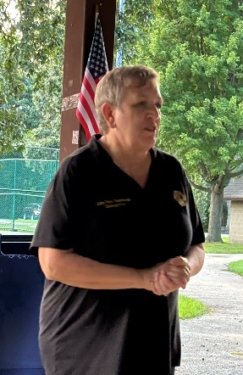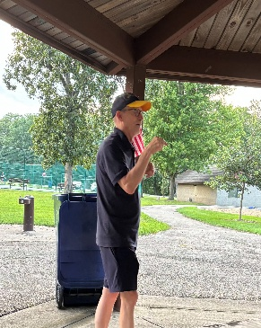  PDG Terri Pasternik Dr. Ed Bates  August 22, 2026 – Charitable Gaming  Bridgeview Community Center  A BIG Thanks to Lions Bonnie Kleinmark & Bill Klawitter, Wes Tredup & Sue Bruneau for manning the table. It was a successful day!  Want to learn more about Lionism?  All Lions are encouraged to attend the District 1-J Annual Fall Forum   Whether you’re a long-time Lion or newly stepping into leadership, this gathering offers a chance to connect, grow, and enjoy the camaraderie of others who share your commitment to community and Lions.  October 17 9:00 to 1:30, lunch $10  At ARC Reed Keppler Park, West Chicago  District 1J Forum Registration - Response Form Link: https://grasshoppersignup.com/s/0mcezv |  |  | LET’S CELEBRATE    September Birthdays  20th – Ed Deal  Board Meeting  Our next Board Meeting will be held on  Tuesday, September 15, 2026 at 06:15 pm. at the American Legion, 820 N Liberty St. Elgin  Picnic  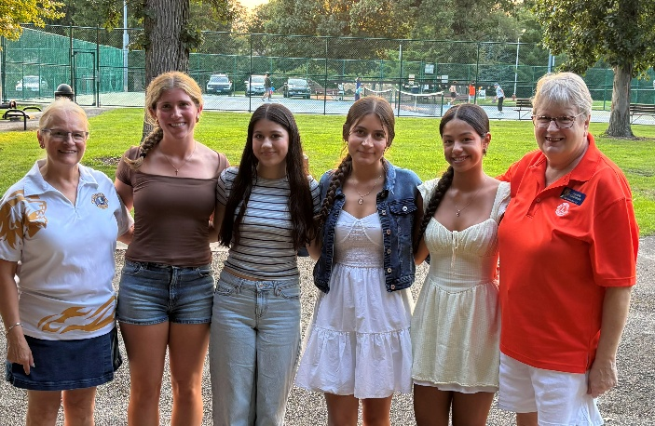  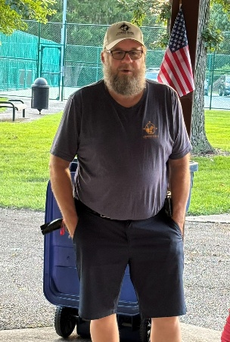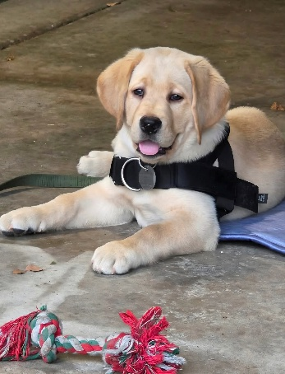  PDG Jeff Cholewa – Leaderdog for the blind, & Timber  Fundraising  Upcoming events:  October  Candy Days: 10/3,10/9-10-11 sign up sheets to be at the September dinner meeting.  November  Poinsettia Fundraiser – will be discussed at the Sept. & Oct. meeting  Upcoming Zone Meeting  Elgin is hosting the next zone meeting in October. If anyone has ideas for raffle baskets, etc., please let Lions Bonnie know.  Doings At Other Clubs – please see the District IJ Journal for upcoming events  2026July-Aug_Lions-Share.pdf    Elgin Lions Club PO Box 276, Elgin, Illinois 60121  Editor: Lion Sue Bruneau

