The Lions Tale
April 2026

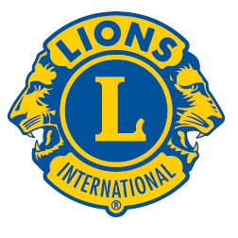 | A Publication of the Elgin Lions Club  PO Box 276, Elgin, Illinois 60121
Message From the President:  Dear Lions,  “Believe nothing, and trust no one this April Fools’ Day.” Watch out for “fake news” – A. I. has taken over. Spring is here, can’t wait for warmer temperatures. Happy Easter!! Enjoy spending time with family and friends – don’t forget those egg hunts.  Our annual Rose Day event has started and will continue into early April, need to sell 400 dozen roses to help fund the eyeglass program. Thanks to all that help sell roses and to those drivers that brought these beautiful roses to the local schools and to the individuals’ homes and businesses. A BIG thank you to Lion Sue for chairing this wonderful event.  We have a guest speaker for our April dinner meeting – Santiago Cuevas – partnering together for a blood drive.  Nominating committee will be getting together in early April to discuss 2026-27 new officers. If you would like to be an officer, step forward and be heard. All positions could be available.  SERVICE INITIATIVES  Eyeglasses Program - Our Eyeglasses Program has been active for many years and is arguably our primary service activity in Elgin. There are many students and individuals in Elgin that cannot afford to buy their own eyeglasses. We work with the U46 School District nursing staff and the Elgin Crisis Center to provide eye examinations and glasses based on an individual’s financial needs. To date we have approved 33 adults and 74 children with eye exams and glasses. We have also collected over 2,000 pairs of used glasses.    Recycling – Don’t forget our Club also collects pull tabs, ink cartridges, hearing aids, cell phones and sneakers.  Food Drives – Our members continue to work with the Northern Illinois Food Bank at their food distribution events. In addition, we have food collection bins for nonperishable food items at a number of Elgin schools during the school year. The food collected at the schools is donated to the Elgin Crisis Center in support of their food distribution program.  Regular Meeting  Our next dinner meeting will be held on Tuesday, April 7, 2026, at 0600 pm at the American Legion Post 57 located at 820 N. Liberty Street, Elgin, IL.  OUT AND ABOUT  Nothing to report - March was a slow month.  Important Dates  April 10-11 – Convention  May 1 – Charitable Gaming Event  May 31 – Fox Trot  July 24-26 - Carnival  If there is something that you would be interested in doing as a service project, let one of the Board members know.  Awards  Our Club was awarded the Silver Partner Award for our participation with events sponsored by the Salvation Army.  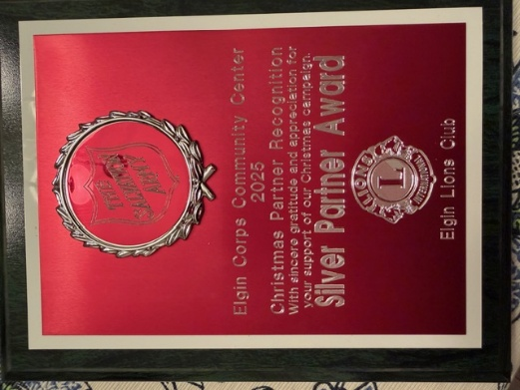  Doings At Other Clubs – please see the District IJ Journal for upcoming events   |  |  | Need ideas for our 105th Anniversary, looking for suggestions, maybe something for the 4th of July parade, we got a big yellow truck we can use.  Spring means baseball season – GO Cubs!! GO White Sox!!  “WE SERVE”  President Gary Hearn  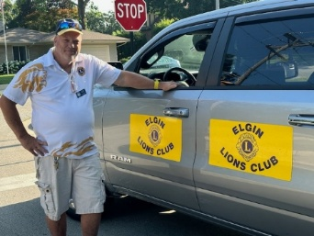  Board Meeting  Our next Board Meeting will be held on  Tuesday, April 21, 2026 at 0600 pm. The meeting will be held at the American Legion at 820 N. Liberty Street, Elgin.  Membership - Attention all Elgin Lions! The number of charitable endeavors we can become involved in as a club depends on how many active members we have in our club. Many non-profit organizations are having a challenging time regarding the recruitment of new members. We are no different but, as Elgin Lions, we have a responsibility to do what we can to recruit new members.  Miscellaneous Items - Appropriate Lions clothing and insignia are required at our monthly meetings. The vest is always appropriate as is the Lions lapel pin. Our Tail Twister has been advised to fine all offenders.  Members are also reminded to keep the housing committee chairperson advised of their plans to attend the monthly dinner meeting to ensure that food is available for all attendees and that no food is wasted.  LET’S CELEBRATE    April Anniversaries  Ed Bates – 22 years  Lynne Dusel – 11 years  Gary Hearn – 9 years  Bonnie Kleinmark – 14 years  April Birthdays  Janet Deal – 04/16  Lynne Dusel – 04/15  Fundraising  Rose Day – Another successful Rose Day has come and gone!!!! Thanks to all of the Lions who helped deliver the roses.  Sight & Sound Sweepstakes – Please give completed raffle books/money to Lion Sue Bruneau for processing.  Terri Pasternik Piggy Bank - Don’t forget, our hungry little piggy bank will be attending the meeting – don’t forget to bring your extra change. All money collected will be donated to a hospital that deals with childhood cancer.  