The Lions Tale
October 2025

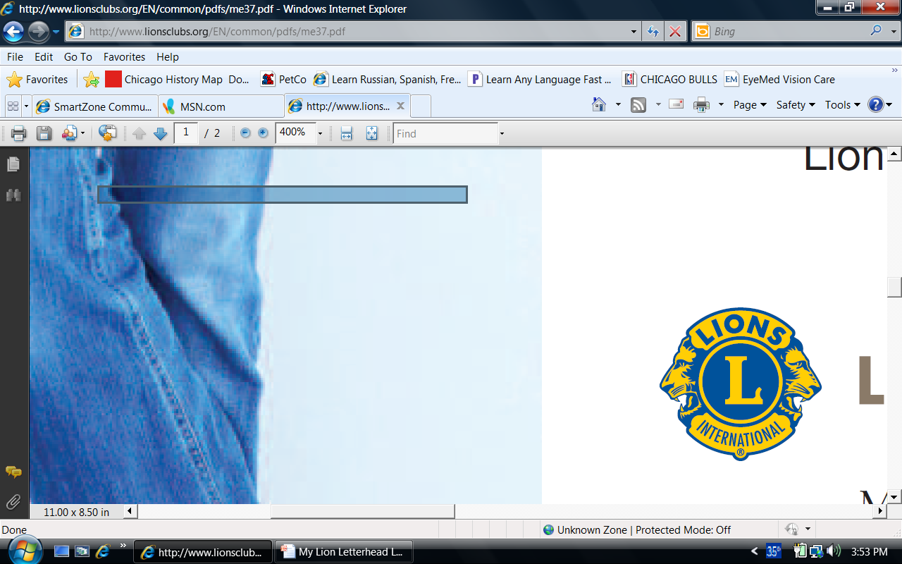 | A Publication of the Elgin Lions Club  PO Box 276, Elgin, Illinois 60121
Message From the President:  "Candy Man, Hey, Candy Man, Alright everybody, gather around, the Candy Man is here?" - Sammy Davis Jr. Candy days are upon us; I want to thank all our volunteers in supporting this terrific event that will be held at Larkin Avenue Jewel (Oct 3), Big Apple Bagels (Oct 4), and Country Donuts (Oct 11 & 12). Lion Wes needs volunteers especially on Oct 12 at Country Donuts.  DUES: Please pay your 2025-26 dues, our club has paid your dues in July to the International, state and district lions clubs. Thank you in advance.  Please get involved - Again, we are here "TO SERVE"  President Gary Hearn  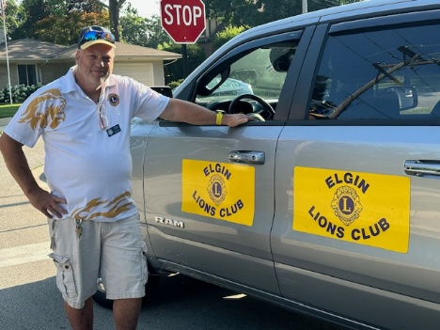  SERVICE INITIATIVES  Eyeglasses Program - Our Eyeglasses Program has been active for many years and is arguably our primary service activity in Elgin. There are many students and individuals in Elgin that cannot afford to buy their own eyeglasses. We work with the U46 School District nursing staff and the Elgin Crisis Center to provide eye examinations and glasses based on an individual’s financial needs. To date we have provided 8 adults and 7 children with eye exams and glasses.    Food Drives – Our members continue to work with the Northern Illinois Food Bank at their food distribution events. In addition, we have food collection bins for nonperishable food items at a number of Elgin schools during the school year. The food collected at the schools is donated to the Elgin Crisis Center in support of their food distribution program.  Regular Meeting  Our next dinner meeting will be held on Tuesday, October 7, 2025, at 0600 pm at the American Legion Post 57 located at 820 N. Liberty Street, Elgin, IL.  A big thanks to Jen Keller of PADS who was our guest speaker. Also, a big thanks to the Lions who donated much needed supplies for PADS.  OUT AND ABOUT  September 13, 2025 – Heritage Fest  Another fun outing helping the West Dundee Lions Club  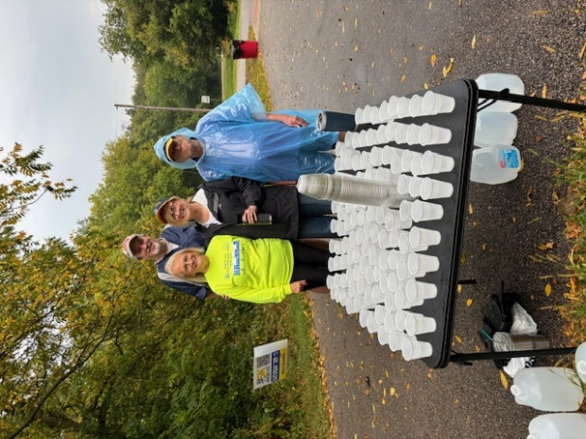  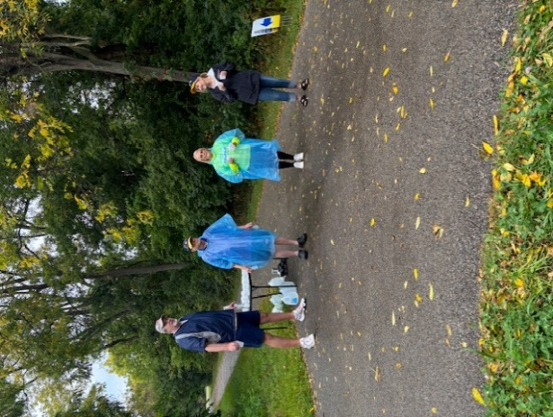  A big thanks to Lions Bill Klawitter, Sue Bruneau, Lyn Dusel, Andy (friend) and Bonnie Kleinmark (not pictured)  Important Dates  - October 18-19 – Heal Elgin  - October 3, 4 and 11– Candy Day  If there is something that you would be interested in doing as a service project, let one of the Board members know.  This and That  People who travel to see the vibrant leaf colors are called “leaf peepers”.  To prepare for winter, squirrels bury up to 3,000 nuts during fall.  Falling back for daylight savings time leads to fewer heart attacks.  More relationships bloom in the fall.  The smell of pumpkin pie is an aphrodisiac.  The largest pumpkin ever weighed nearly 3,700 pounds.  Zombie walks take over towns worldwide.  It’s the only time you can watch all of the major sports at one time.  Doings At Other Clubs – please see the District IJ Journal for upcoming events   |  |  | Board Meeting  Our next Board Meeting will be held on  Tuesday, October 21, 2025, at 0600 pm. The meeting will be held at the American Legion at 820 N. Liberty Street, Elgin.  Membership - Attention all Elgin Lions! The number of charitable endeavors we can become involved in as a club depends on how many active members we have in our club. Many non-profit organizations are having a challenging time regarding the recruitment of new members. We are no different but, as Elgin Lions, we have a responsibility to do what we can to recruit new members.  Miscellaneous Items - Appropriate Lions clothing and insignia are required at our monthly meetings. The vest is always appropriate as is the Lions lapel pin. Our Tail Twister has been advised to fine all offenders.  Members are also reminded to keep the housing committee chairperson advised of their plans to attend the monthly dinner meeting to ensure that food is available for all attendees and that no food is wasted.  LET’S CELEBRATE    October Anniversaries  Ron Heider – 44 years  October Birthdays  Jose Cuerras – 10/30  Ed Bates – 10/31  September 17, 2025  Lurie’s Children Hospital is opening an outpatient clinic in Schaumburg in October. Lion Sue Bruneau dropped off four full bags of stuffed animals and Beanie Babies for the clinic. This will put a smile on the kid’s faces that are going through a tough time.  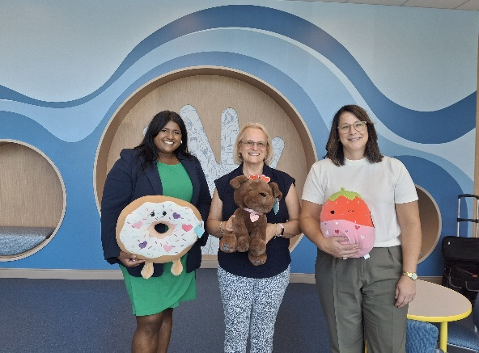  September 24, 2025 – Candy Day Jamboree  Lions Bonnie Kleinmark and Bill Klawitter picked up the Club’s candy and attended the dinner.  