Step 1: Log on to your banking website.
Step 2: Click on Transfer/Zelle.
Step 3: Click ‘SEND’. (Diagram 1)
Step 4: Add Orchard Park Self Storage as a recipient using any of the following:
Name: Orchardparkselfstorage
Email address: opselfstorage@aol.com. (Diagram 2)
Step 5: Enter the payment amount. (Diagram 3)
Step 6: Click ‘continue’. (Diagram 3)
Step 7: Click ‘Send Money’. (Diagram 4)
Step 8: Money has been sent. Thank you for your payment.
Please do not hesitate to call, email or text with any questions.
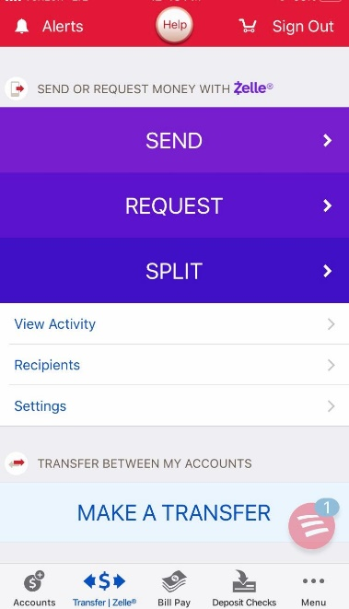
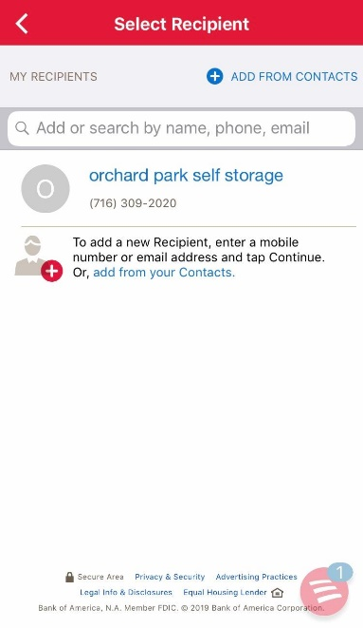
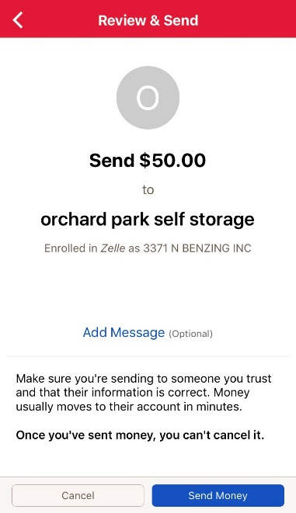
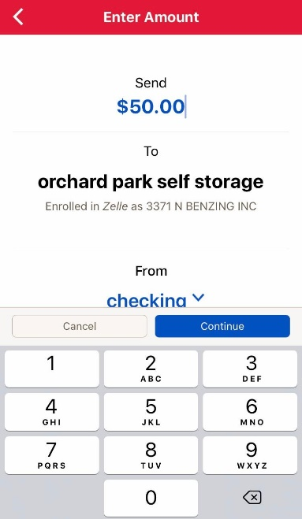
Phone: (716) 309-2020 Email: Opselfstorage@aol.com
Diagram 1 Diagram 2 Diagram 3 Diagram 4
Please note: These example pictures are from the Bank of America APP.
Each bank that offers this service may have different instructions.

