Be a Winner with Wool

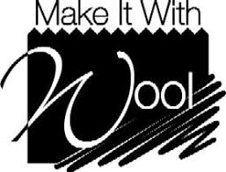
Fashion/Apparel
DESIGN
CONTEST

$1,000 Scholarship to National Winner
A contest for students pursuing a college-level degree in
Fashion or Apparel Design
Entry deadline is November 1, 2023
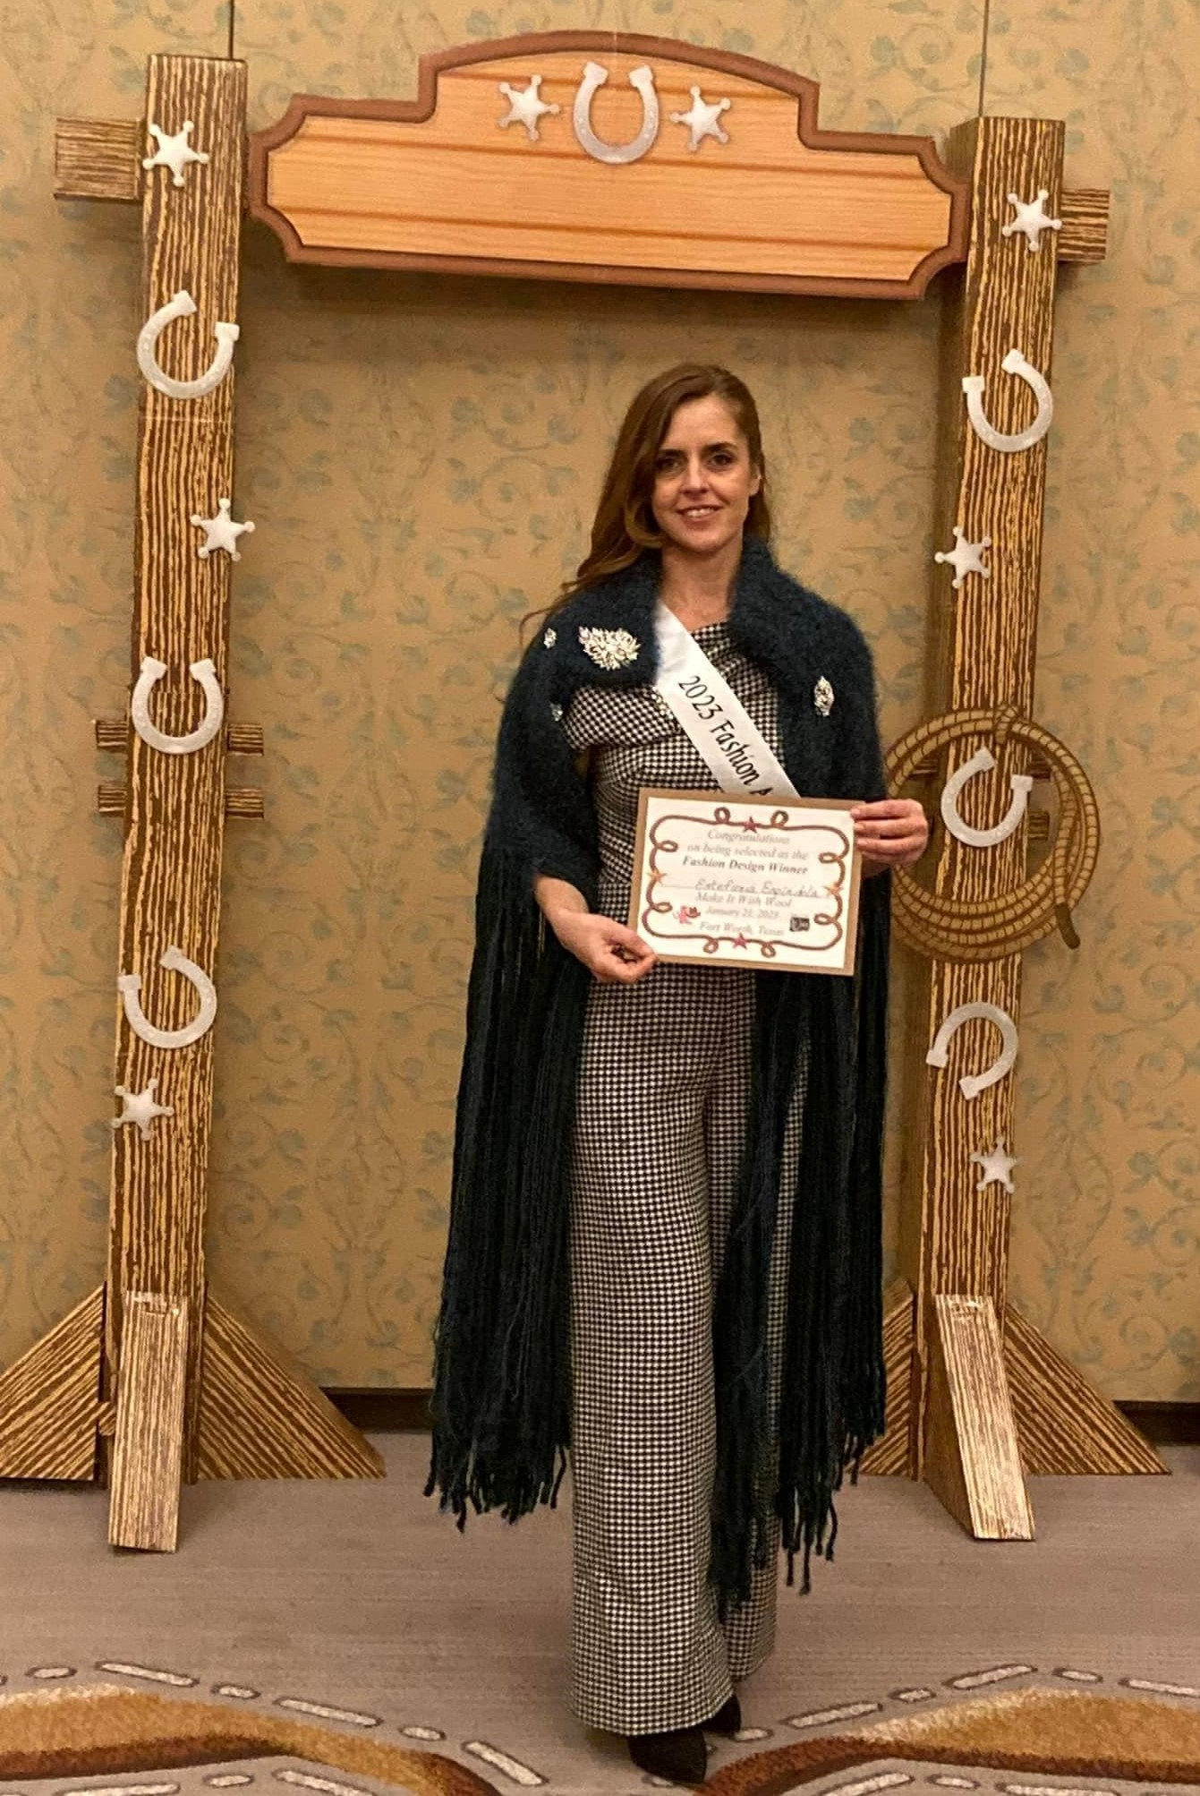

Current National Winner – Estefania Espindola, Houston Community College, Texas

NATIONAL MAKE IT WITH WOOL
KAREN WEIGHT, DIRECTOR
480 South 300 West, Salem, UT 84653
For more Information and Entry Form
Visit the Website: www.makeitwithwool.com • or Email: thew8s@gmail.com

