

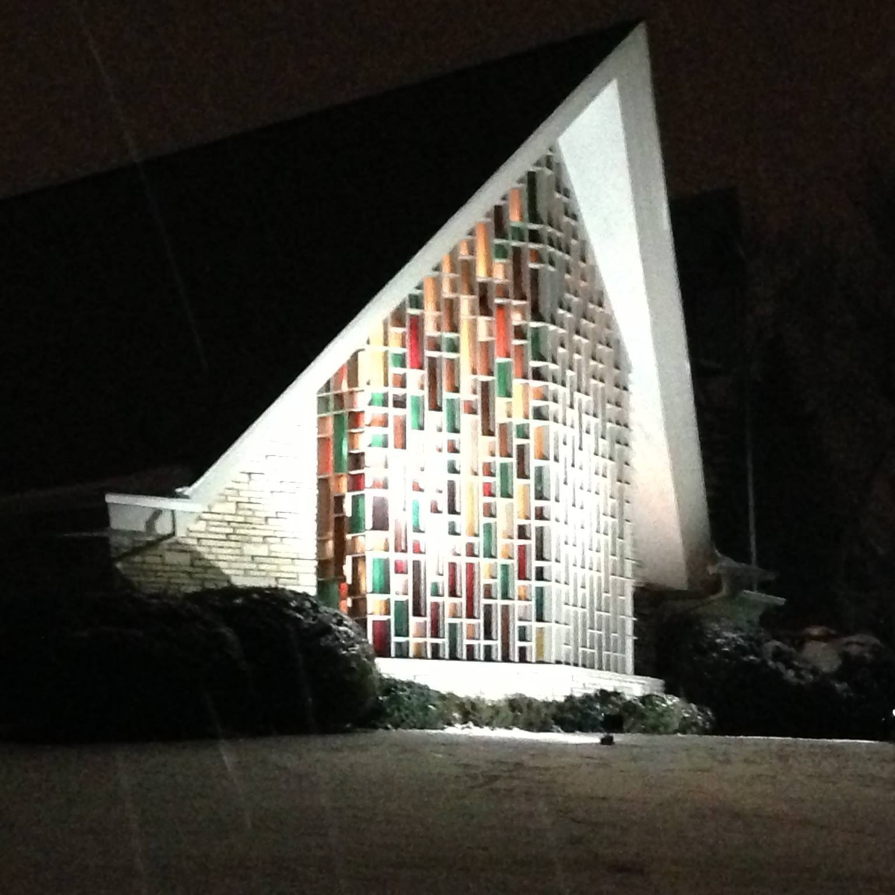

**April 18th, 2021**

**150th Anniversary**

Leaders

**Preservice music** Peg Youngren

**WELCOME** and Introduction of Pastor Patricia Geiseman

150th Anniversary Celebration

**thanksgiving for baptism** – (led by Pr. Geiseman)

**GATHERING SONG** **10,000 Reasons (Bless the Lord, O My Soul)**

**Bless the Lord, O my soul  
O my soul, worship his holy name  
Sing like never before, O my soul  
I'll worship your holy name**

The sun comes up, it's a new day dawning  
It's time to sing your song again  
Whatever may pass and whatever lies before me  
Let me be singing when the evening comes **Chorus**

And on that day when my strength is failing  
The end draws near and my time has come  
Still my soul will sing your praise unending  
Ten thousand years and then forevermore **Chorus x2**

Worship your holy name

Lord, I'll worship your holy name.

**PRAYER OF THE DAY**

**WORD**

**A reading from Acts, Chapter 7**

Now during those days, when the disciples were increasing in number, the Hellenists complained against the Hebrews because their widows were being neglected in the daily distribution of food. 2And the twelve called together the whole community of the disciples and said, “It is not right that we should neglect the word of God in order to wait on tables. 3Therefore, friends, select from among yourselves seven men of good standing, full of the Spirit and of wisdom, whom we may appoint to this task, 4while we, for our part, will devote ourselves to prayer and to serving the word.” 5What they said pleased the whole community, and they chose Stephen, a man full of faith and the Holy Spirit, together with Philip, Prochorus, Nicanor, Timon, Parmenas, and Nicolaus, a proselyte of Antioch. 6They had these men stand before the apostles, who prayed and laid their hands on them. 7The word of God continued to spread; the number of the disciples increased greatly in Jerusalem, and a great many of the priests became obedient to the faith.

8Stephen, full of grace and power, did great wonders and signs among the people. 9Then some of those who belonged to the synagogue of the Freedmen (as it was called), Cyrenians, Alexandrians, and others of those from Cilicia and Asia, stood up and argued with Stephen. 10But they could not withstand the wisdom and the Spirit with which he spoke. 11Then they secretly instigated some men to say, “We have heard him speak blasphemous words against Moses and God.” 12They stirred up the people as well as the elders and the scribes; then they suddenly confronted him, seized him, and brought him before the council. 13They set up false witnesses who said, “This man never stops saying things against this holy place and the law; 14for we have heard him say that this Jesus of Nazareth will destroy this place and will change the customs that Moses handed on to us.” 15And all who sat in the council looked intently at him, and they saw that his face was like the face of an angel.

Chapter 7

2And Stephen replied: “Brothers and fathers, listen to me. The God of glory appeared to our ancestor Abraham when he was in Mesopotamia, before he lived in Haran, 44“Our ancestors had the tent of testimony in the wilderness, as God directed when he spoke to Moses, ordering him to make it according to the pattern he had seen. 45Our ancestors in turn brought it in with Joshua when they dispossessed the nations that God drove out before our ancestors. And it was there until the time of David, 46who found favor with God and asked that he might find a dwelling place for the house of Jacob. 47But it was Solomon who built a house for him. 48Yet the Most High does not dwell in houses made with human hands; as the prophet says, 49‘Heaven is my throne, and the earth is my footstool. What kind of house will you build for me, says the Lord, or what is the place of my rest? 50Did not my hand make all these things?’

51”You stiff-necked people, uncircumcised in heart and ears, you are forever opposing the Holy Spirit, just as your ancestors used to do. 52Which of the prophets did your ancestors not persecute? They killed those who foretold the coming of the Righteous One, and now you have become his betrayers and murderers. 53You are the ones that received the law as ordained by angels, and yet you have not kept it.”

54When they heard these things, they became enraged and ground their teeth at Stephen. 55But filled with the Holy Spirit, he gazed into heaven and saw the glory of God and Jesus standing at the right hand of God. 56“Look,” he said, “I see the heavens opened and the Son of Man standing at the right hand of God!” 57But they covered their ears, and with a loud shout all rushed together against him. 58Then they dragged him out of the city and began to stone him; and the witnesses laid their coats at the feet of a young man named Saul. 59While they were stoning Stephen, he prayed, “Lord Jesus, receive my spirit.” 60Then he knelt down and cried out in a loud voice, “Lord, do not hold this sin against them.” When he had said this, he died.

**Una lectora según Hechos, capitúlo 6, 7**

[*En el tiempo después de la resurrección de Jesucristo*], **8**Esteban, hombre lleno de la gracia y del poder de Dios, hacía grandes prodigios y señales milagrosas entre el pueblo. **9**Con él se pusieron a discutir ciertos individuos de la sinagoga llamada de los Libertos, donde había judíos de Cirene y de Alejandría, de Cilicia y de la provincia de Asia. **10**Como no podían hacer frente a la sabiduría ni al Espíritu con que hablaba Esteban, **11**instigaron a unos hombres a decir: «Hemos oído a Esteban blasfemar contra Moisés y contra Dios».

**12**Agitaron al pueblo, a los ancianos y a los maestros de la ley. Se apoderaron de Esteban y lo llevaron ante el Consejo. **13**Presentaron testigos falsos, que declararon: «Este hombre no deja de hablar contra este lugar santo y contra la ley.

[*Ante el Consejo, Esteben, les explicó toda la escritura hasta Jesus, y al fin les dijo*]

**52**¿A cuál de los profetas no persiguieron sus antepasados? Ellos mataron a los que de antemano anunciaron la venida del Justo, y ahora a este lo han traicionado y asesinado **53**ustedes, que recibieron la ley promulgada por medio de ángeles y no la han obedecido».

**54**Al oír esto, rechinando los dientes montaron en cólera contra él. **55**Pero Esteban, lleno del Espíritu Santo, fijó la mirada en el cielo y vio la gloria de Dios, y a Jesús de pie a la derecha de Dios.

**56**—¡Veo el cielo abierto —exclamó—, y al Hijo del hombre de pie a la derecha de Dios!

**57**Entonces ellos, gritando a voz en cuello, se taparon los oídos y todos a una se abalanzaron sobre él, **58**lo sacaron a empellones fuera de la ciudad y comenzaron a apedrearlo. Los acusadores le encargaron sus mantos a un joven llamado Saulo.

**59**Mientras lo apedreaban, Esteban oraba.

—Señor Jesús —decía—, recibe mi espíritu.

**60**Luego cayó de rodillas y gritó:

—¡Señor, no les tomes en cuenta este pecado!

Cuando hubo dicho esto, murió.

**SERMON** Rev. Patricia Geiseman

**HYMN OF THE DAY**

**SERMON SONG** ***Build Us Up, Lord*  Hymn 670**

Build us up, Lord, build us up  
set in us a strong foundation  
Lead us to do your holy will  
form and shape your new creation  
Build us up, Lord, build us up  
as we guide and teach each other  
help us to share your love with the world  
ev'ry sister, ev'ry brother  
  
**Growing in Christ,**

**we plant seeds for the kingdom  
we follow in faith what's begun  
Lord, set in our hearts**

**the pow'r of your word  
to spread the news of your Son**

Build us up, Lord, build us up  
let our lives reflect your glory  
Cast away all our doubts and fears  
help us tell the world your story  
Build us up, Lord, build us up  
help us bear good fruit for you  
Lord, give us vision and keep us sure  
Grant us faith that's steadfast and true **Refrain**

**PRAYERS OF THE PEOPLE**

Lord, in your mercy,

**hear our prayer.**

**OFFERING SONG *Yours, Lord, Is the Glory/Tuya es la gloria* Hymn 849**

Yours, Lord, is the glory and honor as well

Yours, Lord, now and always amen, amen

Tuya es la gloria, la honor también

Tuya para siempre amén, amén

**OFFERING PRAYER and COMMUNION**

*Those communing from home can have the elements sitting out on a small table for blessing as the Words of Institution are spoken. Pastor Carol will then invite you to receive as we commune together.*

**LORD’S PRAYER**

***The body and blood of Christ given for you.***

**COMMUNION SONG *Lord, Whose Love in Humble Service* Hymn 712**

Lord, whose love in humble service  
bore the weight of human need  
who upon the cross, forsaken  
worked your mercy's perfect deed  
we, your servants, bring the worship  
not of voice alone, but heart  
consecrating to your purpose  
ev'ry gift which you impart

Called by worship to your service  
forth in your dear name we go  
to the child, the youth, the aged  
love in living deeds to show  
hope and health, good will and comfort  
counsel, aid and peace we give  
that your servants, Lord, in freedom  
may your mercy know and live.

**ANNOUNCEMENTS**

**Thank you to Pat Geiseman for preaching and helping to celebrate our 150th anniversary. Thanks Bob Siljestrom for your meaningful reflection.**

**Grupo de Oración con Pr Jose (in Spanish)** Contact Pr. Jose or the Bethlehem office for more information.

**Please remember that due to Covid safety protocols**, we will leave from back row first as directed by the ushers, and proceed outside to greet each other.

**In- person worship with a limit of 50 people at all worship services.**

Register with Cindy**.** Others will be on Zoom or YouTube Live

**PEACE and BLESSING (Pr. Geiseman)**

The Lord bless you and keep you.

The Lord make his face shine on you and be gracious to you

The Lord look upon you with favor and ☩ give you peace. **Amen.**

**CLOSING SONG** ***Praise God, from Whom All Blessings Flow***

Praise God, from whom all blessings flow  
praise him, all creatures here below  
praise him above, ye heav'nly host  
praise Father, Son, and Holy Ghost.

**DISMISSAL** Go in peace, Serve the Lord. **Thanks be to God!**

**Contact Numbers**

Pastor Carol Book: 856-655-4743, Cindy Lange: 847-814-3249, Peg Youngren: 847-337-9805