
CROSSINGS

MAY 2021

Bethlehem Lutheran Church
340 Grand Blvd.
Elgin, IL 60120
Phone: 847-741-8434
Fax: 847-741-8996
__________________________________________________________________________________________

WHAT’S INSIDE

Birthdays 4
Guidelines for Group Gatherings 5
Pastor’s Letter 1
Scout Troop 111 Fundraiser 2
Treasurer’s Report 5
Update Your Information 5
Youth Mission Trip 6
Worship Schedule 2

******

Dear Bethlehem Congregation,
There is something about that sound. Is it the depth, the clarity, the emotions or simply the memories? It is hard to put into words. But when the church bell begins to ring, I see folks take a deep breath and their shoulders begin to relax. It is like sound yoga😊. Ok, I am trying to be relevant throwing “yoga” into the conversation. What I am really looking for is the world resonance. Resonance by one definition is a deep and prolonged sound distinctive for its clarity or meaning.
A few years ago, we considered adding technology including the videotaping our worship as a way of being more “relevant”. We found it nearly impossible to get over learning curve to make that happen. And then the pandemic happened, and online was suddenly a necessity. As one member

said, “Thank you to all of those who helped bring us an online worship. That connection was a spiritual lifeline to me in this pandemic time.” Suddenly online communication was not only relevant but resonate. It filled a deep need to connect both with God and each other.
Could it be that those of my generation have only recently, by necessity, discovered what young people have known for some time, that online community is real community? What role does online church have in our future?
As Lutherans we see change (reformation) as positive. Well, sometimes. Ok, change is hard for everyone, me too. I am encouraged by this pandemic learning about change: maybe finding resonance in our connections with others and God, online or offline, is even more important than relevance. I wonder if resonance, a sense of connection with God, with others and with our created world, could even be the vibration of the Holy Spirit. The church will never be able to change fast enough to keep up with culture. But God will be there regardless of future circumstances. God cares. God resonates with us. God hears your voice in prayer, and it moves God deeply. He has responded in history with an outpouring of love in Jesus Christ, as we say, “for you”. And God is alive in the vibration of the Holy Spirit in and around you. Maybe that’s part of the mystery of depth and clarity of the sound of an old church bell.
May God provide the resonance for our future directions even as we give thanks for the clarity of the faithful witnesses in Bethlehem’s history.
Peace in the Spirit,
Pastor Carol
******
SCOUT TROOP 111 FUNDRAISER

You can support BSA Troop 9111 throughout the year with our Socially Distanced fundraiser. Terri Lynn, in Elgin supports an online store for fundraising. They have all sorts of wonderful nuts and candy assortments. They ship anywhere in the US for a $5.00 flat shipping rate per address. A portion of every purchase from our website https://bsa-troop-11elgin.terrilynn.com will go directly to the troop.
Cate Murschel
******
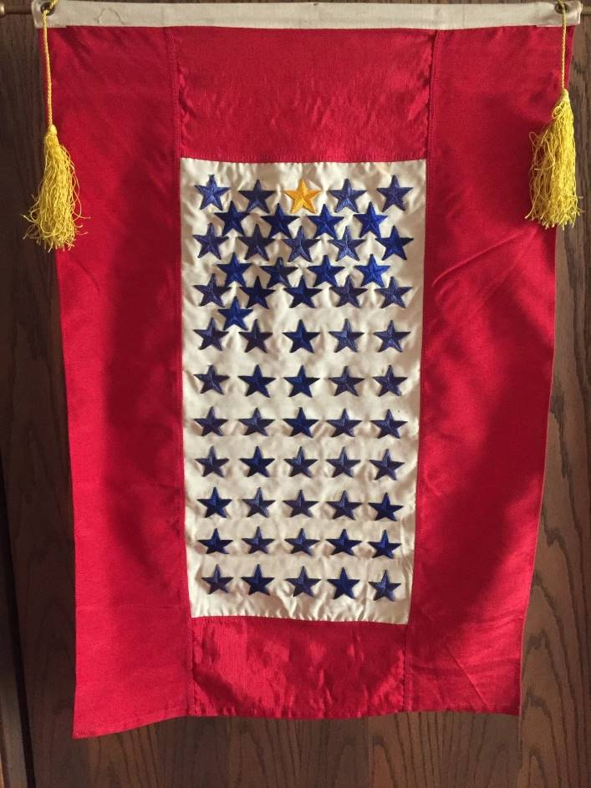
Bethlehem’s Service Flag
In 1918, President Woodrow Wilson approved a new device to replace the wearing of traditional mourning for loved ones who have died in service to our nation, and which could also foster home-front pride for those risking their lives for our freedom. Then known as the Service Flag, we now more descriptively refer to it as the Service Banner. The familiar colors and proportions of the Banner derive from a version copyrighted by Captain R. L. Queisser in 1917. This copyright has since passed to the U.S. Department of Defense, which regulates the authorization to manufacture Service Banners.
The Service Flag may be displayed from homes, places of business, churches, schools, etc., to indicate the number of members of the family (or organization) who are serving in the Armed Forces or who have died from such service. Service Flags have a deep blue star for each living member in the service, and a gold star for each member who has died. When someone was killed in combat, fatally wounded, or died of disease, the gold star was substituted or superimposed upon the blue star to cover it completely. The gold star was meant to convey the honor and glory deserving of the individual who had made the supreme sacrifice for his country.
Organizations, corporations, and churches extended this practice to fly flags incorporating stars for each of their members/employees who were off to war and, of course, would change or overlay the blue stars with gold ones when the news came back that one of their service members had died in action. These larger flags were sometimes flown outside on a pole, but most often were suspended from the ceiling of the factory or meeting hall indoors.
During World War II, Bethlehem had a Service Flag. It was displayed at the front of the sanctuary, hanging from the framework that enclosed the pipes of the church’s organ. The flag can be seen today in the several photographs (currently displayed in the church hallway) taken of confirmation classes during the World War II years There are 58 blue stars and one gold star.
One wonders how many names of those who served are recognized by members of Bethlehem today. They are listed in Bethlehem’s 75th anniversary booklet. Members of Bethlehem who served in World War II are: S/Sgt. David c. Adams; Howard Anderson, F.M. 1/c; Sgt. LeRoy Anderson; Cpl. Vincent Cannan; Axel F. Carlson, C.S.F.; T/Sgt. Erland Carlson; Rudolph S. Colliander, C.C.M.; Donald Wm. Dryer, G.M. 3/c; Harry Eklund, C.M. 1/c; Lt. J.G. Marvin Fricke; Sgt. Russell Funk; T.Sgt. Clifford Goff, Jr.; Cpl. Donald Harrison; Lt. Frances Heinicke; Pvt. Raymond Heinicke; Sgt. Conrad Hoagland; P.F.C. Everett Hoagland; T. 5 Oscar Iverson; Lt. Eber Jernberg; P.F.C. Roy Jernberg; Everett Johnson, Jr., S 2/c C.A.; Sgt. Paul Johnson; Donald Jonson s 2/c; P.F.C. Edward Jonson; Lt. Doris Josephson; S/Sgt. Roland Josephson; Pvt. Edward P. Landwehr; P.F.C. Paul Larson; Lt. Gordon Lindgren; Sgt. Walter D. Lindgren; Donald Lisell, E.T.M. 3/c; 1st Lt. Joseph B. Lusk (killed in action); F.O. Donald Miller; S/Sgt. George Miller; Cpl. Juanita Miller; P.F.C. Donald L. Moberg; Pvt. Oscar Moberg; Cpl. Carl A. Nelson; Martin Norlander, C.M. 1/c; P.F.C. Robert Nyman; Pvt. William G. Nyman; Lt. Wilford E. Oakes; S/Sgt. Merton F. Olson; Charles T. Perry, Q.M. 3/c; Lt. Vernon L. Pilcher; Cpl. William R. Richoz; Lt. Howard Rovelstad; Lt. Harold Samuelson; P.F.C. Donald Sexton; Cpl. Richard T. Solbeck; Cpl. Harold Swanson; Pvt. Richard Tipple; Pvt. John Tolvstad; T/Sgt. Robert Tolvstad; Pvt. C. Baldwin Webb; S/Sgt. Creighton Webb; P.F.C. John Westberg; Pvt. Lawrence Westberg; Flight Engineer LeRoy Williamson (working in the Air Transport Command)
At least 4 current members of Bethlehem have relatives on this list and I, myself, am related to 4 of those listed. (1st Lt. Joe Lusk was my father)

******

BETHLEHEM’S GENERAL
OPERATING FUND

Below is the action report of our giving with dollar amounts for March and YTD.

2021 | March | YTD Actual | YTD Budget
Receipts to Gen. Oper. Fund | $16,571.00 | $ 48,592.60 | $ 46,851.75
Expenses | $17,838.92 | $ 46,368.97 | $ 46,851.75
Total Receipts less Expenses | $ (1,267.92) | $ 2,223.63 | $ 0.00

BLC had higher expenses including all our snow plowing and salting for the season, but the General Operating Fund remains in the black. Thank you for your generous offerings.

Bethlehem’s Renovation and Property Trust Fund

2021 | March | YTD
Contributions to Renovation | $ 550.00 | $ 1,110.00
Contributions to Property Trust | $ 2.00 | $ 4.00

Our Renovation loan balance for our building improvements and sanctuary air conditioners is $63,000. Additional gifts to the memory of John Peacock toward the ACs lowered the debt by $480 plus member gifts to the Renovation Fund brought our principal repayment total to $1,000 for March.

Chery Peacock, Treasurer

******

BETHLEHEM LUTHERAN
CHURCH COUNCIL

Rachel Campbell, President, 847-695-9024
Karin Jones, Vice President 224-558-9504
Margaret Drafall, Secretary 847-695-4721
Heather Thomas 847-977-1371
Ronnie Malave 847-873-9940
Jill Olson 847-741-8918
Tom Ayres 847-697-1248
Chris Hunsicker 847-695-8675

******
Anniversary Celebration Sunday – May 16 at 10 a.m. Pastor Jean Duran will be the guest preacher. She has served as pulpit supply many times in the past six year monthly “Anniversary Video Moment”, Clarence Wittenstrom will share his thoughts and recollections.
******
Pentecost Sunday, May 23 – video with Billie Jo Waugh sharing the information about the Centennial Banner displayed in the front of church.
******


01 Barkley Mapes
02 Linda Fagan
05 Cheryl Peacock
06 Aracely Ojeda
07 Christina Alfaro
09 James Bason
Kalin Taskov
10 Nayely Chimal
Megan Olson
Jennifer Shroder
14 Heather Thomas
Carol Book
16 Deb Sensor
17 Leslie Gomez
18 Kathryn Miller
Ali Rodriguez
19 Kathryne Depaz
20 Alan Lentz
Haley Banks III
21 Dave Topping
22 Ronnie Malave
29 Jeff Lange

******

Organ & Meditation
Tuesday, May 11 at 7 p.m. – join us for Meditation and organ music. In-person registration is required. On Zoom or YouTubeLive. Use Tuesday Zoom link
Prayer Requests
Please pray for:
Our BLC members: Tom Ayres, James Bacon, Beverly Butcher, Char Carey, Ed Chiarugi, Karen Dingel, Jackie Gordon, Fred Harnish, Kathra Naviaux, Ashley Ottaviano, Gary Ottaviano, Wilma Peterson, Shirley Pflederer, Dave Quick, Larry & Juanita Rohrssen, Don Samuelson, Mike Warren, Sharon Williamson.
Homebound BLC members: Sigrid Barker, Kathy Lehman, Alan Lentz, Ellen Nelson, Vivian Peck, Mary Schalow

Please pray for friends and relatives:
Paige Allen, Armando, Rudy Bicic, Kathy Blair, Janet Brodde, Cuca Cartagena, Phyllis Chambers, Anna Marie & Anthony Chiarugi, Linda Conn, Jessica Crampton, Ginny & Harry
Datisman, Lynn Drafall, Kathi Fafendyk, Kristen Forman, Al Grantham, Rheine Grischow, Charlie Harnish, Jan Hornbostel, Jayme Hext, Vicki Kopecky, John Korp, Jacob Lindsedt, Janet Mayes, Charlotte Lee Miller, Belinda Mockler, Richard Osar, Debbie P, Tom Peterson, Josh R, Irma Raddatz, Carla Rawson, Les Ross, Debbie Sanders, Diane Scholinski, Noah Spilotro, Jack & Julie Stewart, Marilyn Twait, Nancy Voross, Jacob Waugh, Bruno Zaucha & family
Please pray for our men and women in the Armed Services:
Jason Patterson (nephew of Shirley Harnish)

Worship /Study Schedule
Sunday Service: 10 a.m. on Zoom
Call 1-312-626-6799
Meeting ID: 947 2112 9583 Password: 058733
Monday Meetings
Call 1-312-626-6799
Meeting ID: 817 3102 4901 Passcode: 069537
Tuesday Bible Study 10 am or meetings
Call 1-312-626-6799
Meeting: 852 4417 3785 Password: 387195
Wednesday Activities
Call 1-312-626-6799
Meeting ID 894 7503 5205 Password: 088632
Thursday Activities
Call 1-312-626-6799
Meeting ID 952 1009 4147 Password: 935958
******

VACCINATION APPOINTMENTS
The site is the Eastside Recreation Center
1080 E. Chicago St. in Elgin
Open 6 days a week: 9 a.m. – 6 p.m. by appointment only
Online: www.kanevax.org OR call the vaccine appointment call center open 7 days a week at 833-621-1284.
Open to anyone 16 years or older.
If you need help or need a ride, call the church office 847-741-8434.
Volunteer at the Eastside Vaccination Site
Volunteers (18+) to assist on Tuesdays-Sundays from 8:30 a.m. to 6:30 p.m.
Volunteer duties include greeting, checking-in and registering, observing individuals in the post-vaccination area and other logistic support. Please visit www.cityofelgin.org/vaxvolunteer.


******
Update Your Information
If you have dropped your landline, changed phone number or email address, please let the office know of any changes. It is important for church to have the new information.
Call 847-741-8434 or email churchoffice@blcelgin.org

GUIDELINES FOR GROUP GATHERINGS
AT BETHLEHEM
Groups, max 50 people, can gather at Bethlehem provided these guidelines are followed.
- Masked
- Distanced – 6 ft
- Ventilation – Windows opened, no fans
- No Food or Drink served at this time, unless folks carry in water bottles
Schedule meetings with the Church Secretary at 847-741-8434.
Due to the above, the following spaces have recommended capacities:
Red Room - Capacity 10 people due to required 6 ft distancing
Wittenstrom Hall - (if group is more than 10) - max 50. Tables and/or chairs can be set up and then need to be taken down when finished.

Youth Loft for Youth Group and others - need permission to use.

******
COMMUNION CUPS FOR ZOOM
If you are running low, please contact Cindy in the office for more.
******

YOUTH MISSION TRIP OFFERS THANKS
It is a month away and the mission team will be heading to Duluth, Minnesota. Youthworks has worked through the details in keeping everyone safe. They have details in place to ensure the safety of youth, leaders as they interact with work sites.
Thank you for your donations and prayers. Continue those prayers for safe travel to Duluth, for the work we will be doing there, for the new relationship that form during the week, for the community of Duluth, and for safe travel back to Elgin.

Thank You:
Darlene Albert, Karen Allen, Donna & Dale Anderson, Larry & Lori Anderson, Meggi & Gary Anderson family, Tom Ayres, Cheryl & James Bacon, Nancy Calderwood, Rachel Campbell, Bruce & Char Carey, Carl & Lin Cruse, Margaret Drafall, Jerry & Judy Drommerhausen, Jennifer Eberdt, Linda Fagan, Andrea Fiorito, Gail Erickson Gilliland, Mark Goers, Robert & Peggy Graham, Fred & Shirley Harnish, Edward Hernandez, Kayla Hernandez, Libby Hoeft, Marilyn House, David & Martha Jernberg, Julie Jindra, Jan & Bill Jones, Jerry Kile, Larry & Nancy Klemm, Carla & Jenny Kroll, Kim Lange & Burt Lynn, Paul Larson, Christopher Lempa, Len & Gina Lempa, Scott Lee MacDuff, James Massa, Barkley Mapes, Ralph & Phyllis Mapes, Stephanie Mathus, Sue McIntyre, in memory of Lorraine Mink, Mike & Cate Murschel, Bob & Diana O’Connor, Erik Olson, Greg & Jill Olson, Kathy Olson, Gary, Karen, Ashley Ottaviano, Chery Peacock, Wilma Peterson, Shirley Pflederer, Joyce Ross, Bernette Ryza, Brian Samuelson, Don & Ruth Samuelson, William Sensor, Jen Shroder, Alex & Judy Sorton, Brian Sullivan, Janine Tanner, Kalin & Bonnie Taskov, Diane Verde & Barry Wolf, Eugene Wilkening, Steve & Peg Youngren.
Family & Friends:
Chuck & Debbie Anderson, John & Sidne Bakker, Steve & Kathy Black, Tracy Chabrier-Huizenga, Tony & Ann Chiarugi, Keith, Ivonne & Camila Chiarugi, Chris & Holly Davis, Joe & Armida Dominguez, Travis, Luci, Cam & Molly Dvorak, Andrea & Jeanne Dunton, Vanessa Dybala, Gary Eatinger, Peter & Patricia Gebaur, Gary Gronberg, Louis Hall, Ted & Georgianna Heise, Cathy Hopkins, Raquel Johnson, Kevin & Mary Jones, Dick & Barb Jones, Keith & Sue Jones, Diane Kerruish, Diana King, John & Shirley Korp, Ron & Bonnie Lock, Donna Mansfield, Greg & Terri Marquez, Juan & Michele Marquez, Jerri McCue, Jim McPheeters, Leigh Miller, Nick & Barb Poulos, Jon & Leighan Pomykala, Grace Richard, William Richoz, Bob & Denise Sell, Phil Seyller, Randy Shedd, Florence Sisler, Roby Thomas, Norm & Kaye Thompson, Mary Ellen Thorsen.
You have our heartfelt thanks for supporting this year’s trip.
The 2021 Youth Mission Team

******

PENTECOST BANNER
The Pentecost Banner is a festival banner. Pentecost is derived from the Greek word for fifty and is celebrated seven weeks after Easter Sunday. The banner is red to signify the fire of the Holy Spirit. The dove is the Holy Spirit sent to us by God to be our comforter and counselor. The Baptismal font is symbolic of the means of grace by which we come to God. The seven tongues of flame are the seven gifts of the Holy Spirit: power, wealth, wisdom, might, honor, glory, and blessing.
HABITAT FOR HUMANITY –
NEW HOPE PARTNERSHIP
Excitement is brewing. We have a new build project starting in May. The new project is located at 57-59 Elm Street in Carpentersville. It is a duplex. Another partnership, Joyful Hands, will join us in this “Faith Build”. Volunteers are needed to accomplish this. Guidelines are currently 10 volunteers at the site.
Visit https://habitatnfv.galaxydigital.com to register as a volunteer. For more information, contact your church representative.
