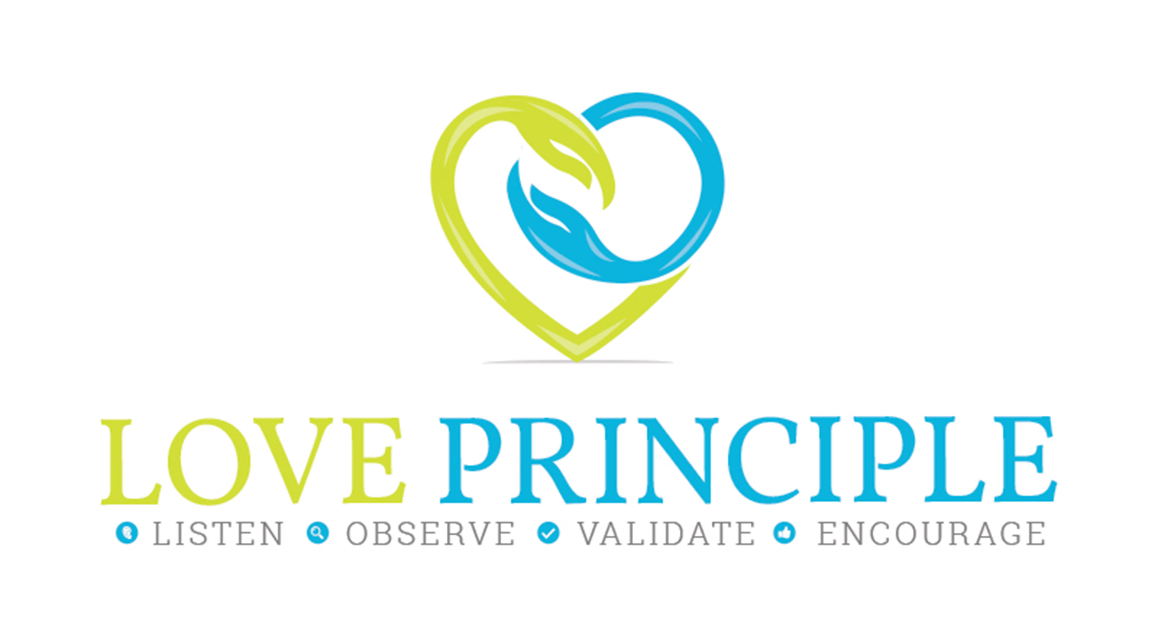

Contents
Welcome 1
Ugh, Parenting 3
Raw Teenagers 3
Secret doors 3
Your Teenager 5
The Importance of Connection 6
Ways to Connect 7
L. is Listen 7
O is Observe 7
V. is for Validate 7
E. is for Encourage 8
Putting the Principles into Practice 8

In an effort to reduce and prevention violence in the home, the Love principle strengthens communication between teens and parents.

Ugh, Parenting

Parenting is a complex and sometimes bewildering journey. Every time you think you have it figured out, someone shuffles your deck of cards. The joys of parenting make most of the journey worth it, but during the teenage years the journey proves more difficult and the joyful moments take a drastic decline.
Perhaps you feel the way I did, that while my son was off exploring new adventures, I suddenly felt like I was on the outside of his world. These principles are designed to restore your relationship so you remain the most important influence in your teenager’s life.

Raw Teenagers

“Teenagers” the word was added to the English language only 55 years ago, and with it came a widely accepted notion that independence, privacy, moodiness and disrespect were normal. I disagree with this notion. This booklet can show you how to transform that misconception and keep an active and prominent role in your teenager’s life.
Studies are showing that teenagers still listen to their parents. Parental involvement has everything to do with school performance, delayed sexual activity, drug use, alcohol consumption, teen pregnancy, and suicide prevention.

Secret doors

Have you ever lived in a castle? There’s a fort in St. Augustine Florida that has prison cells you can tour from. While taking the self-guided tour I looked at these cells not as a prisoner but as a warden.
If your teen is anything like my son, the word warden brings a smile. Unbeknownst to me, my son began building walls. When he didn’t get his way, or was offended, hurt or misunderstood, his behavior changed and the “warden” appeared. My son would take each situation that didn’t meet with his satisfaction, and simply lock me up.
Like the fort in Saint Augustine, he made many cells for me, and he had each situation or occurrence still floating through his mind. He did not have the ability that adults have to stop and think and analyze why his parent would be reacting the way I had been to his choices, conversations and decisions.
After a while your child builds a wall around this prison. They keep your offenses in the front of their mind as if to trap you, using past experiences to not trust, listen, or obey any new circumstance. Slowly the wall builds, and it invades all areas of your home life, dinner, TV, hygiene, car rides and anything you once enjoyed.
The truth is, even when your teen erects a prison and builds a fortified wall around their life, they still have doors that open in and out. Believe it or not, your teen actually wants you to find this door or if you must, scale the barricade. Are you ready to try something new?

Your Teenager

The best way to introduce you to the L.O.V.E. principle, which are so easy, I promise you, is to have you do some self-awareness homework. If there is one thing I learned about parenting it is this, you can know what to do but doing it is much harder than just reading about it. So in your own words, use five different adjectives and describe your teenager:

Now describe your current relationship between you and your teen in 5 words: and be honest as if you were talking to your closest friend.

What 3 words would your teen use to describe their relationship with you? Take a guess. (I will give you a glimpse into my world before I developed the principles. In 2014 my son would say: Overbearing, Unfair, Manipulative. When asked about other family members he would describe his sibling as: Manipulative, Favored and Selfish. Now write down the 3 words he/she would use to describe their relationship with you:

How about with other family members?
Take a deep breath. You just identified reality. (Hopefully you did by being honest) You can’t change what you aren’t willing to accept. I believe you want to see positive change in your home life and relationship with your teen. That is why we are identifying the problem areas. If you were your teen, and you felt those 3 words about your parent, how would behave at home?
Can you imagine answering these questions again in month and seeing different results, ones that you are proud of? I hope you answered yes.

The Importance of Connection

Human beings were born with an innate need for connection. It’s why babies are comforted when held, caressed or hear their parent’s voice. As a child’s basic needs are met, the brain continues to develop. When those needs are denied, the brain stops growing and leaves off in place without empathy and is unable to attach and form proper relationships.
What does this have to do with your teen?

Ways to Connect

The Love Principles are a new method used to strengthen parent teen connection. Though the principles were originally developed to reduce teen dating violence they quickly grew into a parenting communication tool. The principles are simple action oriented words based on the acronym for love.
L. is Listen. Listening is the hardest thing to do. Sharing our opinion and wanting to help, or fix a problem is motive behind a majority of our listening skills. But to truly listen to someone you have to give your full attention and be present. Listening to a teenager requires taking an interest, giving eye contact, sharing excitement or disappointment.
Listening is not answering, it is not cheerleading, it is not agreeing or disagreeing. Listening is all about sharing.
O is Observe. Observation skills are imperative and if you are like most parents, the time and attention you gave your teen in their toddler years, far outweighs the time you spend with them today. One way to stay connected is through observation. The Love Principles teaches observation as a powerful tool and can be used to spot red flags in behavior changes and motives of individuals. But at home, what you observe your teen doing is the truest test to their behaviors and beliefs.
Teenagers shut down from time to time, but their behavior speaks loud and clear. There’s so much happening if you just use your eyes and ears. Their choice of clothes, behavior patterns, TV schedule, Netflix routine, their texts, social media use, grades, dress, word choice, hygiene, mood, music, ear buds, daily eating habits, exercise and sleep all tell a story.

V. is for Validate. Teens have trusted friends based on one thing, validation. Whether or not your teens is ranting about how they hate their teacher or even you. Validation is a strong component to suicide prevention and rectifying angry teens.
Have you ever been in an argument? Has your teen said you are being unreasonable or that you don’t understand? What are the common back talking devices your teen uses? Do you they back talk or are they afraid of you? Is fear your only source of parenting?
Think back to an argument you had with their other parent, or with your boss. Did you win? Did the other person hear your point of view or did the misunderstand you?
Being understood is a vital role in making a connection to your teen. Relationships thrive on validation and chances are your teen is starving for validation. If you think about it through their eyes, how often do you validate their feelings? I didn’t ask whether you agreed with them or not. Chances are you won’t. But if you want to reason with your teen about anything, from studying to alcohol, you will need common ground and validation provides that opportunity. The more you validate the more they will listen.
E. is for Encourage. There is a vertical painting in my office that reads, “Where there is Life, there is Hope.” Clients comment on the piece daily, which shows me that encouragement often comes in a manner of replacing negative thoughts and feelings with hope.
Encouragement is a powerful tool. If you’ve ever had your hopes dashed, heart broken or suffered a devastating loss you know that an encouraging word is hard to find. Seldom heard are the words of wisdom when the heart is broken. Used during everyday life, encouragement strengthens our connection to others and proves our ability to depend on someone for support. While encouragement often masks itself as flattery or a pat on shoulder, people know when they are being brushed off. Flattery cannot compare to genuine encouragement. When one person engages another through encouragement there is a transfer that occurs. The person giving the encouragement uses words and body language to show sincerity and extracts the negative response out and replaces it with a positive statement.
Encouragement does not define a goal, it merely removes the doubt when one is advancing toward change. That is what encouragement does.

Putting the Principles into Practice
Now that you know what the Love Principle is, are you ready to apply it? (I hope you said yes)
The first step you need to take is to choose one area to apply the principle. You can do this by identifying the areas where you want to see an increase in communication and respect from your teen. You can start big or small but the best way to demonstrate the Love Principles is to start with one area of your relationships.
Application takes time, there is a learning curve. If you commit to responding differently in one area, you will build up to conquer more areas until the process is natural.
Whenever your teen is combative in an area such as housework, homework, church attendance, job applications, sports practice, or everyday dinner conversation use the principles. I would suggest staying away from the topics that are bringing you the most stress, which could be their dating life, partying habits or temperament.

You can provide the Love Principles to your child even if they have shut you out! Taking a genuine interest in them, in a non-direct way can start a short conversation. Be smart, share a funny video, or surprise them with a treat. Taking a short car ride to get a coffee while having light conversation, which means not asking questions about their performance or personal life, can begin to build trust.

For more ideas, we encourage you to get the book or sign up for our weekly thread on how to implement the principles and read about other parents and their success stories.
Thanks for reading. I truly hope you and your teen reconnect in an authentic way.

About the Author

Jessica Gaffney has been working with families since 2008. A graduate of Southern Connecticut State University and Our lady of the Lake University, Jessica has both a Master’s degree and bachelors in Social Work. She is the co-founder of the Restart Foundation established in 2015 with her husband John as a source of hope, education and resources to individuals impacted by trauma. She has spent four years advocating on behalf of domestic violence victims and speaks openly about her past history. She is also the author of six books, What Love is all About (for kids) a teen trilogy dealing with addiction and trauma, and Every Last Breath, an adaptation on surviving PTSD.
Jessica is the creator of the LOVE Principle, and opened the LOVE Institute to reach, impact and provide therapeutic tools to families. She is available on a limited basis for speaking and coaching for out of state clients, and works in South Florida with women, teens and clients with PTSD. Jessica’s passion is to restore America’s families and reduce the risks of violence.

JessicaGaffney.com
LovePrinciple.org

