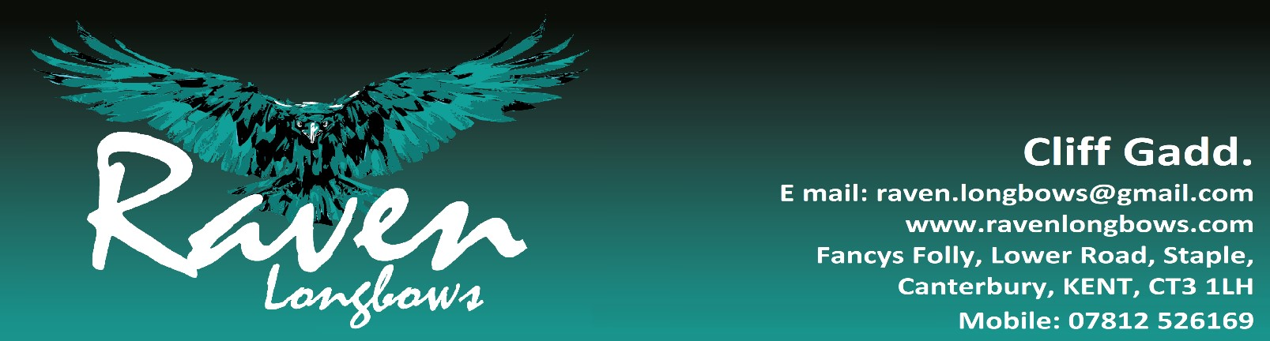

**Basic club arrows. £115.00** per dozen.

Spine matched to plus or minus 4 lb of your selected spine and weight matched to within a 10 grain range.

**Matched arrows. £145.00** per dozen.

Spine matched to plus or minus 3 lb of your selected spine and weight matched to within a 5 grain range.

**Footed Arrows £290.00** (5/16” diameter only) per dozen.

Spine matched to plus or minus 3 lb of your selected spine and weight matched to within a 5 grain range.

Arrows are footed with either an Ipe, Greenheart or Black Walnut Footing. Footed arrows have a minimum delivery time of 6 weeks.

**Extra’s available for Matched and Footed Arrow Sets. (All prices shown are for a dozen arrows.)**

|  |  |  |  |
| --- | --- | --- | --- |
| **Rear Taper (bobtailed)** | **+** | **£16.00** | **Matched and Foot Arrow Sets.** |
| **Barrelled** | **+** | **£35.00** | **Foot Arrow Sets Only** |
| **Cresting** | **+** | **£33.00** | **Matched and Foot Arrow Sets.** |
| **Purple heart Footing** | **+** | **£35.00** | **Footed sets only.** |
| **3” fletching (shield or parabolic)** | **+** | **£5.75** | **All sets.** |
| **4” fletching (shield or parabolic)** | **+** | **£9.00** | **All sets.** |
| **5” fletching (shield or parabolic)** | **+** | **£15.00** | **All sets.** |
| **Custom Logo. (Raven as standard)** | **+** | **£5.00** | **All sets.** |
| **Numbers and Initials** | **+** | **Included as standard.** | **All sets.** |
| **For Gateway Tre, Barred or Han-Bunn Kuro style fletchings please enquire as these are not stocked and special order only.** | | | |

**All prices shown are per dozen arrows.**

* Prices shown are for arrows with a parallel shaft and fletched with 2 1/4” shield fletching in your choice of colours**. Please add extras as required from the above list.**
* Shafts, available in either, 5/16” or 11/32” diameter, in your choice of Spruce (std) or Pine.
* AAE Plasti-nocks used as standard in 1/4”, 9/32”, 5/16” or 11/32” sizes. All standard colours and sizes if available.
* Bohning Classic Or Bearpaw nocks can be supplied if required. 5/16” and 11/32” only (Limited colours)
* TopHat target piles used as standard 9/32”, 5/16” and 11/32” sizes available.
* All arrows are finished with the Raven Longbows Crest with numbers and your initials and 3 coats of Manns Extra Tough Gloss Polyurethane varnish.
* Postage, packing and insurance, **From** **£12.00 per dozen**.

**Arrow Racks (Arrows not included)**

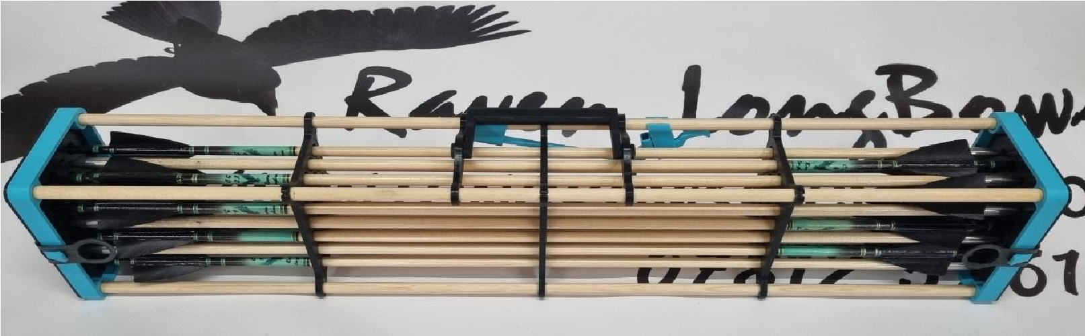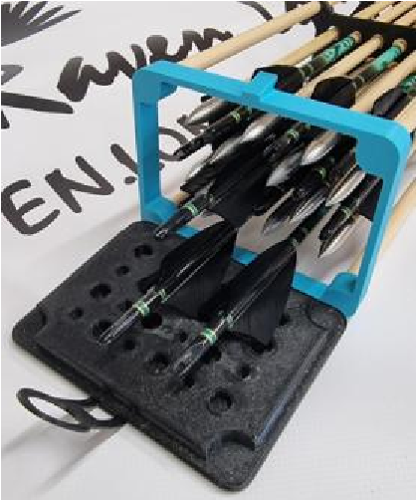

|  |  |  |
| --- | --- | --- |
| The Raven Longbows arrow rack is designed to hold either 12 or 24 arrows, with a lid at either end and dividers along the length to help keep you arrows safe and straight. 5/16” and 11/32” versions available. | | |
| 12 Arrow Rack (Not shown) | £35.00 | Various colours (please specify) |
| 24 arrow Rack (Shown above) | £45.00 | Various colours (please specify) |
| If ordered with arrow sets, please racks will be supplied fully assembled. P&P £4.50 | | |

**Arrow Straightener.**

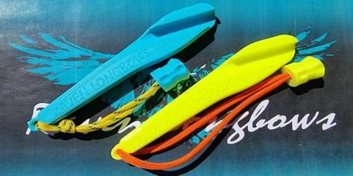

|  |  |  |
| --- | --- | --- |
| Straighten your arrows on the go, keep it in your quiver and straighten as you walk back from the boss. | | |
| Right Handed Straightener. | £8.00 inc p&p | Various colours (please specify) |
| Left Handed Straightener. | £8.00 inc p&p | Various colours (please specify) |

**Foot Markers and Field Whistle.**

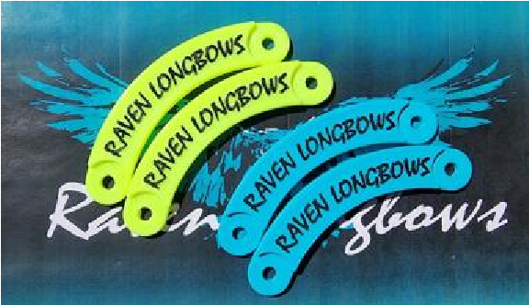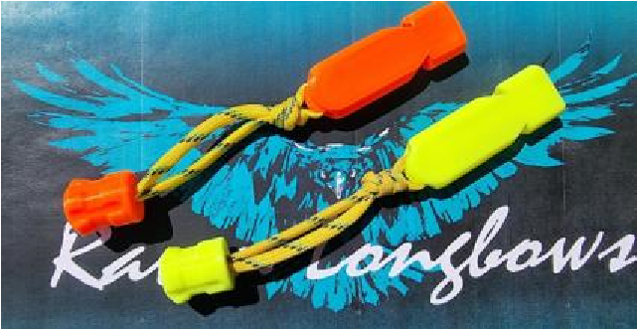

|  |  |  |
| --- | --- | --- |
| Shooting Line Foot Markers | £6.75 inc p&p | Various colours (please specify) |
| As above with custom name. | £9.00 inc p&p | Various colours (please specify |
| Field Archery Whistle | £5.75 inc p&p | Various colours (please specify) |

Please feel free to contact me to discuss your requirements either by, email: raven.longbows@gmail.com Or, via the contact link on my website. www.ravenlongbows.com

If contacting by mobile phone, please text your contact details and a note about your requirements prior to phoning so I can add you to my contact list.

Happy Shooting: Cliff.

**Raven Longbows Arrows Specification Sheet.**

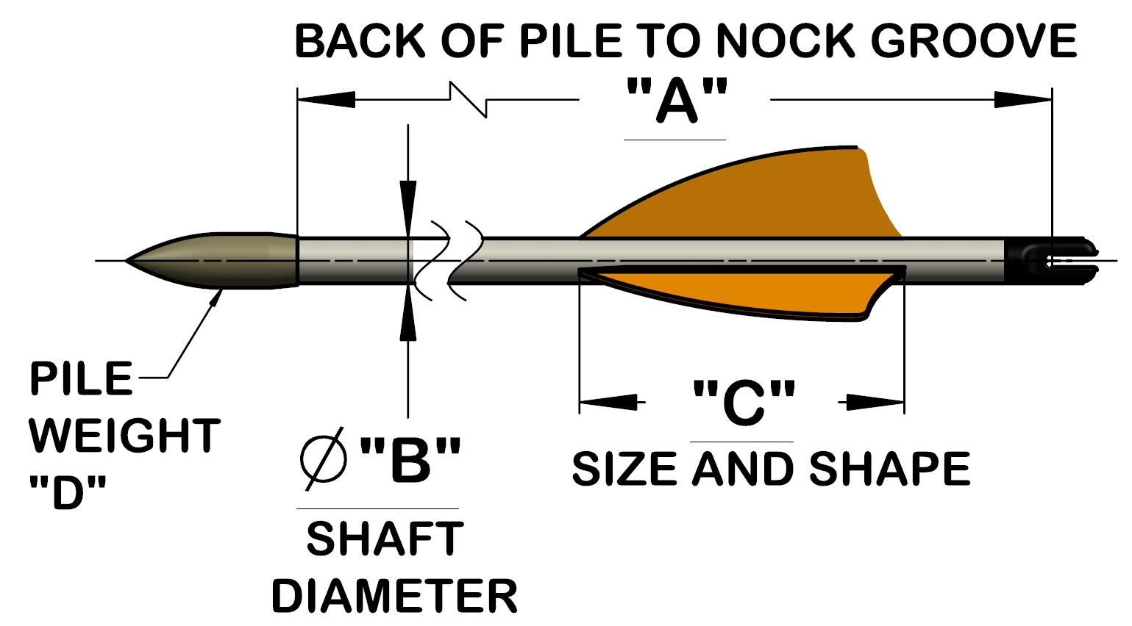

|  |  |  |  |  |  |  |  |  |  |  |  |  |  |  |  |  |  |  |  |  |  |  |  |  |  |  |  |
| --- | --- | --- | --- | --- | --- | --- | --- | --- | --- | --- | --- | --- | --- | --- | --- | --- | --- | --- | --- | --- | --- | --- | --- | --- | --- | --- | --- |
| **Name:** |  | | | | | | | | | | | | | | | | | | | | | | | | | | |
| **Bow Style** |  | | | | | | | | | | **Left Handed** | |  | | | | | | **Right Handed** | | | | | |  | | |
| **Address:** |  | | | | | | | | | | | | | | | | | | | | | | | | | | |
| **Phone Number:** |  | | | | | | | | | | | | | | | | | | | | | | | | | | |
| **Email:** |  | | | | | | | | | | | | | | | | | | | | | | | | | | |
|  |  | | | | | | | | | | | | | | | | | | | | | | | | | | |
| **Dim “A”** |  | | | | | | | | | | | | | | | | | | | | | | | | | | |
| **Style** | **Parallel** | | | | | | | | | **Tapered** | | | | | | | | | | | **Footed** | | | | | | |
| **Dim “B”** | **5/16”** | | | | | | | | | | | | | | | **11/32”** | | | | | | | | | | | |
| **Shaft Spine** | **25/30lb** | | | | | **30/35lb** | | | **35/40lb** | | | | | **45/50lb** | | | | | | **Specify:** | | | | | | | **lb** |
| **Dim “C” Fletching size** | **2”** | | | **2 ¼”** | | | | | **2 ½”** | | | **3”** | | | **4”** | | | **5”** | | | | **Specify** | | | |  | |
| **Fletching shape** | **Shield** | | **Parabolic** | | | | | **Rayzr Style** | | | | **Custom Please Specify:** | | | | | | | | | | | |  | | | |
| **Fletching Colour** | **Cock** |  | | | | | | | | | **Hen 1** |  | | | | | | | **Hen 2** | | | | |  | | | |
| **Nock Colour** | **RED** | | | | **BLUE** | | | | | | **WHITE** | | **BLACK** | | | | | | **YELLOW/**  **GREEN** | | | | | | **ORANGE** | | |
| **Cresting colours** | **No** | | | | | | | | | | | | | | | | | | | | | | | | | | |
| **Pile weight “D”** | **9/32” Dia** | | | | | | **50 grain** | | | | | | | | | | **70 grain** | | | | | | | | | | |
| **5/16” Dia** | | | | | | **70 grain** | | | | | **100 grain** | | | | | | | | | | | **125 grain** | | | | |
| **11/32” Dia** | | | | | | **80 grain** | | | | | **100 grain** | | | | | | | | | | | **125 grain** | | | | |
| **Pile Type** | **Target** | | | | | | | | | | | **Field** | | | | | | | | | | | | | | | |
| **Number Required** | **12** | | | | | | **24** | | | | | **36** | | | | | | | | | | | **48** | | | | |
| **Arrow Rack** | **12 Arrow** | | | | | | | | | | | **24 Arrow** | | | | | | | | | | | | | | | |
| **Additional info** | | | | | | | | | | | | | | | | | | | | | | | | | | | |