Raven Longbows Arrows Specification Sheet.
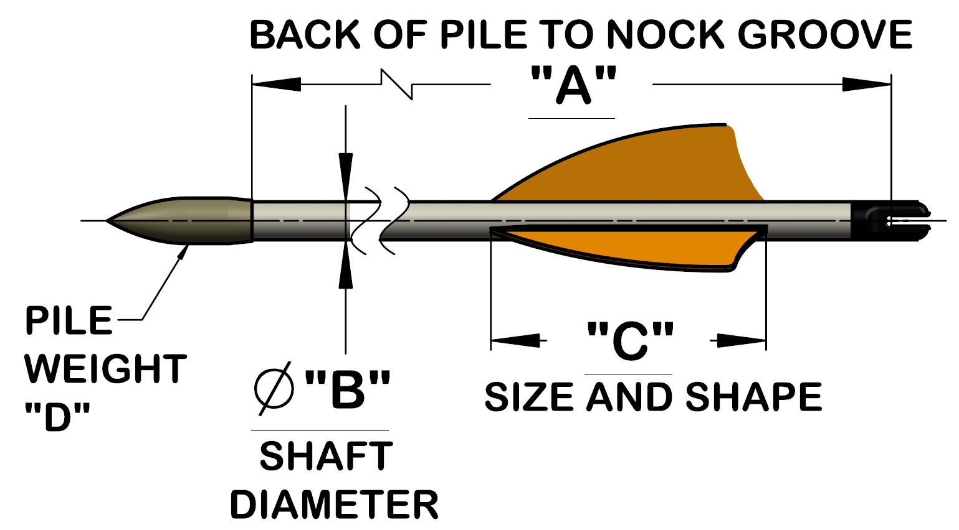
Name:
Address:
Phone Number:
Email:
Dim “A”
Style | Parallel |  |  |  |  |  |  |  |  | Tapered |  |  |  |  |  |  |  |  |  | Footed
Dim “B” | 5/16” |  |  |  |  |  |  |  |  |  |  |  |  | 11/32”
Shaft Spine | 25/30lb |  |  | 30/35lb |  |  |  |  | 35/40lb |  |  |  | 45/50lb |  |  |  |  | Specify: |  |  |  | lb
Dim “C” | Fletching size
Fletching shape | Shield |  | Parabolic |  |  |  | Rayzr |  |  |  | Batwing |  |  |  | Specify:
Fletching Colour | Cock |  |  |  |  |  |  | Hen 1 |  |  |  |  |  |  |  |  | Hen 2
Nock Colour
Cresting | Yes |  |  |  |  |  |  |  |  |  |  | No
Pile weight “D” | 9/32” |  |  |  |  | 50 grain |  |  |  |  |  |  |  |  |  | 70 grain
 | 5/16” |  |  |  |  | 70 grain |  |  |  |  |  | 100 grain |  |  |  |  |  |  | 125 grain
 | 11/32” |  |  |  |  | 80 grain |  |  |  |  |  | 100 grain |  |  |  |  |  |  | 125 grain
Pile Type | Target |  |  |  |  |  |  |  |  |  |  | Field
Number Required | 12 |  |  |  |  | 24 |  |  |  |  |  | 36 |  |  |  |  |  |  | 48
Rack/Racks | 12 Arrow |  |  |  |  |  |  |  |  |  |  | 24 Arrow

