SAILING INSTRUCTIONS
2020 Dillon Yacht Club Summer Series
Lake Dillon, Colorado

1.RULES
1.1 This series will be governed by the rules as defined in The Racing Rules of Sailing 2017-2020 (RRS).
1.2 Add to RRS 41(e): help to recover from the water and return on board a crew member, providing that the return on board is at the approximate location of the recovery.
1.3 The DYC COVID 19 guidelines and the most current State and local guidelines [DP]
1.4 The notation ‘[DP]’ in a rule in the sailing instructions means that a penalty for a breach of that rule may, at the discretion of the protest committee, be less than disqualification.
1.5 It is the intention of the Dillon Yacht Club to be a leader in COVID 19 safety and always remain in compliance with Dillon Marina and all local, state, and federal guidelines. The club will conduct races on Lake Dillon following the most current guidelines and reserves the right to modify, change, or suspend any of these guidelines or scheduled racing activities.
The DYC is in no way promoting social gatherings. It is the personal decision of each individual to participate in the races. These guidelines are also adapted as a part of the Sailing Instructions.
2. NOTICES TO COMPETITORS
2.1 Advance Notices to Competitors will be sent via email and posted on the DYC webpage. Changes that are made and take effect for the day of racing shall be announced at 11:30 on VHF radio Channel 69 as well as posted on the Official Notice Board (ONB) located on the south-east side of the DYC clubhouse.
2.2 Any changes to these Sailing Instructions (SI) will be posted before 11am on the day it will take effect.
2.3 Any change in racing schedule will be posted by 7pm on the day before it will take effect.
2.4 Oral changes to the Sailing Instructions may be made on shore and on the water. If on shore, the RC will hoist code flag L and make an announcement on VHF radio Channel 69. If on the water, RC signal boat will display code flag L with one sound signal, and announce the change over VHF Channel 69.

3. SIGNALS MADE ASHORE
3.1 Signals made ashore will be displayed from the DYC flagstaff at the south corner of the DYC clubhouse.
3.2 When code flag “AP” is displayed ashore, the first warning signal will be no sooner than 30 minutes after lowering the “AP” flag.

4. SCHEDULE
4.1 Registration: Pre registration is required.
4.2 A competitors meeting will be held at 11:30 via VHF radio Channel 69 on the first race day of the series. A competitors meeting may be held on the Saturday of subsequent regattas. Meeting will be via VHF Channel 69. Code Flag L will be hoisted on the official flagpole outside the DYC clubhouse

prior to 11:30 on the day that an announcement over VHF radio channel 69 will be made.
4.3 Warning time for the first race of each day is 1pm
4.4 Eight races are scheduled for each regatta. Races will be sailed back to back. One race constitutes a series.
4.5 No races will be started after 6pm on Saturday and 5pm on Sunday.

5 CLASS FLAGS
5.1 Class flags are shown on attachment A. The order of starts for the first race of the day will be announced at the first competitors meeting and posted on the Official Notice Board within 15 minutes of the meeting’s conclusion.

6 RACING AREA
6.1 Racing area is the main body of Lake Dillon. Map of lake and approximate position of marks will be posted on Official Notice Board and shown here as attachment B.

7 MARKS
7.1 The DYC fixed marks are Lime green cylinders approximately 4’ high and 10” in diameter, numbered 1-12 as shown on Attachment C.
7.2 The start and finish line will be between an orange flag on the RC boat and either a robo or inflatable mark nearby.

8 COURSES
8.1 The RC shall post the marks to be rounded and the order in which they are to be rounded on a white board on the starboard side of the RC boat.
8.2 All marks are to be rounded to port unless mark number is underlined, in which case it is left to starboard.
8.3 A “G” may be used along with numbered marks to indicate a gate. The gate will be between the RC boat and the start/finish mark. Any boat that is not starting, finishing, or rounding this gate, or sailing a leg that does not require passing through the gate shall consider the gate an obstruction.
8.4 To change course, the RC chase boat will display a “C” flag with repeated sound signals and post on a white board the new and subsequent marks to be rounded. If a class flag is also displayed, the change of course is only for that class. This modifies RRS 33.
8.5 The RC may at their discretion finish between a mark and a fixed location with an orange flag displayed, such as a dock or pier. This changes SI 7.2. An example would be finishing at “A” dock for the last race of the day.

9 THE START
9.1 Races will be started using RRS 26.
9.2 A boat starting later than 10 minutes after her starting signal will be scored DNS without a hearing. This changes RRS A4 and A5.
9.3 Boats whose warning signal has not been made shall avoid the starting area.[DP]
9.4 Recalls will be made in accordance with RRS 29.1 or 29.2
9.5 An attempt to notify OCS boats may be made by hail or on channel 69 VHF radio.

10. TIME LIMITS
10.1 The time limit for the first boat in class to start, correctly sail the course, and finish will be 90 minutes
10.2 The RC may give any boat not finishing within 30 minutes of the first boat in that class a finishing place or estimation for her time to finish. This is at the discretion of the RC and is not grounds for redress. This changes RRS 62.1(a).
- Penalty System
  - RRS Appendix V1 (Alternative Penalties) applies and is in effect.
11.2 RRS Appendix T (Arbitration) applies.

12 PROTESTS
12.1 Immediately upon finishing a race, a boat intending to protest a boat for a violation occurring in that race must notify the RC.
12.2 Protest forms are available in the DYC clubhouse. Protest form must be received by the PRO or DYC Race Director within 30 minutes from the time the RC boat docks. The time of docking will be announced on VHF Channel 69 with one sound. The end of the filing period will be announced on VHF Channel 69 with one sound.
12.3 Protests and Arbitration will be held in the DYC clubhouse following all social distancing protocols.
12.4 Parties to the protest must remain in the area until called.
12.5 At the discretion of the RC or Protest Committee, hearings may be scheduled for a later time and heard on line or on a conference call.

13 SCORING
13.1 Races will be scored according to RRS A2 with the following modification to A2.1: There will be one score excluded for every 6 races scored.
13.2 PHRF scoring will use the Sailing Association of Intermountain Lake PHRF time on time correction using the formula:
Corrected time=715/ (515+PHRF Handicap) x Elapsed time.

14 COMMUNICATIONS
14.1 The RC will monitor VHF channel 69 for radio communications. RC may hail starting sequences and identification of boats not complying with RRS 29.1 on channel 69.
14.2 Competitors are urged to monitor RC radio communications as the RC may attempt to give competitors advanced warning of upcoming starting sequences and schedules.
14.3 Failure to hear any RC radio transmission shall not be grounds for redress.
14.4 Operational VHF Radios are REQUIRED on each competitors boat and shall be tested by the skipper each day prior to leaving the dock.

15 SAFETY REGULATIONS
15.1 Participants shall check in at the Committee Boat on Starboard prior to the first start.
15.2 A boat that retires from a race shall notify the race committee by radio as soon as possible. The transmission must be acknowledged by race committee.

ATTACHMENT A
CLASS FLAGS

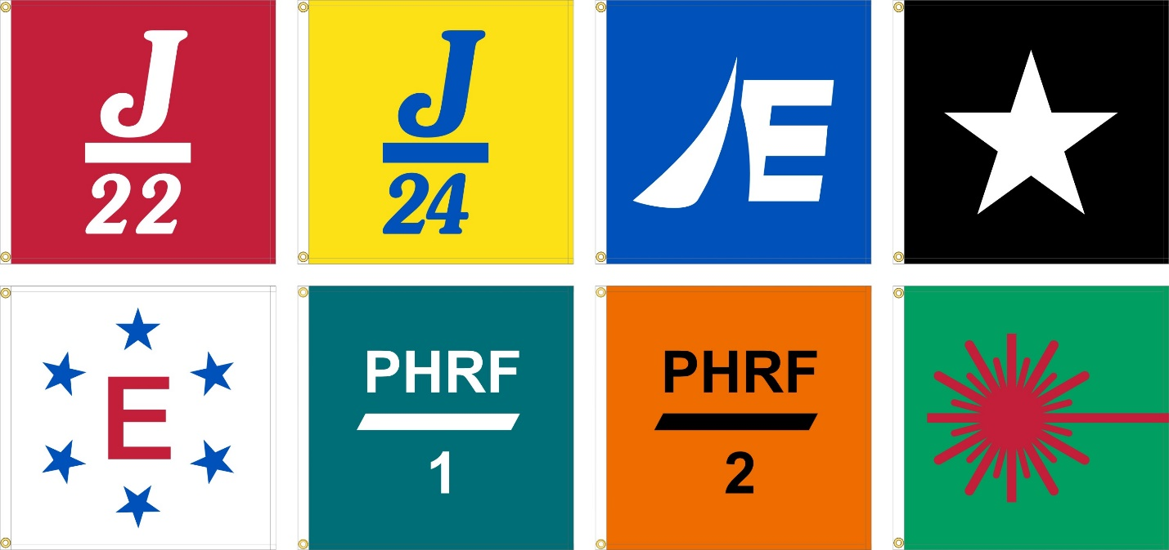

ATTACHMENT B
MAP OF LAKE

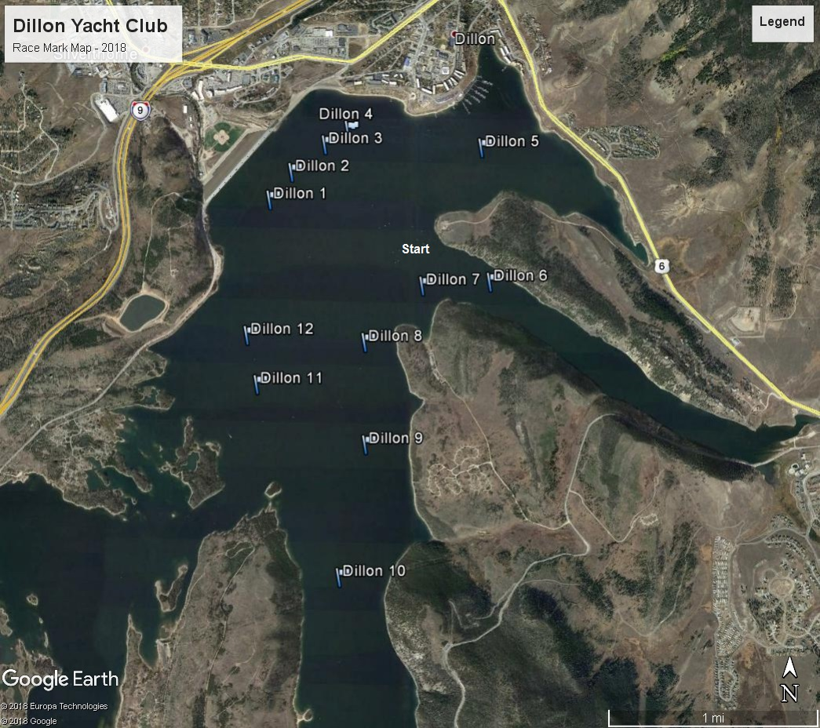

ATTACHMENT C
SAMPLE RACING MARKS

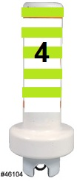

DYC aspires to host its sailing season in accordance with Intl’ Green Regatta guidelines: Use reusable drink containers instead of throwaway plastic bottles; Recycle trash to the greatest extent possible; Use water sparingly to wash boats; Use green cleaning products; Respect our waters.

