***Gamblers Anonymous***

**Website**

*Find* ***Gamblers Anonymous Meetings*** *in*

**Connecticut & Western Massachusetts**

**ctwmaga.org**

Find basic information on problem gambling and Gamblers Anonymous; the ***Meeting Directory for CT & W. MA***; referrals to related websites including Gam-Anon and the International GA office; member’s **Anniversary dates**; **News** and **Upcoming Events**, such as **Open Meetings**. Information for administering Gamblers Anonymous groups can be found under “Intergroup.”

***Email***

**ctwmaga@yahoo.com**

***Help Line*** *(available 24 hours)*

**855-222-5542**

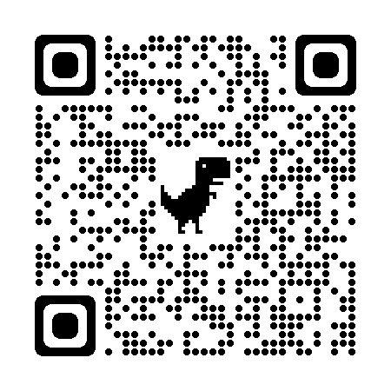

Rev. 10/24