GAMBLERS ANONYMOUS MEETINGS
Connecticut and Western Massachusetts

Visit our Website: <ctwmaga.org>
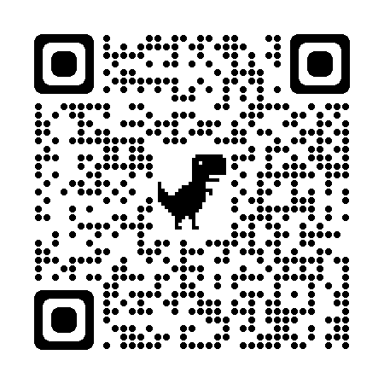

Check Website for up to date Meeting information!

MONDAY
GALES FERRY - 7:00 PM. St. David Church, 284 Stoddard Wharf Rd, Gales Ferry, CT
GUILFORD - 7:00 PM. Guilford Community Center, 32 Church St, Guilford, CT
BLOOMFIELD - 7:00 PM. Congregational Church, 10 Wintonbury Ave, Bloomfield, CT
Enter via handicap ramp, take a left to Lounge Meeting Room.
NORTHAMPTON - 7:00 PM. (Zoom Meeting)
https://lesley.zoom.us/j/8198532703
Meeting ID: 819 853 2703 Passcode: Lesley
(OR) Call-In: (929) 205-6099 Meeting ID: 819 853 2703# Passcode: 950764#

STAMFORD - 8:00 – 10:00 PM. Church of Christ, 1264 High Ridge Road, Stamford, CT
MIDDLEBURY - 7:00 PM. Saint George Episcopal Church, 1 Tucker Hill Rd, Middlebury, CT

TUESDAY
ENFIELD - 6:30 PM. Hazardville United Methodist Church, 330 Hazard Ave, Enfield, CT
MILFORD - 7:00 PM. Mary Taylor Memorial United Methodist Church, 168 Broad St, Milford, CT.
On the Green in Milford Center next to M&T Bank. Parking and entrance to Wesley Center building in rear.
NORTHAMPTON - 7:00 PM. Edwards Church, 297 Main St, Northampton, MA. Must pay for parking on streets or lots until 8 PM. Enter side door facing State St, ring top doorbell.
PAWCATUCK - 7:30 PM. United Church of Christ, 9 Castle Rd, Pawcatuck, CT

WEDNESDAY
COVENTRY - 7:00 PM. 2nd Congregational Church, 1746 Boston Turnpike, Coventry, CT
>>> GAM-ANON - Meets same time and place, 2nd Floor)

DARIEN - 7:30 - 9:30 PM. Congregational Church of Darien, 14 Brookside Rd, Darien, CT
LONGMEADOW - 7:00 PM. (ZOOM Meeting)
https://us02web.zoom.us/j/259713541
Meeting ID: 259 713 541 (Meeting Host will let you in)
(OR) Call-In: (929) 205-6099 Meeting ID: 259713541# (Meeting Host will let you in)

THURSDAY
BETHEL / DANBURY - 7:00 - 9:00 PM. First Congregational Church, 46 Main St, Bethel, CT
LONGMEADOW - 10:00 AM. First Church of Christ, 763 Longmeadow St, Longmeadow, MA
LONGMEADOW - 6:30 PM. First Church of Christ, 763 Longmeadow St, Longmeadow, MA
>>> GAM-ANON - Meets same time and place.
>>> (OR) Call in: (712) 775-8972 Passcode: 121020

MIDDLETOWN - 7:00 PM. CT Valley Hospital, 39 Tynan Circle, Middletown, CT. Merritt Hall, Lee Auditorium
>>> GAM-ANON - Meets same time and place. Merritt Hall, Finkelstein Rm
>>> (OR) Zoom: https://us02web.zoom/j/87456347200
>>> Meeting ID: 874 5634 7200 Passcode: 819733

FRIDAY
HARTFORD - 7:00 PM. Universalist Church, 433 Fern St, W. Hartford, CT. Boardroom, 2nd floor. Park in rear.
WALLINGFORD - 7:00 PM. Gaylord Hospital, 50 Gaylord Farm Rd, Wallingford, CT
Meeting in the Chauncey Room (stand-alone building, behind hospital)
NOTE: Last Friday of every month, Combined Meeting of GA and GAM-ANON, in person only.
AGAWAM - 6:30 PM. (Open Meeting) Alano Club, 36 King St, Agawam, MA. Park on left side of building.
(OR) Zoom: https://us06web.zoom.us/j/85085058864
Meeting ID: 850 8505 8864 Passcode: 801297
(OR) Call-In: (305) 224-1968
Meeting ID: 850 8505 8864# Passcode: 801297#

SATURDAY
HOLYOKE - 10:00 AM. (Zoom Meeting) Combined meeting of GA and GAM-ANON. https://lesley.zoom.us/j/8198532703
Meeting ID: 819 853 2703 Passcode: Lesley
(OR) Call-In: (929) 205-6099 Meeting ID: 819 853 2703# Passcode: 950764#
HOLYOKE - 10:00 AM. (In Person) Holyoke Medical Center, 575 Beech St, Holyoke, MA.
Building 20, Group Room A. Use Parking Lot C. Behind Hospital.
WATERFORD – 11:00 AM. Waterford Library, 49 Rope Ferry Rd, Waterford, CT. Enter in rear, room on left.

SUNDAY
INDIAN ORCHARD - 6:00 PM. Orchard Covenant Church, 95 Berkshire St, Indian Orchard, MA
Combined GA and Gam-Anon ZOOM or Call-In Meeting - Third Sundays - 7:00 - 8:30 PM.
A discussion topic or guest speaker will be introduced at the beginning of each meeting. Time will be reserved for Questions & Answers. One time registration required.
https://us06web.zoom.us/j/84881934841
Meeting ID: 848 8193 4841 Passcode: 226190
(OR) Call-In: (646) 931-3860 Meeting ID: 848 8193 4841# Passcode: 226190#
Please note: Meetings are closed to GA members ONLY, unless otherwise noted.
SPANISH SPEAKING MEETINGS: Go to the <gamblersanonymous.org> website. Search under "Virtual" meetings, search for "Oxnard, CA" (meets every day @ 9:00 am, PST) OR "Thousand Palms, CA" (meets Fridays @ 7:00 pm, PST) OR "Palm View, TX" (meets Fridays @ 8:00 pm, CST) There you will find the information for the Zoom connection.

CONFERENCE CALL MEETINGS: (Run by national GA office) https://gamblersanonymous.org/ga/content/phone-meetings

VIRTUAL MEETINGS:
https://gamblersanonymous.org/ga/virtual-meetings
Help Line: 855-2-CALL-GA (855-222-5542)

Contact us: ctwmaga@yahoo.com

Revised 10/26/25

