Area 17 G.A. & Gam-Anon Presents:
Pressure Relief Workshop #2
“Nuts & Bolts”
Saturday, May 20 @ 11:45am
Holyoke, MA
(In-Person and Online)

Anyone and everyone in G.A. and Gam-Anon are welcome to attend.

Immediately following Saturday 10:00am In-Person and Zoom Meeting
located at the Holyoke Medical Center, 575 Beech St, Holyoke, MA.
Building 20, Group Room A. Use Parking lot C (behind Hospital)

What to expect:
- The contents and procedures for a Pressure Relief meeting
- How to conduct a Pressure Relief (G.A.) & Budget Relief (Gam-Anon) meeting
- Tools and Best Practices

Registration for Online attendance required using the following link or QR code below:
https://us06web.zoom.us/meeting/register/tZwucu-trDIsHNzfXT4nlWT0ReSwoDtudTth
(After registering, you will receive a confirmation email containing information about joining the meeting)
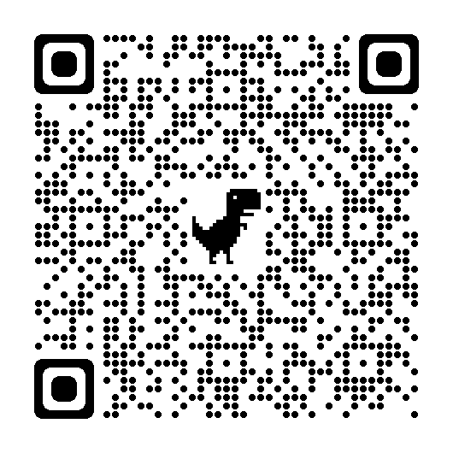

Contact Information:
- Workshop: Bob B or Marie B @ 860-664-0053
- Registration: Paul D @ paul.downing@snet.net or call/text 203-676-5582

