Connecticut & Western Massachusetts
Gamblers Anonymous
Website

Find Gamblers Anonymous Meetings in
Connecticut & Western Massachusetts:

ctwmaga.org

The website includes basic information on problem gambling and Gamblers Anonymous; the Meeting Directory for CT & W. MA; referrals to related websites including Gam-Anon and the International GA office; member’s Anniversary dates; News and upcoming events, such as Open Meetings. Also, information for administering Gamblers Anonymous groups, such as forms and documents, can be found under “Intergroup.”

To contact us, use email address:

ctwmaga@yahoo.com

Help line Phone Number (available 24 hours):

855-222-5542

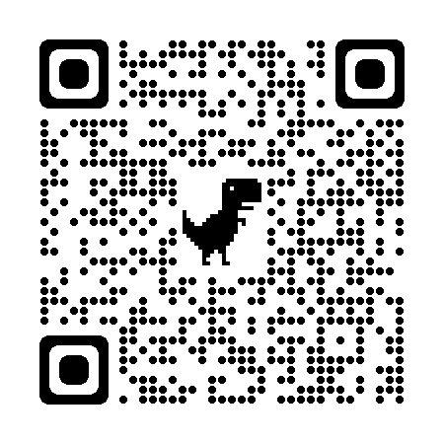
Rev. 11/22

