John Emmett Coaching

Life Alignment Programs
Bronze – 3 Month Essential Alignment (€567)

€189 Per Month

Start Your Journey to Balance
6 Fortnightly 60-minute 1:1 coaching calls
Personalized road-map to guide your progress to help with accountability
Access to 3 guided Meditations for inner calm.
Email support for quick questions
1 Mid-program review call
Total calls for 3 months -7
Why Choose Bronze?
Perfect for those who want a solid foundation and gentle guidance without overwhelming commitment.
Silver – 3 Month Enhanced Alignment (€1,137)

€378 Per Month
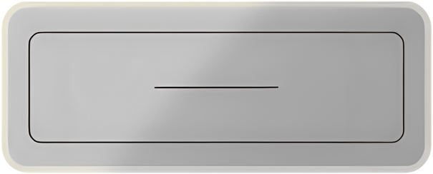
Step Into Deeper Transformation
12 weekly 60–80 minute 1:1 coaching calls for more depth
Full life alignment assessment to uncover your true path Access to guided meditations for inner calm.
1 Functional Breathwork session
Priority email/Whats App support
1 Mid-program review call
Weekly reflection worksheets to keep you on track with accountability
Total Calls for 3 Months-14
Why Choose Silver?
Ideal for those ready to invest in structured progress and consistent support.

Gold – Transformational Alignment (€1,497)

€499 Per Month

Your Life Being Reset

12 weekly 60–90 minute 1:1 coaching calls for maximum impact
Full life alignment assessment to uncover your true path Access to guided Meditations for inner calm.
2 Functional Breathwork Sessions included
- Mid-program review call
Whats App support for real-time guidance
- Extra Clarity Calls (60 mins each)
Monthly progress reports
Weekly reflection worksheets to keep you on track with accountability
Total Calls for 3 Months-17
Custom action plan for lasting transformation
Why Choose Gold?
Designed for those committed to full transformation and high-touch support.
Flexible Monthly/Weekly Payment Plans
Available on all Programs

Monthly Check in calls
These sessions will be around 60-90 Minutes long and will be based on where you have been on your journey so far.These calls are priced are €125 or €100 if you have had done a 3 month program before with me.

