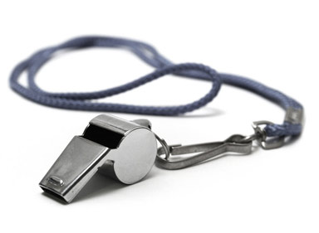
Metro Volleyball Conference Referee Evaluation Form – 2024

Official: _______________________________ Evaluation Site: ___________________________

Match: _______________________________ Match Date: ______________________________

Level (Grade): __________________________

 | Excellent | Good | Average | Poor | Needs Improvement | Notes
Pre-Match Duties:
Arrived on time, checked game ball & net height, checked gym playable areas, etc.
Match Administration:
Warm-ups, time-out and substitution administration
Techniques & Mechanics: Signals, protocols & procedures, whistle use, positioning
Ball Handling:
Overall consistency & judgement, First, second, & third contacts
Player Positioning:
Positional faults, awareness, appropriate prevention
Play at the Net:
Net faults, blocking/attacking, back-row faults, touches
Appearance:
Poise/demeaner, court presence, uniform, professional appearance
Professionalism:
Positive attitude, appropriate communication, match control, issues/problems
Teamwork:
Works well with crew (line judges, scorekeepers, gym personnel), rapport, eye contact, communication

Comments: _____________________________________________________________________________

________________________________________________________________________________________

________________________________________________________________________________________

Evaluator: ____________________________ Print Name: ________________________________

