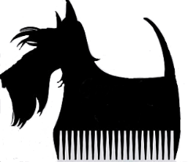\
Blossom’s Grooming Salon
Shave Down Policy – Matted Pet Release Form
Shaving a dog may be necessary due to matting or it may be by personal choice. Shaving means to clip the coat very close to the skin, which gives a “smooth” look. There can be a variety of skin and coat –care problems that may occur after the shave down of a dog. These problems may include the following but are not limited to:
- Loss of hair growth
- Bald patches and/or thin spots where skin is visible
- A different coat color close to the skin, e.g. a red coat may be blond after the haircut
- Coat growing back in different color or texture
- Itching, scratching, biting, licking, shaking, twitching, spinning, rubbing, etc.
- Hyper pigmentation – a darkening of the skin where the coat has not grown back
- Sunburn (sunscreen is recommended after a shave down)
- Loss of guard coat, especially in double-coated breeds
- Coat re-growth in different directions (cowlicks)
- Hotspots can develop days or even weeks after a shave down
If the coat is matted you need to be aware that nicks, cuts, abrasions, clipper burn, and overall skin irritation(s) are more likely. Be aware that Blossom’s will use all precautions to prevent these from happening such as changing and cleaning blades throughout the groom. The owner recognizes that they have been made verbally aware of all conditions that can occur after a double coat shave down.
Knowing that any and all of the above conditions can occur I authorize Blossom’s Grooming Salon to shave my dog down. I do not hold Blossom’s Grooming Salon responsible if any and /or all of the conditions occur on my pet

I have read and agree to this waiver

signature of owner / agent date

