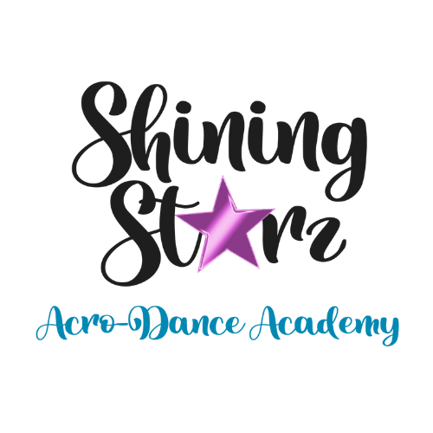**Studio Policies**

**Attendance and Tardiness:** Regular attendance is crucial for progress in dance. Students are expected to attend all scheduled classes. If a student will be absent, parents must notify the studio in advance by contacting (203)298-8894. Excessive absences may result in reassessment of class placement. Students should arrive on time for all classes. If a student arrives more than 10 minutes late, they may be asked to sit and observe the class to avoid disruption. Repeated tardiness may result in a meeting with the instructor and parents.

**Code of Conduct:** Students are expected to show respect to instructors and peers at all times. This includes listening attentively, following instructions, and maintaining a positive attitude. Disruptive behavior will not be tolerated and may result in disciplinary action. Parents should support a positive environment by encouraging their children and respecting the studio policies. Any concerns or issues should be addressed privately with the studio staff.

**Health and Safety Guidelines:** Students should stay home if they are feeling unwell, especially if they have symptoms of contagious illnesses. Please inform the studio if your child will be absent due to illness. All injuries must be reported to the instructor immediately. An incident report will be completed, and parents will be notified. In case of a serious injury, emergency medical services will be contacted.

**Dress Code Enforcement:** Students must adhere to the dress code at all times. Non-compliance may result in being asked to sit out of class until proper attire is worn.

**Inclement Weather Policy:** Closures due to inclement weather will be announced via email, and social media by 2 PM on the day of the closure.

**Makeup Class Policy:** Students may attend makeup classes for any missed classes due to illness, family emergencies, or weather-related closures. To schedule a makeup class, please contact us. Makeup classes must be scheduled in advance and are subject to availability.

**Refund Policy:** Tuition is non-refundable except in cases of medical emergencies with a doctor's note. Requests for refunds must be submitted to shiningstarzacrodance@gmail.com. Costume fees are non-refundable after costumes have been ordered. Private lesson fees are only refundable with 24-hour notice of cancellation. Summer camp deposits are non-refundable. No refunds will be issued for no-shows or last-minute cancellations.

**Photo/Video Release:** Photos and videos of students may be used for marketing and promotional purposes. By enrolling your child, you consent to the use of their images. If you wish to opt-out, please contact shiningstarzacrodance@gmail.com

**Liability Release:** Participation in dance classes involves some risk. By enrolling, you agree to release Shining Starz Acro-Dance Academy LLC from any liability for injuries or accidents that may occur during classes or events.

**Credit Card on File:** A credit card must be on file as a backup method of payment. Payment information is securely stored and protected. If you need to update your payment information, please contact shiningstarzacrodance@gmail.com

**Communication Policy:** We prefer communication via email. We aim to respond within 24 hours to all inquiries. Studio staff will respond to inquiries during office hours. Please allow 24-48 hours for a response.

**Studio Etiquette:** Students should show respect to instructors and peers at all times. This includes listening attentively, following instructions, and maintaining a positive attitude. Students are expected to clean up after themselves and maintain a tidy environment. No food or drinks are allowed in the studio, except for water bottles. Students should use the bathroom for changing and the waiting area for resting. Parents and siblings should wait in our designated waiting area.

**Lost and Found Policy:** Lost items should be reported to the office. Unclaimed items will be kept in the lost and found for 30 days before being donated. Please check the lost and found regularly for any missing items.

**Attendance, Absences, and Makeups:** Regular attendance is crucial for community and technique development. Inform the studio of absences via email, band or text. Only two makeup classes are allowed per month scheduled by contacting us within 24 hours prior to missed class. Makeup classes must be from the same or a lower level.