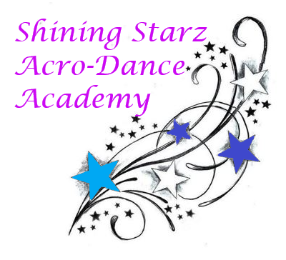
Dear Parents and Shining Starz:
Per governor Lamont’s new law, it will now be required to wear a mask when physical distancing of 6 feet is not possible. Masks will be required in the waiting area, and if someone needs to use the bathroom. Parents are now allowed in the waiting area with a mask. Students will not be required to wear them while exercising, but it is optional. Level I and II Starz will continue to be taught in a station format, allowing for proper spacing while still accomplishing the same curriculum. Feel free to read our current and ongoing sanitary/safety measures listed below
- All students (and anyone entering the studio) are required to have their temperature taken. If it is above 99.6⁰ F they will have to go home.
- All students (and anyone entering the studio) are required to sanitize their hands upon entering and exiting the studio. Hand sanitizer can be found in the lobby.
- All studio equipment is sanitized before and after each class, this includes the air tumble track, mats, ballet barre, and weights.
- Door knobs, light switches, and seats are also sanitized upon opening the studio each day and upon closing up.
- At the ballet barre, there will be tape on the ground to allow for proper spacing. If the portable barre needs to be used, tape will be put down to allow for proper spacing.
- On the floor there will be tape on the ground for proper spacing. Each student will have their own tape to stand on.
- The door will remain open to allow for proper air flow unless there is a major storm.
- You must bring your own water bottle.
- There will be 15 minutes between classes to allow for proper sanitization.
- If you feel the slightest bit under the weather, please stay home! If you are sick, it is required to be back to normal 24 prior to your class.
- If you are missing your class it is required to notify us via email, phone call, or text.
These sanitation procedures are in place to help keep us safe and healthy. Let’s continue our fun filled 3rd season of dance!
With love,
Miss Shine, Miss Kate, Miss Robyn, & Miss Jordyn

