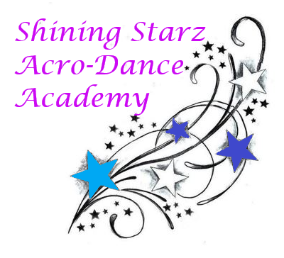**Dear Parents and Shining Starz:**

We are excited to announce our reopening plans! As you know, May 20th we reopened for solo, duo and private lessons. Beginning June 4th, we will be opening for our regular class schedule from Spring 2020. Each class has less than 10 students and our studio space allows for proper social distancing measures. Even though in person classes are beginning, there are new safety and sanitary measures in place as well as an online option for the first two weeks of June. Please review:

* All students are *required* to wash their hands upon entering and exiting the studio. Parents are also required to use hand sanitizer upon entering and exiting the studio, this can be found in the lobby entryway.
* All studio equipment is sanitized before and after each class, this includes the air tumble track, mats, ballet barre, and weights.
* Door knobs, light switches, and seats are also sanitized upon opening the studio each day and upon closing up.
* At the ballet barre, there will be tape on the ground to allow for proper spacing. If the portable barre needs to be used, tape will be put down to allow for proper spacing.
* On the floor there will be tape on the ground for proper spacing. Each student will have their own tape to stand on.
* You *must* bring your own water bottle.
* There will be 15 minutes between classes to allow for proper sanitization.
* If you feel the slightest bit under the weather, please stay home! If you are sick, it is required to be back to normal 48 prior to your class.
* If you are missing your class it is *required* to notify us via email, phone call, or text.

If you wish to keep taking classes online, please respond to Miss Shine and Miss Kate. We will be holding one class per week to be determined via Google Meet for the first two weeks of June for those of you who prefer this option.

These sanitation procedures are in place to help keep us safe and healthy. We can’t wait to see you all in person or on Google Meet!

With love,

Miss Shine & Miss Kate