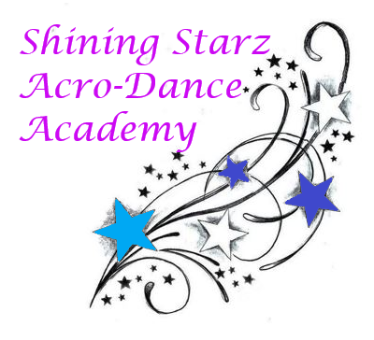
Dear Parents, Starz & Future Starz,

-During the COVID-19 Pandemic we will be holding all of our group classes online through Facebook Live.

Classes will cost $50 for the month during this difficult time. Your child will be able to access the class(es) they are registered for as well as one additional class (either Ballet-Strength or Acro-Jazz).
The studio remains open for solo and private lessons by appointment only and up to the discretion of Miss Shine. Please note the studio is cleaned and sanitized after each use including all of our equipment (mats, barre, weights etc.).
We wish you a safe and healthy stay at home. We will come back stronger and more determined together as a family!

With love,
Miss Shine & Miss Kate

