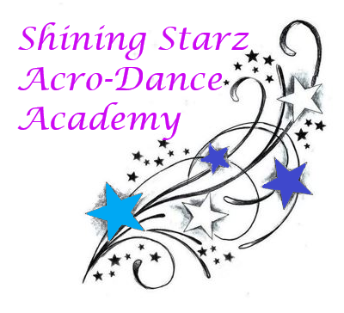
December Newsletter

Happy December, shining starz!
This month we are focusing on cleaning up our routines and our dance moves! Costume money is due by December 14th, as we will be ordering them that weekend. We will also be performing at Atria Larson December 14th in our Holiday Showcase. This is a free event, all are welcome. Let’s continue to focus, learn, and improve in our dancing and tumbles!

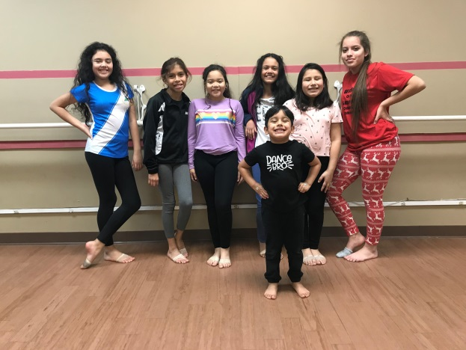
Announcements:
~The studio will be closed December 5th - 11th.
~Holiday Show at Atria Larson in Hamden, December 14th 2:15-3:15pm.
~Parents are welcome to view classes December 19th & 21st, we will be providing refreshments!
~There is class the week of Christmas (Thursday 26th and Saturday 28th)

Dancers: As the weather gets colder, drink more water and warm up your body before you stretch! Jumping jacks or jump rope are great cardio exercises to try.

Check us out at: www.shiningstarzacrodanceacademyct.com

We hope everyone has a wonderful Christmas!

-Miss Shine and Miss Kate

Photos from October:
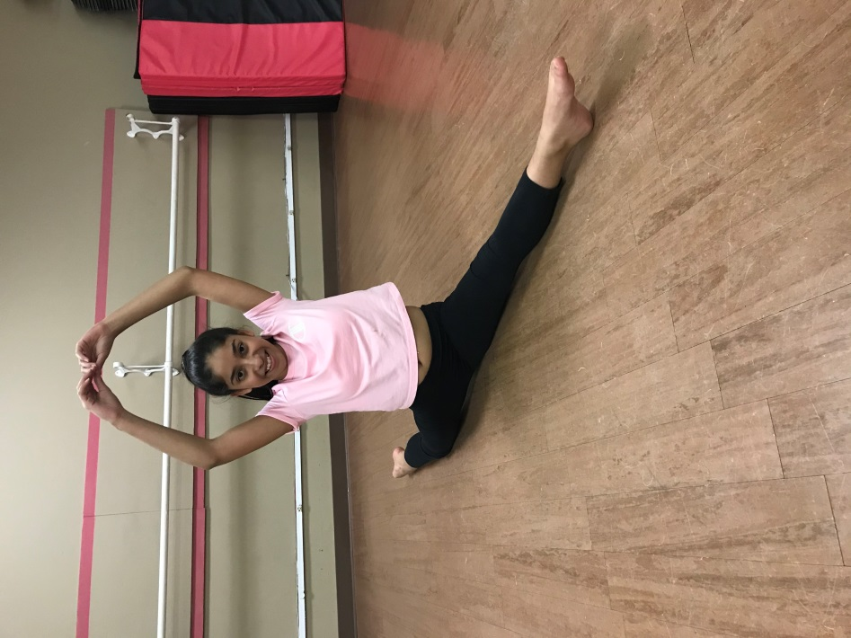
Shooting Starz:
Jaylina practicing splits!

Newstarz:
Bridges!

