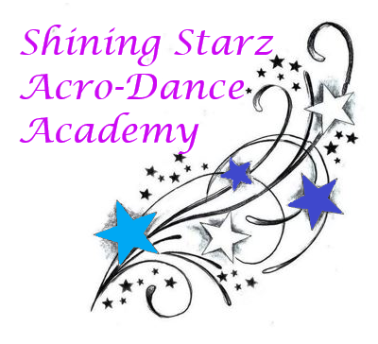
February Newsletter

February has arrived, Shining Starz! This month we look forward to working on our personality and extra smiles while dancing. Don’t forget, we also have pancake breakfast tickets available at the studio for everyone. Let’s keep dancing on (and stretching) at home and at the studio!

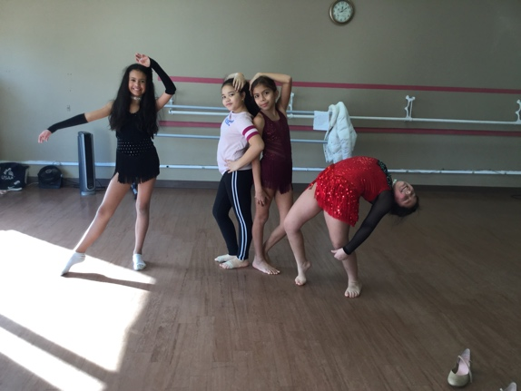
Announcements:

~ Our pancake breakfast will be Saturday February 29th from 8-10:30am. There will not be any classes.
~ Studio Jackets are available to order for $59 until February 15th.
~ In the event of a snowstorm, please check WTNH or our Facebook page for closing/delay.

Dancers: A back bend a day for 10 seconds against the wall can help improve your flexibility tremendously! Let’s see who’s up for a challenge: do one back bend daily in February and show us on the last Saturday of the month how far you have come!

Check us out at: www.shiningstarzacrodanceacademyct.com

We hope everyone has a great February!

-Miss Shine and Miss Kate

