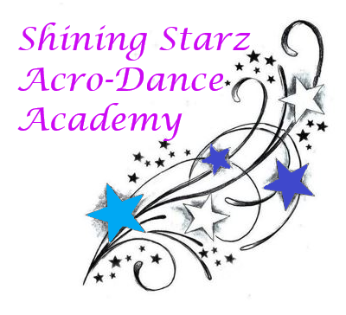
January Newsletter

Happy New Year, Shining Starz!

As we dance our way into 2021 we are focusing on new skills and continued technique. Classes resume on Saturday, January 2nd. Apparel is out including company jackets, plus customized shirts. We will have order forms available on our website & at the studio. Please note the jackets are ordered from a company and will take 5-6 weeks. Enjoy the cold and hopefully some more snow to play in!

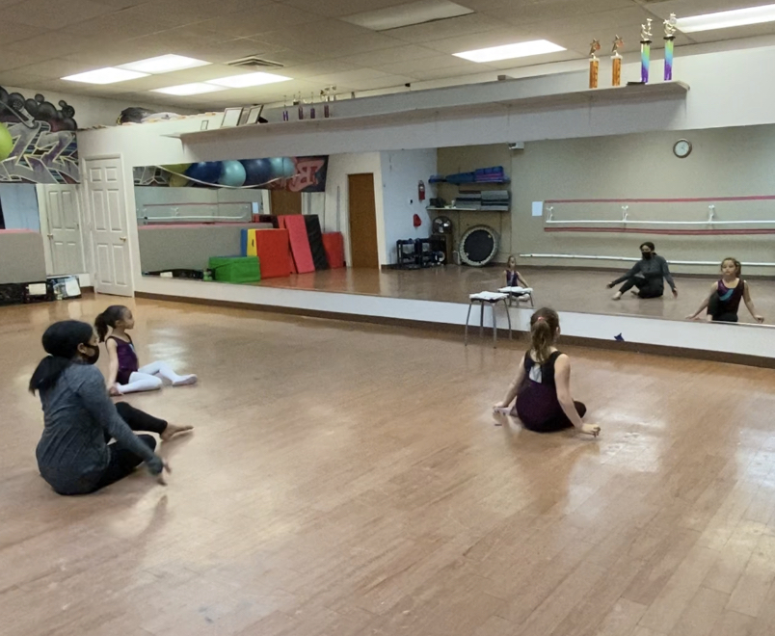
Announcements:

~ Classes resume Saturday, January 2nd.
~ Apparel available on our website (email to order) and in person.
~ Level II Starz & Soloists competing: KAR competition fees will be distributed January 9th and are due by the 31st.

Dance Tip: Sore after dance class? Lightly stretch those sore muscles out to avoid increased soreness the next day or day after. A foam roller works great!

Check out our website: www.shiningstarzacrodanceacademyct.com

We hope you have a great January!

-Miss Shine, Miss Kate, Miss Robyn, and Miss Jordyn

