July Newsletter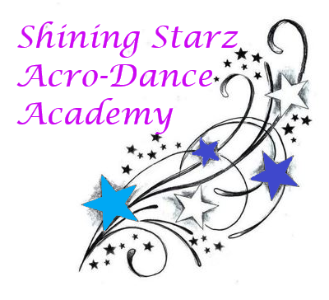

Summer is here, Shining Starz~ We hope everyone is enjoying the warm, sunny weather. This month we are holding our first annual summer camp! Sign-ups can be done via email or at the studio. Classes have resumed in person with safety and health precautions including temperature taking upon entering along with hand washing and six foot spacing. As always, private lessons are a great alternative to a class if you’re looking for a smaller size.

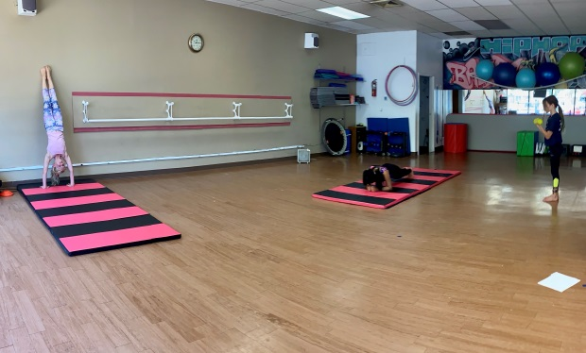

**Announcements:**

**~** Summer camp registration is due by July 8th.

**~** Ballet-Strength will be cancelled Thursday, July 9th.

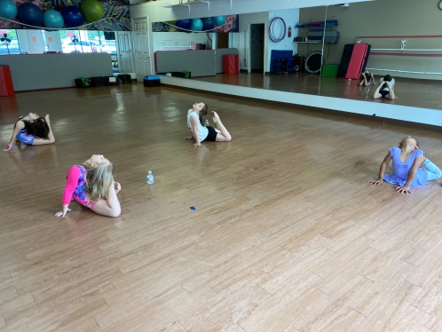**~**The recital is on Saturday, August 29th

**~** Private lessons available!

**Dance Tip:** As we tend to slow down in the Summer, it is a *perfect* time for stretching! Take some time to stretch your hips, legs, and back. Always remember to cool down by taking deep breaths and drinking lots of water.

Schedule and price information can be found on our website: [www.shiningstarzacrodanceacademyct.com](http://www.shiningstarzacrodanceacademyct.com)

Have a great July!

-*Miss Shine and Miss Kate*