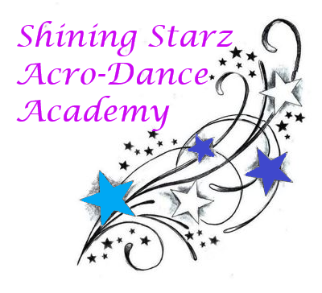
March Newsletter

We’ve leaped into March, Shining Starz! This month marks our level II starz’s first competition of the season. We will be focusing on personality and technique in all our classes! Some exciting news: we will be having our first annual picture day on March 21st after regular classes. Let’s keep dancing on (and stretching) at home and at the studio!

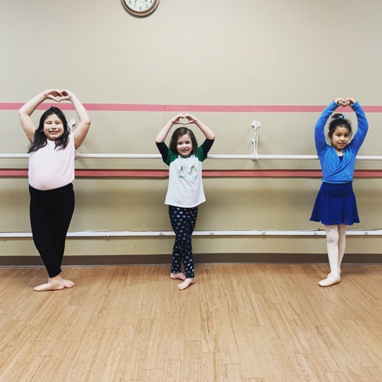
Announcements:

~ Level II Starz rehearsal will be held March 10th from 6:45-8:15pm.
~ Spirit of Dance Competition has been postponed
~ Our live stream classes for enrolled students take place Tuesdays and Saturdays. Ballet will be open to everyone during the quarantine.

Dancers: As we prepare for our upcoming performances, ask yourself “how does dancing make me feel?” Whatever your response may be, show that while you dance!

Check us out at: www.shiningstarzacrodanceacademyct.com

We hope everyone has a lovely March!

-Miss Shine and Miss Kate

