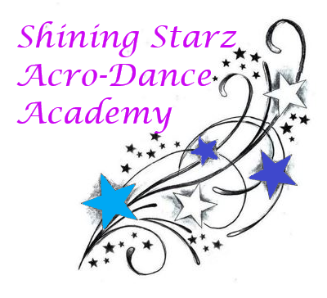
November Newsletter

Happy November, Shining Starz!

It’s already mid-autumn and snow is arriving! This month we are looking forward to continuing choreography in our Level I, II, and Tap Starz classes as well as working on improving our strength and technique in all classes. We will be sending out costume information (pricing, deadlines) and measuring everyone. Please keep an eye out for a notice in class! We will also be announcing our new 2020-2021 apparel this month.

Announcements:
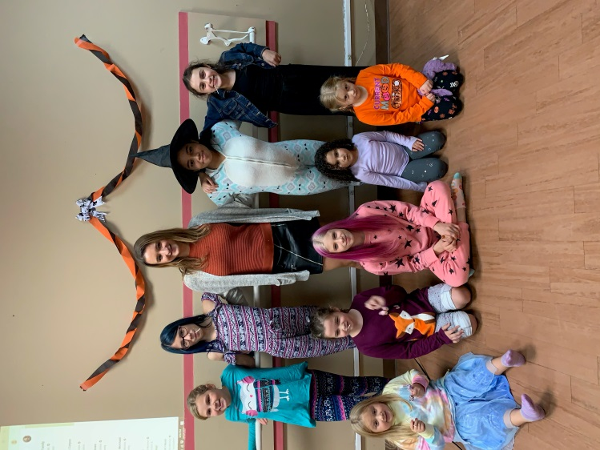
~ New apparel coming out early November.

~ The studio will be closed Wednesday November 25th thru Sunday November 30th for Thanksgiving Break.

~ There will be a makeup class for anyone interested in extra practice on Tuesday November 24th. Time TBA.

Dance Tip: Are there any vitamins I can take to help me stay healthy while at dance? Yes, vitamin C and Zinc are both great to take to help build up your immune system. Your immune system helps protect your body against yucky colds and sicknesses.

Schedule and price information can be found on our website: www.shiningstarzacrodanceacademyct.com

We hope you have a wonderful November, Happy Thanksgiving!

-Miss Shine, Miss Kate, Miss Robyn, and Miss Jordyn

