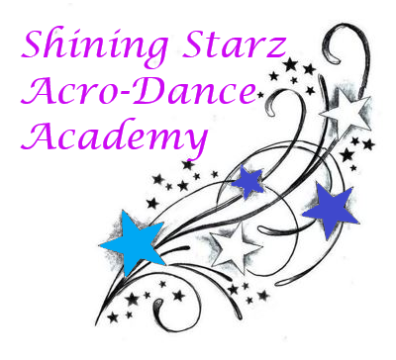September Newsletter

Welcome to September, Shining Starz!

We are dancing our way into a new dance year and are so excited to welcome our new and returning starz. This newsletter will provide important announcements and will always be emailed as well as hanging up inside the studio. Here’s to a great fun filled year!

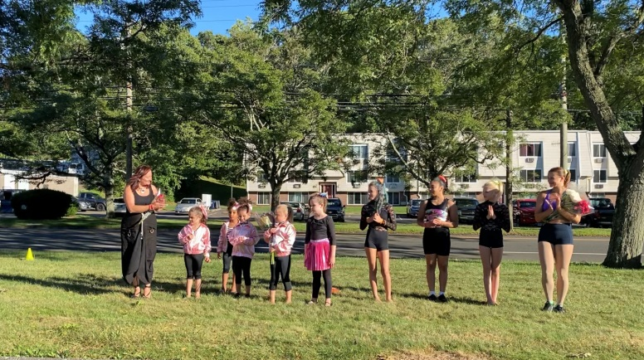**Announcements:**

**~** Registration is ongoing and on Wednesday September 2nd from 5:30 – 7pm

**~** Classes begin Tuesday, September 8th

**~** No private lessons or solos September 12th

**~** Please remember to bring a water bottle and hair must be tied back!

**Dance Tip:** Hungry for a snack? Try some fresh fruits, especially berries. Berries have many vitamins to help keep us healthy and energized with not so much sugar.

Schedule and price information can be found on our website: [www.shiningstarzacrodanceacademyct.com](http://www.shiningstarzacrodanceacademyct.com)

We hope you have a wonderful September!

-*Miss Shine, Miss Kate, Miss Robyn, and Miss Jordyn*