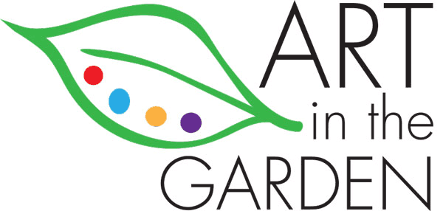
Art in the Garden
Instructor Information

Thank you for sharing your artistic talents with our community at Art in the Garden, a community art school planting creativity and art.

Please find below a few things we want to be sure that we are all on the same page.

- Artist/instructors may set up for their classes in advance. It is tricky to arrive, pull out supplies and have your class set up the way you want when folks arrive early. Please have your class ready at least 15 minutes before time as folks are often excited and ready to start (sometimes before you are!)

- Be sure to send images that we can use to promote your class/workshop. These images need to be your property, not copies of someone else’s work. If you have questions as to what this entails, please let us know and we can have a discussion.

Classes at Art in the Garden are in a few categories:
- Youth Classes and workshops
- Adult Classes and workshops
- Exhibits with artist presentation
- Professional Development Workshops
- Friday Night Art Party
- Saturday Studio
- Fundraiser Make and Take
- Lunch and Learn

These workshops and classes are open for instructors in all media and artforms; Visual Art, Craft, Experimental Techniques, Music, Multi-Media, Poetry, Dance, Literature, Theatre in collaboration with RCTG and other artistic collaborations.

Art in the Garden strives for compensation for all artist presentations, promoting art as an economic driver for community interaction, creative engagement, commerce and cultural awareness. To this end, AITG intends to promote the arts with fundraisers, requests for support through grants, foundation funding, sales and other financial opportunities that allow us to invest in the arts, planting the seeds of art in our community.

