**DOJO RULES**

1. *All students must bow when entering and exiting dojo*
2. *Students are not allowed to play on the mats when class is in session*
3. *Students must ask before using pads, sparring gear, weapons and punching bags*
4. *Students are not allowed to use weights, weight bench or exercise equipment unless special permission is given, and supervision is available by Sensei or Senpai*
5. ***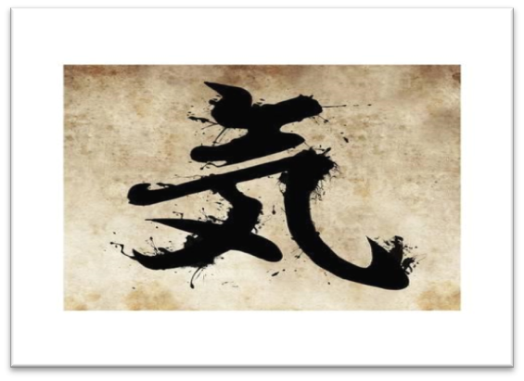****Students are not allowed to use their karate skills to purposely injure another person/student*
6. *Students must always practice self-control*
7. *Students must be on time, ready for class wearing complete Gi with belt*
8. *Students will address all instructors as Sensei or Senpai; depending on kyu level (rank)*
9. *Students are expected to focus and follow all rules*
10. NO FOOD OR DRINK ON THE MATS

*Failure to respect the rules of the Open-Air Dojo may result in students not being able to participate in class or move up in Kyu level****.***