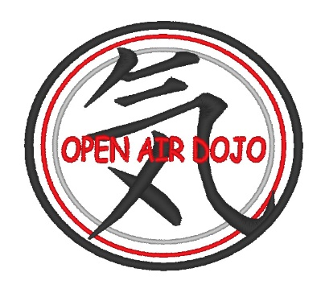
Rayford Shorin-Ryu
Open Air Dojo

WAIVER OF LIABILITY
IN THE EVENT OF ACCIDENT OR INJURY, BY SIGNING THIS FORM, I ACCEPT FULL RESPONSIBILITY AND RELINQUISH ANY AND ALL CLAIMS AGAINST ALL INSTRUCTORS, TEACHERS, AND OWNERS OF PROPERTY IN WHICH CLASSES ARE OR WILL TAKE PLACE.
ANY AND ALL MEDICAL ATTENTION WILL BE SOUGHT AND PAID FOR BY THE UNDERSIGNED PARTICIPANT, PARENT, OR GUARDIAN.
IF TRAINING WITH A PRE-EXISTING MEDICAL CONDITION, RESPONSIBILITY OF GETTING A DOCTOR’S CLEARANCE AND ANY AND ALL CONCEQUENCES OF TRAINING WITH THE MEDICAL CONDITION IS THE SOLE RESPONSIBILITY OF THE STUDENT/ GUARDIAN OF THE STUDENT (IF STUDENT IS UNDER 18 YEARS OF AGE).

- STUDENT: (PRINT NAME) _______________________________Date: ___________
- SIGNATURE: _______________________________________Date: ____________
If student is under 18 parents must sign

