RESUME TIPS: (Side 1)

Top Third of Resume: 5 Sample Formats: OPTIMIZE resume “real estate”

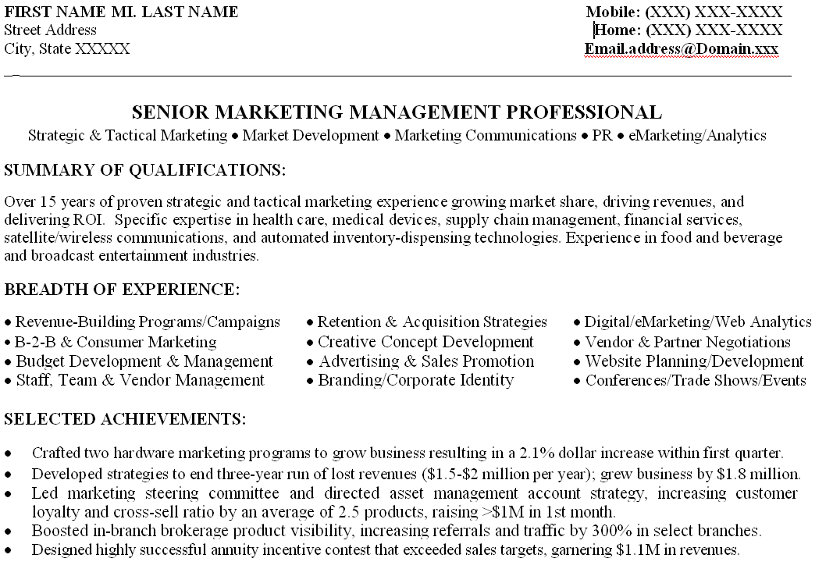
1

3
2

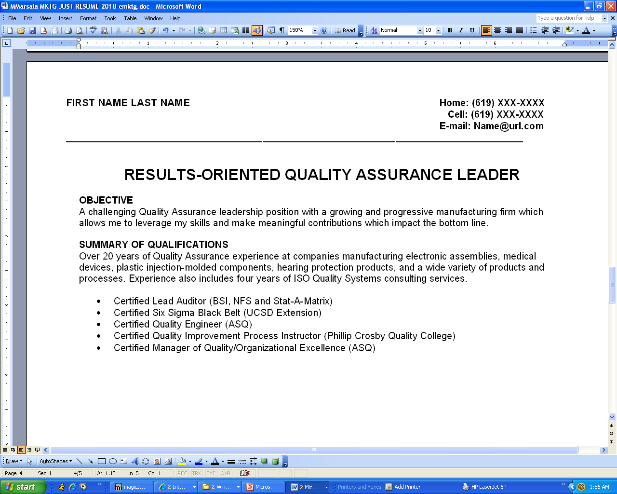
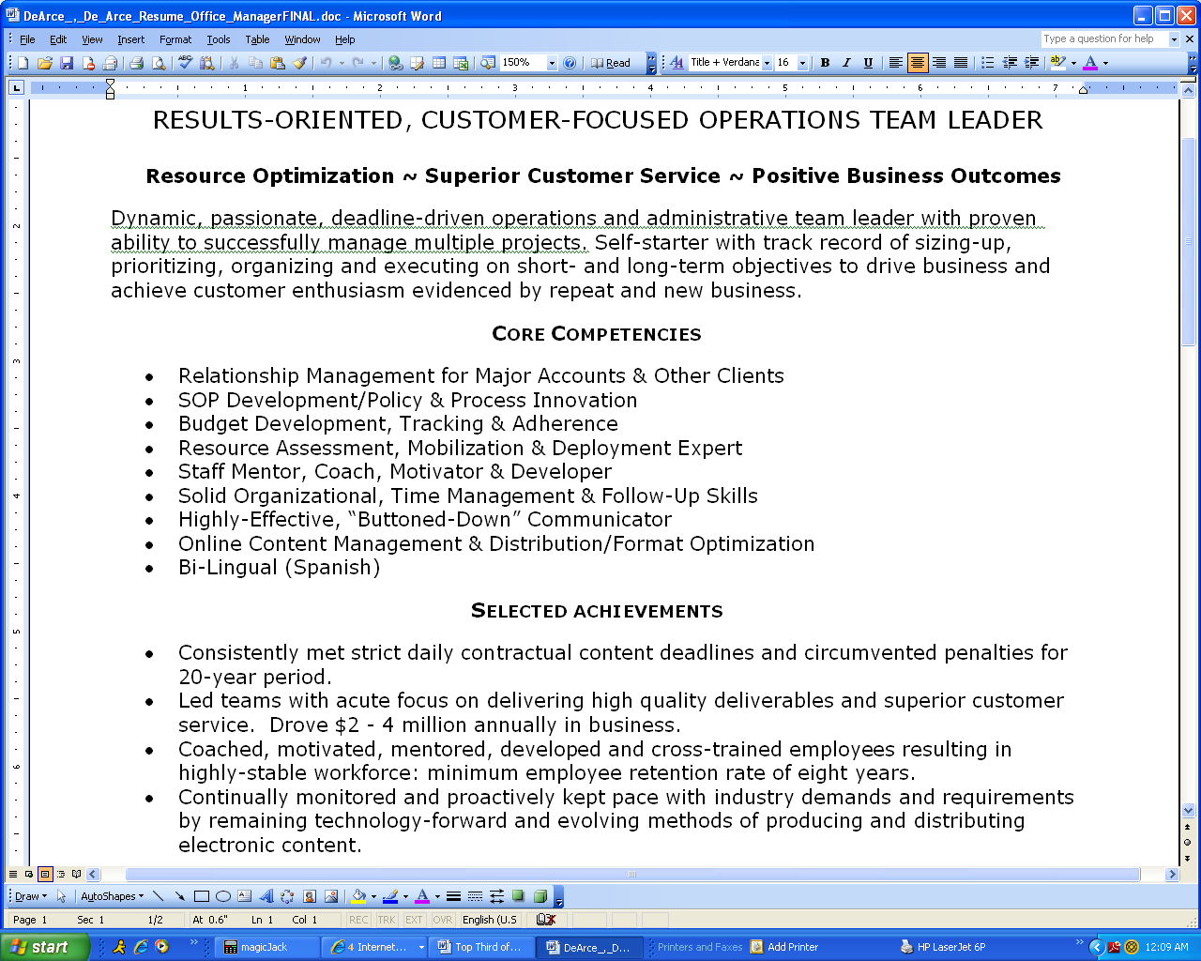
2

RESUME TIPS: (Side 2)

Top Third of Resume: 5 Sample Formats: OPTIMIZE resume “real estate”
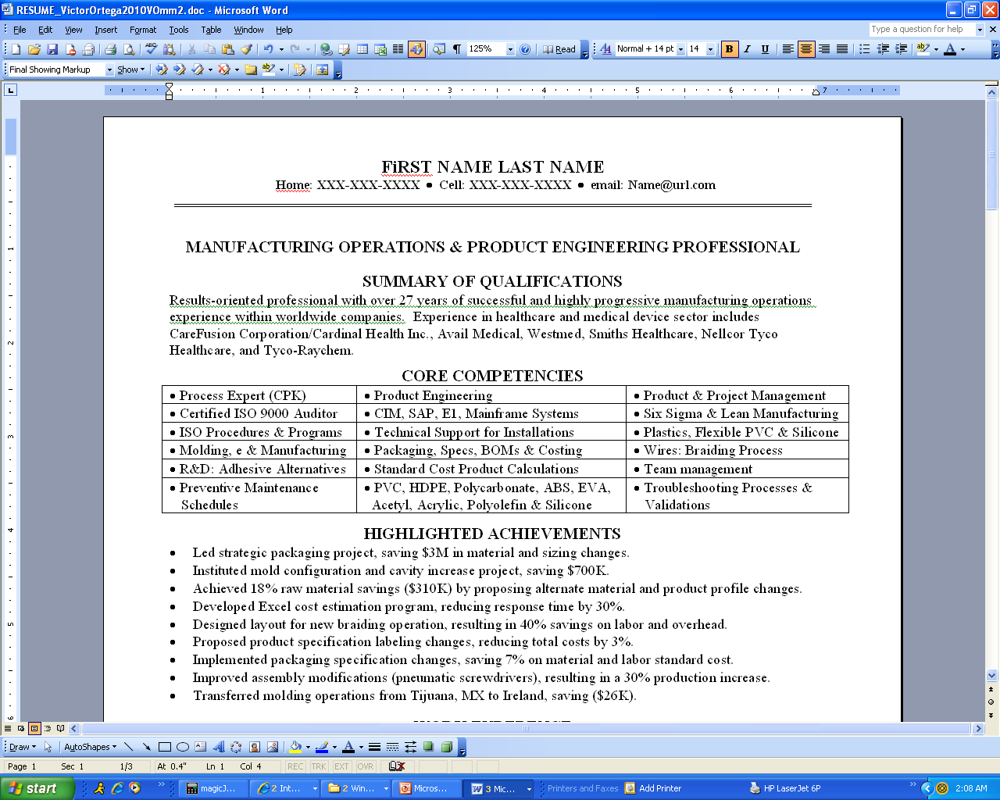

Even if you “hide gridlines,” your key terms CANNOT be read by MOST ATS software!
Do NOT Use Tables – ATS Issue
4

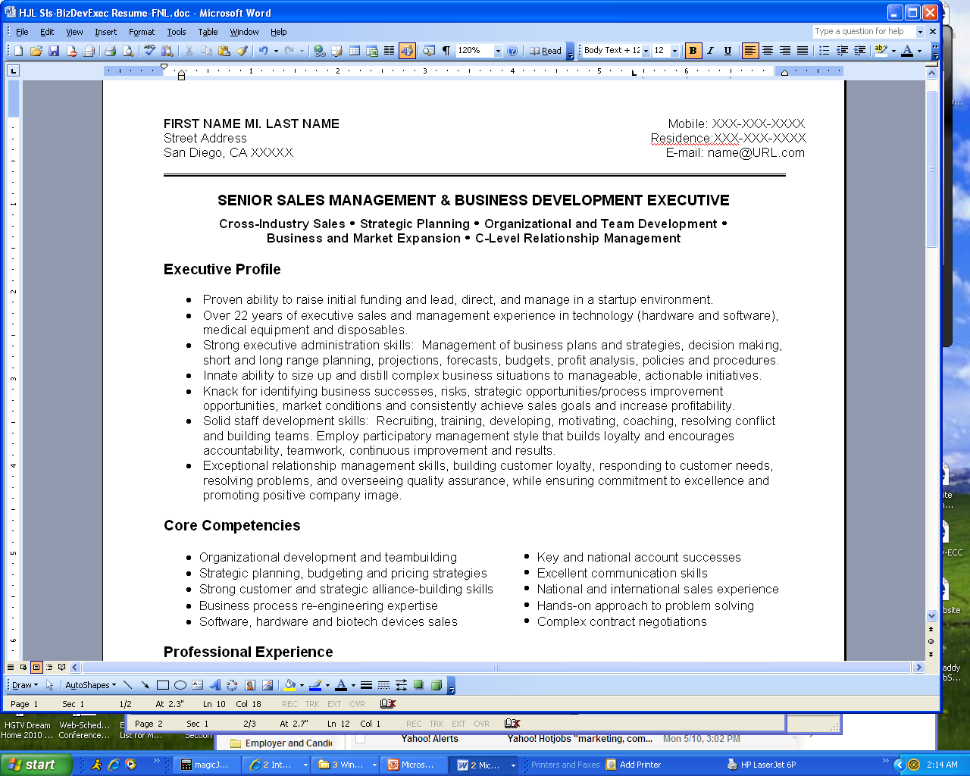
5

