Saint John Bike Share Program
REGISTRATION FORM
Return form to CVRC in person, via Email: crescentvalleyresourcecentre@gmail.com
or Fax: 506 693-1513

IMPORTANT INFORMATION

- This registration form must be filled out in full to be eligible to receive a bike.
- Participants must be a minimum 4 years of age to receive a bike.
- Applicant will receive a phone call once a bike is available.
- Children must be with a parent/guardian in order to receive their bike.
- Each applicant is solely responsible for their bike and must lock it up when not in use.
- One application per year; there is no guarantee a bike will be available.

Full Name ______________________________________________________________________________

Date Of Birth (Month/Day/Year) ____________________________________________________________
Age_______________ Height (Feet/Inches) ____________
Phone Number __________________________________________________________________________
Home Address ___________________________________________________________________________

Postal Code _____________________________________________________________________________

Preferred Style of Bike (Girls/Women’s, Boys/Men, Either) _______________

Special Requests/Details___________________________________________________________________

ALL PARTICIPANTS UNDER THE AGE OF 18 ARE REQUIRED TO HAVE THEIR APPLICATION, LIABILITY WAIVER, AND MEDIA RELEASE SIGNED BY THEIR PARENT OR GUARDIAN TO PARTICIPATE. This includes children who may be riding in a child seat on a tricycle or in a cycle trailer.

Participant or Parent/Guardian Name __________________________________________________________________

Participant or Parent/Guardian Signature ________________________________________ Date ___________________

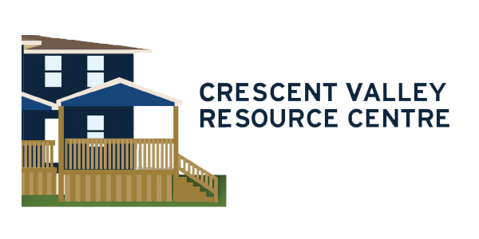
Saint John Bike Share Program
LIABILITY WAIVER

I/my family/associates will not hold the City of Saint John, Anglophone School District South, Crescent Valley Resource Centre, NB Dept. of Social Development, its employees or volunteers responsible for damage, injury or death suffered by myself/my child/children directly or indirectly related to my/my child's/children’s participation in the Crescent Valley Resource Centre associated programs or activities.

I am aware and understand that once I/my child/children have received a bike, it becomes my/their sole responsibility to check/maintain bike safety and follow bike safety practices. For example, I/my child/my children will monitor bicycle functionality (wheels, brakes, body, handlebars, etc), drive safely following traffic rules and wear a helmet at all times.

Participant or Parent/Guardian Name __________________________________________________________________

Participant or Parent/Guardian Signature ________________________________________ Date ___________________

Saint John Bike Share Program
MEDIA RELEASE

I hereby consent to the participation in interviews, the use of quotes, and the taking of photographs, movies or videos of participant by staff of Crescent Valley Resource Centre and the Saint John Bike Program. I understand that any such photographs, audio recordings, and video recordings become the property of the CVRC/Saint John Bike Program and may be used by the CVRC/Saint John Bike Program for educational, instructional, or promotional purposes in broadcast and electronic media formats now existing or in the future created.
I also hereby release the Crescent Valley Resource Centre and the Saint John Bike Program, and its agents and employees from all claims, demands, and liabilities whatsoever in connection with the above.
Please check one of the options below:
____ Yes, I give consent. ____ No, I do not give consent.
Participant or Parent/Guardian Name ___________________________________________________________________

Participant or Parent/Guardian Signature ________________________________________ Date ___________________

