www.MassageTherapyHouston.com 713-861-2411
“Focused, effective therapy in comfortable clothes”

Disclaimer: You should feel no more than mild discomfort doing these stretches. You should feel the stretch only in the color/shaded area. If you are not sure about the technique, please call or come by for a review.

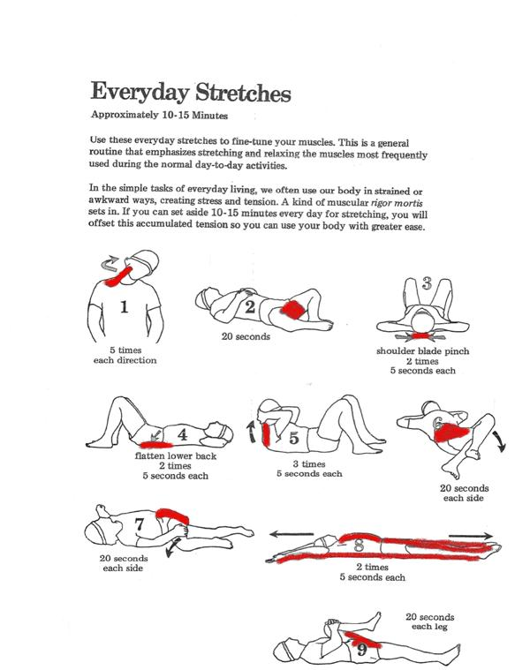
After # 9, try some abs!
Want more detail? Looking for Sports specific routines? Get a copy of “Stretching” by Bob Anderson!

