KARINA SORELLI  Film Crew CV  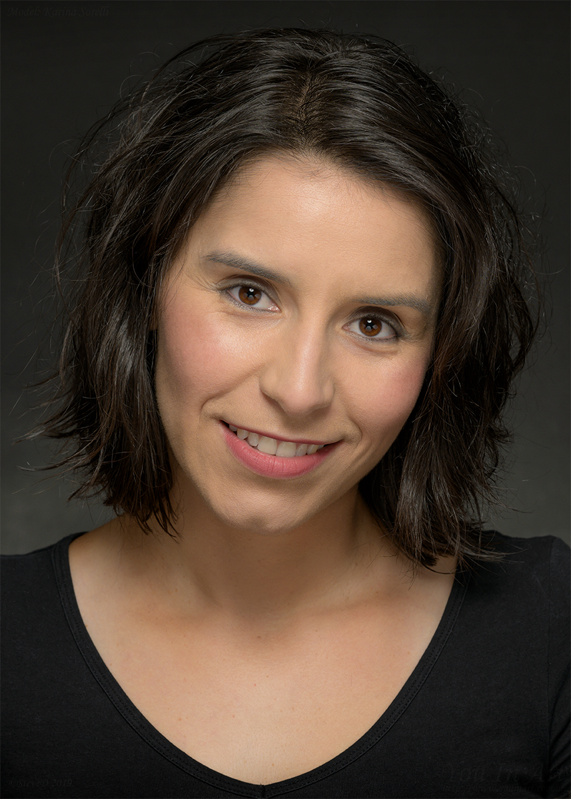  Contact  PHONE:  (+61) 424 383 529  WEBSITE:  www.karinasorelli.com  EMAIL:  contact@karinasorelli.com  skills  Reliable and Punctual  Time Management  Attention to detail  Problem-solving abilities  Multitasking Abilities  Adaptability and flexibility  Production scheduling  Strong work ethic  Strong communication skills  Directing experience  Licenses  Full Driving License  Full Motorcycle License  Work With Children Check  Forklift  Elevated Work Platform over 11m |  | WORK EXPERIENCE  Staw Hut Productions – A GOOD BOY - Melbourne  1st Assistant Director/Assistant Producer  January 2022 - September 2024  Developed strong relationships with local authorities for swift permit approvals and access to restricted locations when necessary.  Maintained a safe working environment on set by enforcing strict adherence to safety protocols and guidelines.  Facilitated seamless transitions between scenes by coordinating extras, actors, and crew members during shoots.  Collaborated with directors and producers to develop shooting schedules that maximized resources and minimized conflicts.  Oversaw daily call sheets, ensuring accurate information was communicated to all relevant parties.  Rebel Pictures – STILL HERE - Melbourne  1st Assistant Director  May 2024 - May 2024  Enhanced overall production efficiency by streamlining communication between departments and delegating tasks effectively.  Managed tight schedules for successful completion of film projects, ensuring timely delivery without compromising on quality.  Facilitated seamless transitions between scenes by coordinating extras, actors, and crew members during shoots.  Amazon Prime US – TWO NOVAKS - Melbourne  Production Coordinator/Fixer  December 2024 - January 2025  Provided hands-on support during peak production periods, assisting teams in meeting tight deadlines.  Coordinated with production team to support productivity targets and deadline management.  Monitored and tracked progress of all production tasks for on-time delivery.  Coordinated communication between departments, fostering a collaborative work environment.  Worked with supervisors and team members to understand supply needs and bring levels within desired tolerances.  Managed daily operations on the production floor, maintaining a safe and organized workspace.  Assisted with budgeting and accounting of production-related tasks.  Reduced material waste and improved sustainability through diligent inventory management.  Liaised with production managers, suppliers and vendors to support production needs.  Karina Sorelli - #FOLLOWME , THE END OF US (BYTE BACK) - Melbourne  Film Producer/Writer/Director  January 2019 - Current  Collaborated with screenwriters to refine scripts, enhancing plotlines and character development for a more engaging audience experience.  Developed strong relationships with talent agencies, resulting in the successful casting of high-profile actors for lead roles.  Managed location scouting efforts to identify visually stunning settings that enhanced overall cinematic impact while adhering to budget constraints.  Coordinated cross-functional departments such as art direction, cinematography, costume design ensuring cohesion between all elements of the film.  Managed budgets and resources effectively, ensuring timely completion of projects within allocated funds.  M'Creativ - Mlebourne  1st Assistant Director/Co-Producer  February 2022 - August 2024Enhanced overall production efficiency by streamlining communication between departments and delegating tasks effectively.  Managed tight schedules for successful completion of film projects, ensuring timely delivery without compromising on quality.  Facilitated seamless transitions between scenes by coordinating extras, actors, and crew members during shoots.  Developed strong relationships with local authorities for swift permit approvals and access to restricted locations when necessary.  Supervised script revisions to ensure continuity and clarity throughout the entire production process.  Coordinated pre-production activities, including location scouting and casting, to set the stage for smooth shooting processes.  EDUCATION  AFTRS Director’s Journey  2025  10 week course learning with a professional director, Elissa Down about Directing  Media Mentors Australia  Current  Regular Workshops about Producing, Working with Talent, Storytelling,…  Acting courses at TAFTA, Film&Television Studio International, The Hollywood Initiative, HALO Actors  2010-Current  Learn different techniques, approaches, accents, physical movements  Lonsdale Institute Melbourne, VIC  June 2017  Diploma of Business  Lonsdale Institute Melbourne, VIC  March 2015  Certificate III Accounting  HOBBIES  Personal Training, Martial Arts, Fitness & Well-Being, Dancing, Rock Climbing/Bouldering  Hiking, Music, Film, TV and Theater, Volunteer Work.  LANGUAGES  English, French, Italian, Spanish, a dialect of Arabic, AUSLAN.

