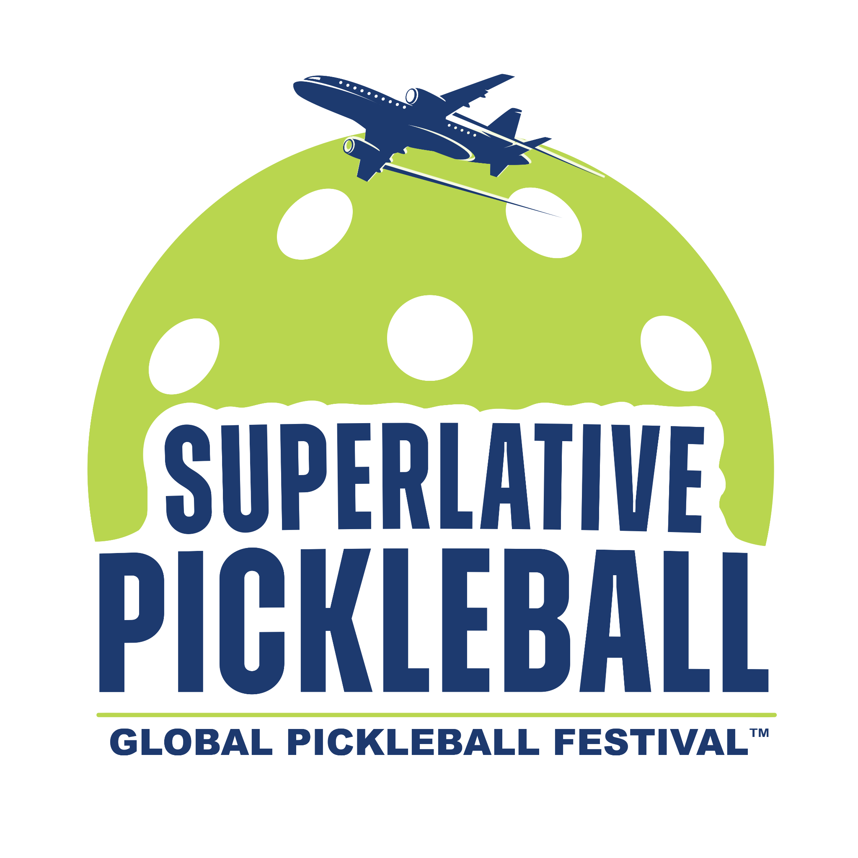

**Marketing Plan for the Global Pickleball Festival at Sandals Resorts**

**Executive Summary**

The Global Pickleball Festival, in exclusive partnership with Sandals Resorts and Vibe Getaways, is the ultimate "anti-tournament" experience for recreational pickleball players. This marketing plan outlines the strategies to promote this luxurious, all-inclusive pickleball getaway at five distinct Sandals Resorts in the Caribbean, attracting players seeking fun, social play, and world-class amenities. This plan incorporates the detailed requirements and benefits of the Superlative Pickleball Program Certificate of Excellence to ensure a premium pickleball experience for all participants.

**Target Audience**

* **Recreational pickleball players:** Individuals and couples who prioritize fun, social play over competitive tournaments.
* **Luxury travelers:** Discerning individuals seeking a premium vacation experience with pickleball as a key component.
* **Sandals Resort enthusiasts:** Existing Sandals customers and those interested in experiencing the Luxury Included® concept.
* **Superlative Pickleball Travel Club members:** Leverage the existing community to drive bookings and promote the festival.

**Marketing Objectives**

* **Position as the "anti-tournament":** Clearly communicate the festival's focus on fun, social play and contrast it with traditional competitive tournaments.
* **Drive bookings:** Maximize registrations for the festival across all five Sandals Resorts and throughout the five-month period.
* **Highlight the Luxury Included® experience:** Showcase the unparalleled amenities, services, and inclusions offered by Sandals Resorts.
* **Leverage the partnership:** Capitalize on the synergy between Superlative Pickleball, Vibe Getaways, and Sandals Resorts to amplify marketing reach.
* **Build anticipation:** Generate excitement and anticipation for the inaugural festival and establish it as an annual event.
* **Emphasize the Certificate of Excellence:** Highlight the quality and standards guaranteed by the certification to attract discerning pickleball players.

**Marketing Strategies**

**1. Digital Marketing**

* **Dedicated landing page:** Create a visually appealing landing page on the Superlative Pickleball website with detailed festival information, resort options, pricing, and booking functionality. Prominently display the Certificate of Excellence logo and link it to the certification details.
* **Social media campaign:** Develop a targeted social media campaign across Facebook, Instagram, and potentially TikTok, highlighting the "anti-tournament" concept, luxurious amenities, and unique selling points of each Sandals Resort. Emphasize the quality playing environment and inclusive culture in posts.
* **Email marketing:** Utilize segmented email lists to target Superlative Pickleball Travel Club members, past Sandals guests, and potential luxury travelers with personalized messages and promotional offers. Include information about the Certificate of Excellence and its benefits.
* **Online advertising:** Employ targeted online advertising on platforms like Google Ads, social media, and travel websites to reach the desired audience with compelling visuals and messaging. Highlight the "Superlative Pickleball-approved" experience.
* **Content marketing:** Create blog posts, articles, and videos showcasing the festival experience, featuring testimonials from past Sandals guests and pickleball enthusiasts, and highlighting the unique aspects of each participating resort. Include details about the quality equipment, organized play, and complimentary lessons.

**2. Public Relations and Media Outreach**

* **Press release distribution:** Issue a press release announcing the partnership and the Global Pickleball Festival, emphasizing the "anti-tournament" concept, the luxurious offerings, and the high standards guaranteed by the Certificate of Excellence.
* **Targeted media outreach:** Pitch the festival story to travel publications, lifestyle magazines, and pickleball-focused media outlets, securing coverage that highlights the unique experience and the quality standards of the certified resorts.
* **Influencer marketing:** Collaborate with travel and pickleball influencers to experience the festival and share their authentic experiences with their followers. Encourage them to highlight the quality of the facilities and equipment.

**3. Leverage Existing Communities**

* **Superlative Pickleball Travel Club:** Promote the festival heavily within the club, offering exclusive discounts and perks to members. Utilize the club's communication channels to reach a highly engaged audience. Emphasize the benefits of attending a certified resort.
* **Sandals Select Rewards:** Engage with Sandals' loyalty program members, offering special promotions and incentives to book the Global Pickleball Festival. Highlight the enhanced pickleball experience offered at the certified resorts.
* **Vibe Getaways Network:** Utilize Vibe Getaways' existing customer base and marketing channels to promote the festival to their audience of Caribbean travel enthusiasts.

**4. On-Site Marketing at Sandals Resorts**

* **Promotional materials:** Display eye-catching brochures, posters, and digital signage at all participating Sandals Resorts to promote the festival to current guests. Highlight the Certificate of Excellence and the resort's commitment to quality pickleball.
* **Welcome events:** Host welcome events for festival participants at each resort, fostering a sense of community and providing information about the activities and amenities. Reinforce the inclusive and fun atmosphere of the festival.
* **Branded merchandise:** Offer exclusive Global Pickleball Festival merchandise at Sandals Resorts, creating a sense of exclusivity and serving as a memento of the experience.

**5. Partnerships and Cross-promotion**

* **Pickleball equipment providers:** Partner with pickleball equipment manufacturers to offer exclusive discounts or product demonstrations to festival participants. Feature these partnerships in marketing materials.
* **Local excursion providers:** Collaborate with local tour operators to offer curated excursions and activities that complement the pickleball experience.
* **Health and wellness brands:** Partner with relevant brands to offer wellness activities, spa treatments, or healthy food and beverage options at the festival.

**6. Implement Certificate of Excellence Requirements**

* **Prominently display the logo:** Ensure the Certificate of Excellence logo is prominently displayed on the landing page, marketing materials, and on-site signage.
* **Host a site inspection:** Facilitate a site inspection with the Superlative Pickleball consulting team and provide a complimentary SWOT analysis.
* **Offer exclusive perks:** Collaborate with Sandals to offer exclusive perks and benefits to Superlative Pickleball guests, such as room upgrades, early check-in, or discounts on spa treatments.

**7. Maximize Certificate of Excellence Benefits**

* **Featured articles:** Leverage the featured articles in Pickleball Travel Magazine to showcase the resorts, highlight the festival, and promote group trips.
* **Advertising:** Utilize the full-page ad and booking link in each issue of Pickleball Travel Magazine to drive traffic and bookings.
* **Social media promotion:** Utilize the dedicated posts in Superlative Pickleball's social media groups to reach a wider audience and generate interest in the festival.
* **Free consultation:** Take advantage of the free consultation with the resort services team to enhance the pickleball program and optimize the guest experience.
* **Discounted equipment:** Utilize the online wholesaler partnership to purchase discounted equipment and offer competitive pricing in the pro shop.

**Evaluation and Measurement**

* **Booking data:** Track bookings across all five resorts and five months to measure the overall success of the festival and identify peak demand periods.
* **Website traffic and engagement:** Monitor website traffic, landing page conversions, and social media engagement to assess the effectiveness of digital marketing efforts.
* **Media coverage and sentiment:** Track media mentions and analyze the sentiment of coverage to evaluate the impact of public relations and influencer marketing.
* **Guest feedback:** Collect feedback from festival participants through surveys and online reviews to gauge satisfaction and identify areas for improvement.
* **Partner feedback:** Obtain feedback from Sandals Resorts, Vibe Getaways, and other partners to assess the success of the partnership and identify opportunities for future collaboration.

**Conclusion**

By implementing this comprehensive marketing plan and fully leveraging the benefits of the Superlative Pickleball Program Certificate of Excellence, the Global Pickleball Festival at Sandals Resorts can effectively reach its desired audience, communicate its unique value proposition, and drive bookings for this luxurious and fun-filled pickleball getaway. The plan's emphasis on leveraging existing communities, digital marketing, public relations, on-site promotion, and the Certificate of Excellence will ensure that the festival is a resounding success and establishes itself as a premier event in the pickleball and luxury travel landscape.