[**Make Your Bed: Little Things That Can Change Your Life...And Maybe the World**](https://www.amazon.com/Make-Your-Bed-Little-Things/dp/1455570249/ref=sr_1_1?dchild=1&keywords=make+your+bed&qid=1619722411&sr=8-1)

by [Admiral William H. McRaven](https://www.amazon.com/Admiral-William-H-McRaven/e/B08T8HQPSJ?ref=sr_ntt_srch_lnk_1&qid=1619722411&sr=8-1)

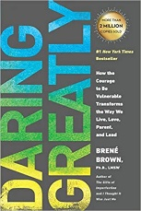[**Daring Greatly: How the Courage to Be Vulnerable Transforms the Way We Live, Love, Parent, and Lead**](https://www.amazon.com/Daring-Greatly-Courage-Vulnerable-Transforms/dp/1592408419/ref=sr_1_1?crid=1DQZM28OLIYRA&dchild=1&keywords=daring+greatly+brene+brown&qid=1619717785&sprefix=daring+grea%2Caps%2C191&sr=8-1)

by [Brené Brown](https://www.amazon.com/Bren%25C3%25A9-Brown/e/B001JP45BA?ref=sr_ntt_srch_lnk_1&qid=1619717785&sr=8-1)

[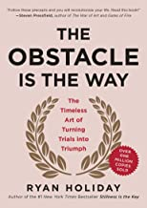](https://www.amazon.com/Obstacle-Way-Timeless-Turning-Triumph/dp/1591846358/ref=sxts_sxwds-bia-wc-rsf-lq2a1_0?cv_ct_cx=the+obstacle+is+the+way&dchild=1&keywords=the+obstacle+is+the+way&pd_rd_i=1591846358&pd_rd_r=f4a7a2fe-121b-4863-9477-0561d22d5e4b&pd_rd_w=qOeV4&pd_rd_wg=oBL2R&pf_rd_p=26b0e770-de1c-4342-bf97-c57fd874dbaf&pf_rd_r=VN9P5FHNSAT4X5T0A1K1&psc=1&qid=1619718035&sr=1-1-49946e88-733b-44df-869b-c05699555c56)

[**The Obstacle Is the Way: The Timeless Art of Turning Trials into Triumph**](https://www.amazon.com/Obstacle-Way-Timeless-Turning-Triumph/dp/1591846358/ref=sxts_sxwds-bia-wc-rsf-lq2a1_0?cv_ct_cx=the+obstacle+is+the+way&dchild=1&keywords=the+obstacle+is+the+way&pd_rd_i=1591846358&pd_rd_r=f4a7a2fe-121b-4863-9477-0561d22d5e4b&pd_rd_w=qOeV4&pd_rd_wg=oBL2R&pf_rd_p=26b0e770-de1c-4342-bf97-c57fd874dbaf&pf_rd_r=VN9P5FHNSAT4X5T0A1K1&psc=1&qid=1619718035&sr=1-1-49946e88-733b-44df-869b-c05699555c56)

by [Ryan Holiday](https://www.amazon.com/Ryan-Holiday/e/B007LUHFH8?ref=sxts_sxwds-bia-wc-rsf-lq2a1_0&qid=1619718035&sr=1-1-49946e88-733b-44df-869b-c05699555c56)

[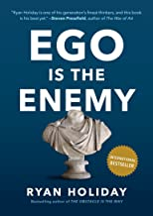**Ego Is the Enemy**](https://www.amazon.com/Ego-Enemy-Ryan-Holiday/dp/1591847818/ref=sr_1_1?crid=30SYG2EMLGDWB&dchild=1&keywords=ego+is+the+enemy&qid=1619720898&sprefix=ego+is+the+en%2Caps%2C208&sr=8-1)

[Book 2 of 3: The Way, the Enemy and the Key](https://www.amazon.com/dp/B08M63YR2N?searchxofy=true&binding=kindle_edition&ref_=dbs_s_aps_series_rwt_tkin&qid=1619720898&sr=8-1) | by [Ryan Holiday](https://www.amazon.com/Ryan-Holiday/e/B007LUHFH8?ref=sr_ntt_srch_lnk_1&qid=1619720898&sr=8-1)

[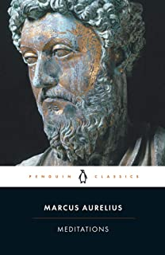](https://www.amazon.com/Meditations-Penguin-Classics-Marcus-Aurelius/dp/0140449337/ref=sr_1_6?crid=2D0WF783F307L&dchild=1&keywords=meditations+marcus+aurelius&qid=1619719038&sprefix=meditaions%2Caps%2C323&sr=8-6)

[**Meditations (Penguin Classics)**](https://www.amazon.com/Meditations-Penguin-Classics-Marcus-Aurelius/dp/0140449337/ref=sr_1_6?crid=2D0WF783F307L&dchild=1&keywords=meditations+marcus+aurelius&qid=1619719038&sprefix=meditaions%2Caps%2C323&sr=8-6)

by [Marcus Aurelius](https://www.amazon.com/Marcus-Aurelius/e/B000AR7YUW?ref=sr_ntt_srch_lnk_6&qid=1619719038&sr=8-6) and Martin Hammond

[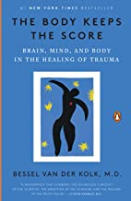](https://www.amazon.com/Body-Keeps-Score-Healing-Trauma/dp/0143127748/ref=sr_1_1?crid=8CGAJ54RR2M3&dchild=1&keywords=the+body+keeps+the+score&qid=1619719388&sprefix=Th%2Caps%2C294&sr=8-1)

[**The Body Keeps the Score: Brain, Mind, and Body in the Healing of Trauma**](https://www.amazon.com/Body-Keeps-Score-Healing-Trauma/dp/0143127748/ref=sr_1_1?crid=8CGAJ54RR2M3&dchild=1&keywords=the+body+keeps+the+score&qid=1619719388&sprefix=Th%2Caps%2C294&sr=8-1)

by Bessel van der Kolk M.D.

[](https://www.amazon.com/Boy-Who-Raised-Psychiatrists-Notebook-What/dp/0465094457/ref=sr_1_1?crid=1GF40DWPUWEAF&dchild=1&keywords=the+boy+who+was+raised+as+a+dog&qid=1619719520&sprefix=The+boy+who%2Caps%2C230&sr=8-1)

[**The Boy Who Was Raised as a Dog: And Other Stories from a Child Psychiatrist's Notebook -- What Traumatized Children Can Teach Us About Loss, Love, and Healing**](https://www.amazon.com/Boy-Who-Raised-Psychiatrists-Notebook-What/dp/0465094457/ref=sr_1_1?crid=1GF40DWPUWEAF&dchild=1&keywords=the+boy+who+was+raised+as+a+dog&qid=1619719520&sprefix=The+boy+who%2Caps%2C230&sr=8-1)

by [Bruce D Perry](https://www.amazon.com/Bruce-D-Perry/e/B004G8LMOU?ref=sr_ntt_srch_lnk_1&qid=1619719520&sr=8-1) and [Maia Szalavitz](https://www.amazon.com/Maia-Szalavitz/e/B001ILFON8?ref=sr_ntt_srch_lnk_1&qid=1619719520&sr=8-1)

[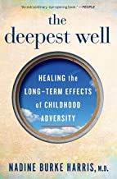**The Deepest Well: Healing the Long-Term Effects of Childhood Adversity**](https://www.amazon.com/Deepest-Well-Long-Term-Childhood-Adversity/dp/132850266X/ref=sr_1_2?crid=1ZVXA3330V0GH&dchild=1&keywords=the+deepest+well+nadine+burke+harris&qid=1619721705&sprefix=the+deepest+well%2Caps%2C208&sr=8-2)

by Nadine Burke Harris M.D.

[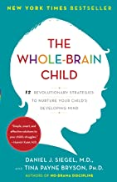**The Whole-Brain Child: 12 Revolutionary Strategies to Nurture Your Child's Developing Mind**](https://www.amazon.com/Whole-Brain-Child-Revolutionary-Strategies-Developing/dp/0553386697/ref=sr_1_3?dchild=1&keywords=the+whole+brain+child&qid=1619721935&sr=8-3)

by [Daniel J. Siegel](https://www.amazon.com/Daniel-J-Siegel/e/B00459LSPI?ref=sr_ntt_srch_lnk_3&qid=1619721935&sr=8-3) and [Tina Payne Bryson](https://www.amazon.com/Tina-Payne-Bryson/e/B005O0PL3W?ref=sr_ntt_srch_lnk_3&qid=1619721935&sr=8-3)

[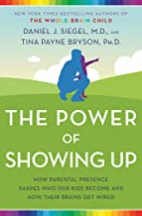**The Power of Showing Up: How Parental Presence Shapes Who Our Kids Become and How Their Brains Get Wired**](https://www.amazon.com/Power-Showing-Up-Parental-Presence/dp/1524797731/ref=sr_1_1?dchild=1&keywords=the+power+of+showing+up&qid=1619722022&sr=8-1)

by [Daniel J. Siegel](https://www.amazon.com/Daniel-J-Siegel/e/B00459LSPI?ref=sr_ntt_srch_lnk_1&qid=1619722022&sr=8-1) and [Tina Payne Bryson](https://www.amazon.com/Tina-Payne-Bryson/e/B005O0PL3W?ref=sr_ntt_srch_lnk_1&qid=1619722022&sr=8-1)

[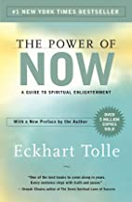**The Power of Now: A Guide to Spiritual Enlightenment**](https://www.amazon.com/Power-Now-Guide-Spiritual-Enlightenment/dp/1577314808/ref=sr_1_1?dchild=1&keywords=The+Power+of+now&qid=1619719619&sr=8-1)

by [Eckhart Tolle](https://www.amazon.com/Eckhart-Tolle/e/B001H6GZ5K?ref=sr_ntt_srch_lnk_1&qid=1619719619&sr=8-1)

[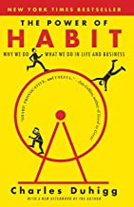](https://www.amazon.com/Power-Habit-What-Life-Business/dp/081298160X/ref=sr_1_1?dchild=1&keywords=The+Power+of+habit&qid=1619719685&sr=8-1)  
[**The Power of Habit: Why We Do What We Do in Life and Business**](https://www.amazon.com/Power-Habit-What-Life-Business/dp/081298160X/ref=sr_1_1?dchild=1&keywords=The+Power+of+habit&qid=1619719685&sr=8-1)

by [Charles Duhigg](https://www.amazon.com/Charles-Duhigg/e/B006X0XPLM?ref=sr_ntt_srch_lnk_1&qid=1619719685&sr=8-1)

[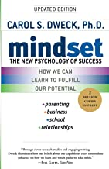**Mindset: The New Psychology of Success**](https://www.amazon.com/Mindset-Psychology-Carol-S-Dweck/dp/0345472322/ref=sr_1_1?dchild=1&keywords=mindset&qid=1619721792&sr=8-1)

by [Carol S. Dweck](https://www.amazon.com/Carol-S-Dweck/e/B001H6UR6S?ref=sr_ntt_srch_lnk_1&qid=1619721792&sr=8-1)

[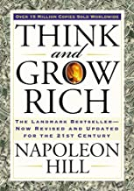**Think and Grow Rich: The Landmark Bestseller Now Revised and Updated for the 21st Century (Think and Grow Rich Series)**](https://www.amazon.com/Think-Grow-Rich-Landmark-Bestseller/dp/1585424331/ref=sr_1_1?dchild=1&keywords=think+and+grow+rich&qid=1619719864&sr=8-1)

[Part of: Think and Grow Rich (3 Books)](https://www.amazon.com/dp/B087JLT3JB?searchxofy=true&binding=kindle_edition&ref_=dbs_s_aps_series_rwt_tkin&qid=1619719864&sr=8-1) | by [Napoleon Hill](https://www.amazon.com/Napoleon-Hill/e/B000APAMYE?ref=sr_ntt_srch_lnk_1&qid=1619719864&sr=8-1) and Arthur R. Pell

[**The Four Agreements: A Practical Guide to Personal Freedom (A Toltec Wisdom Book)**](https://www.amazon.com/Four-Agreements-Practical-Personal-Freedom/dp/1878424319/ref=sr_1_1?dchild=1&keywords=the+4+agreements&qid=1619720036&sr=8-1)

[Part of: A Toltec Wisdom Book (6 Books)](https://www.amazon.com/dp/B07WPYK81P?searchxofy=true&binding=kindle_edition&ref_=dbs_s_aps_series_rwt_tkin&qid=1619720036&sr=8-1) | by [Don Miguel Ruiz](https://www.amazon.com/Don-Miguel-Ruiz/e/B001JP23NM?ref=sr_ntt_srch_lnk_1&qid=1619720036&sr=8-1)

[](https://www.amazon.com/Fifth-Agreement-Practical-Self-Mastery-Toltec/dp/1878424610/ref=sr_1_1?dchild=1&keywords=the+5th+agreements&qid=1619720113&sr=8-1)  
[**The Fifth Agreement: A Practical Guide to Self-Mastery (Toltec Wisdom)**](https://www.amazon.com/Fifth-Agreement-Practical-Self-Mastery-Toltec/dp/1878424610/ref=sr_1_1?dchild=1&keywords=the+5th+agreements&qid=1619720113&sr=8-1)

[Part of: A Toltec Wisdom Book (6 Books)](https://www.amazon.com/dp/B07WPYK81P?searchxofy=true&binding=kindle_edition&ref_=dbs_s_aps_series_rwt_tkin&qid=1619720113&sr=8-1) | by [Don Miguel Ruiz](https://www.amazon.com/Don-Miguel-Ruiz/e/B001JP23NM?ref=sr_ntt_srch_lnk_1&qid=1619720113&sr=8-1) , [Don Jose Ruiz](https://www.amazon.com/Don-Jose-Ruiz/e/B07X3CXMQS?ref=sr_ntt_srch_lnk_1&qid=1619720113&sr=8-1) , et al.

[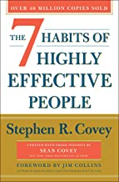](https://www.amazon.com/Habits-Highly-Effective-People-Powerful/dp/1982137274/ref=sr_1_3?crid=3F58ONJYUNLN1&dchild=1&keywords=7+habits+of+highly+effective+people&qid=1619720250&sprefix=7+ha%2Caps%2C236&sr=8-3)  
[**The 7 Habits of Highly Effective People (30th Anniversary Edition)**](https://www.amazon.com/Habits-Highly-Effective-People-Powerful/dp/1982137274/ref=sr_1_3?crid=3F58ONJYUNLN1&dchild=1&keywords=7+habits+of+highly+effective+people&qid=1619720250&sprefix=7+ha%2Caps%2C236&sr=8-3)

by [Stephen R. Covey](https://www.amazon.com/Stephen-R-Covey/e/B000AQ2VAQ?ref=sr_ntt_srch_lnk_3&qid=1619720250&sr=8-3)

[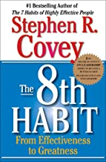](https://www.amazon.com/8th-Habit-Effectiveness-Greatness/dp/0743287932/ref=sr_1_1?crid=55B2CQN5W55&dchild=1&keywords=the+8th+habit&qid=1619720309&sprefix=the+8th%2Caps%2C231&sr=8-1)  
[**The 8th Habit: From Effectiveness to Greatness**](https://www.amazon.com/8th-Habit-Effectiveness-Greatness/dp/0743287932/ref=sr_1_1?crid=55B2CQN5W55&dchild=1&keywords=the+8th+habit&qid=1619720309&sprefix=the+8th%2Caps%2C231&sr=8-1)

by [Stephen R. Covey](https://www.amazon.com/Stephen-R-Covey/e/B000AQ2VAQ?ref=sr_ntt_srch_lnk_1&qid=1619720309&sr=8-1)

[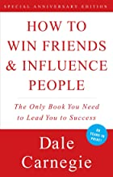**How to Win Friends & Influence People**](https://www.amazon.com/How-Win-Friends-Influence-People/dp/0671027034/ref=sr_1_1?crid=SVZSQTJU3OY7&dchild=1&keywords=how+to+win+friends+and+influence+people+dale+carnegie&qid=1619720381&sprefix=how+to+win+friends+and+in%2Caps%2C810&sr=8-1)

[Part of: How To Win Friends and Influence People Series (2 Books)](https://www.amazon.com/dp/B07VVJCF1B?searchxofy=true&binding=kindle_edition&ref_=dbs_s_aps_series_rwt_tkin&qid=1619720381&sr=8-1) | by [Dale Carnegie](https://www.amazon.com/Dale-Carnegie/e/B00OIFV2S2?ref=sr_ntt_srch_lnk_1&qid=1619720381&sr=8-1)

[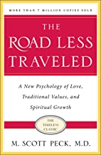](https://www.amazon.com/Road-Less-Traveled-Timeless-Traditional/dp/0743243153/ref=sr_1_1?dchild=1&keywords=the+road+less+traveled&qid=1619720550&sr=8-1)

[**The Road Less Traveled, Timeless Edition: A New Psychology of Love, Traditional Values and Spiritual Growth**](https://www.amazon.com/Road-Less-Traveled-Timeless-Traditional/dp/0743243153/ref=sr_1_1?dchild=1&keywords=the+road+less+traveled&qid=1619720550&sr=8-1)

by [M. Scott Peck](https://www.amazon.com/M-Scott-Peck/e/B000APXCQ4?ref=sr_ntt_srch_lnk_1&qid=1619720550&sr=8-1)

[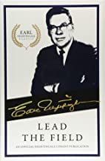**Lead the Field: An Official Nightingale Conant Publication (Earl Nightingale Series) (Earl Nightingale Classics)**](https://www.amazon.com/Lead-Field-Official-Nightingale-Publication/dp/1640950389/ref=sxts_sxwds-bia-wc-rsf-lq2a1_0?cv_ct_cx=lead+the+field&dchild=1&keywords=lead+the+field&pd_rd_i=1640950389&pd_rd_r=91320ccb-78fa-496d-b6a6-5e9932d2a9e8&pd_rd_w=zwkCj&pd_rd_wg=9ISEK&pf_rd_p=26b0e770-de1c-4342-bf97-c57fd874dbaf&pf_rd_r=AK12EWR5HQNNHEP907EW&psc=1&qid=1619722935&sr=1-1-49946e88-733b-44df-869b-c05699555c56)

by [Earl Nightingale](https://www.amazon.com/Earl-Nightingale/e/B001K8R50O?ref=sxts_sxwds-bia-wc-rsf-lq2a1_0&qid=1619722935&sr=1-1-49946e88-733b-44df-869b-c05699555c56)

[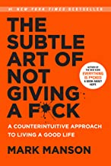**The Subtle Art of Not Giving a F*ck: A Counterintuitive Approach to Living a Good Life**](https://www.amazon.com/Subtle-Art-Not-Giving-Counterintuitive/dp/0062457713/ref=sr_1_1?crid=1J5UZV46KY8GB&dchild=1&keywords=the+subtle+art+of+not+giving+a+fck&qid=1619720462&sprefix=the+subtle+ar%2Caps%2C199&sr=8-1)

[Part of: The Subtle Art of Not Giving a F*ck (2 Books)](https://www.amazon.com/dp/B07SZ9Q9DT?searchxofy=true&binding=kindle_edition&ref_=dbs_s_aps_series_rwt_tkin&qid=1619720462&sr=8-1) | by [Mark Manson](https://www.amazon.com/Mark-Manson/e/B00BIJOMOC?ref=sr_ntt_srch_lnk_1&qid=1619720462&sr=8-1)

[**Unfu*k Yourself: Get Out of Your Head and into Your Life (Unfu*k Yourself series)**](https://www.amazon.com/Unfu-Yourself-Your-Head-into/dp/0062803832/ref=sr_1_1?dchild=1&keywords=unfuck+yourself&qid=1619720819&sr=8-1)

[Part of: Unfu*k Yourself (5 Books)](https://www.amazon.com/dp/B07VVHKBDR?searchxofy=true&binding=kindle_edition&ref_=dbs_s_aps_series_rwt_tkin&qid=1619720819&sr=8-1) | by [Gary John Bishop](https://www.amazon.com/Gary-John-Bishop/e/B01M9F5EEN?ref=sr_ntt_srch_lnk_1&qid=1619720819&sr=8-1)

[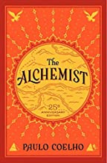**The Alchemist, 25th Anniversary: A Fable About Following Your Dream**](https://www.amazon.com/Alchemist-Paulo-Coelho/dp/0062315005/ref=sr_1_1?crid=2J79RHXA73W42&dchild=1&keywords=the+alchemist&qid=1619720692&sprefix=the+alch%2Caps%2C597&sr=8-1)

by [Paulo Coelho](https://www.amazon.com/Paulo-Coelho/e/B000AQ3HB8?ref=sr_ntt_srch_lnk_1&qid=1619720692&sr=8-1)

[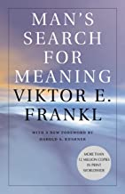**Man's Search for Meaning**](https://www.amazon.com/Mans-Search-Meaning-Viktor-Frankl/dp/0807014273/ref=sr_1_1?crid=WB2GU1P5Q108&dchild=1&keywords=mans+search+for+meaning&qid=1619720993&sprefix=man%2Caps%2C441&sr=8-1)

by [Viktor E. Frankl](https://www.amazon.com/Viktor-E-Frankl/e/B000APVZJU?ref=sr_ntt_srch_lnk_1&qid=1619720993&sr=8-1) , William J. Winslade, et al.

[](https://www.amazon.com/gp/slredirect/picassoRedirect.html/ref=pa_sp_atf_aps_sr_pg1_1?ie=UTF8&adId=A0537995174RHE23DL2ZV&url=%2FAs-man-Thinketh-Original-Wisdom%2Fdp%2FB08W7DWHSS%2Fref%3Dsr_1_1_sspa%3Fcrid%3D1E65X7A1BCXCG%26dchild%3D1%26keywords%3Das%2Ba%2Bman%2Bthinkith%2Bjames%2Ballen%26qid%3D1619721063%26sprefix%3Das%2Ba%2Bman%2Bthinki%252Caps%252C262%26sr%3D8-1-spons%26psc%3D1&qualifier=1619721063&id=6205576224352526&widgetName=sp_atf)

[**As a man Thinketh: The Original 1902 Edition (The Wisdom Of James Allen)**](https://www.amazon.com/gp/slredirect/picassoRedirect.html/ref=pa_sp_atf_aps_sr_pg1_1?ie=UTF8&adId=A0537995174RHE23DL2ZV&url=%2FAs-man-Thinketh-Original-Wisdom%2Fdp%2FB08W7DWHSS%2Fref%3Dsr_1_1_sspa%3Fcrid%3D1E65X7A1BCXCG%26dchild%3D1%26keywords%3Das%2Ba%2Bman%2Bthinkith%2Bjames%2Ballen%26qid%3D1619721063%26sprefix%3Das%2Ba%2Bman%2Bthinki%252Caps%252C262%26sr%3D8-1-spons%26psc%3D1&qualifier=1619721063&id=6205576224352526&widgetName=sp_atf)

by James Allen | Feb 7, 2021

[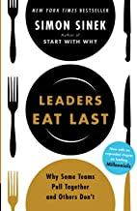](https://www.amazon.com/Leaders-Eat-Last-Together-Others/dp/1591848016/ref=sr_1_1?dchild=1&keywords=leaders+eat+last&qid=1619721154&sr=8-1)

[**Leaders Eat Last: Why Some Teams Pull Together and Others Don't**](https://www.amazon.com/Leaders-Eat-Last-Together-Others/dp/1591848016/ref=sr_1_1?dchild=1&keywords=leaders+eat+last&qid=1619721154&sr=8-1)

[Part of: Start with Why Series (3 Books)](https://www.amazon.com/dp/B07VVJF819?searchxofy=true&binding=kindle_edition&ref_=dbs_s_aps_series_rwt_tkin&qid=1619721154&sr=8-1) | by [Simon Sinek](https://www.amazon.com/Simon-Sinek/e/B002CB2SDC?ref=sr_ntt_srch_lnk_1&qid=1619721154&sr=8-1)

[**Can't Hurt Me: Master Your Mind and Defy the Odds - Clean Edition**](https://www.amazon.com/Cant-Hurt-Me-Master-Clean/dp/1544507852/ref=sr_1_1?crid=8XQYEM25WOSD&dchild=1&keywords=cant+hurt+me+david+goggins&qid=1619721275&sprefix=cant+%2Caps%2C239&sr=8-1)

by [David Goggins](https://www.amazon.com/David-Goggins/e/B07H23VT42?ref=sr_ntt_srch_lnk_1&qid=1619721275&sr=8-1)

[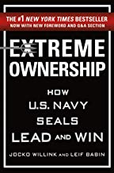**Extreme Ownership: How U.S. Navy SEALs Lead and Win**](https://www.amazon.com/Extreme-Ownership-U-S-Navy-SEALs/dp/1250183863/ref=sr_1_1?dchild=1&keywords=extreme+ownership&qid=1619721357&sr=8-1)

[Part of: Extreme Ownership Series (2 Books)](https://www.amazon.com/dp/B07VZXCQHH?searchxofy=true&binding=kindle_edition&ref_=dbs_s_aps_series_rwt_tkin&qid=1619721357&sr=8-1) | by [Jocko Willink](https://www.amazon.com/Jocko-Willink/e/B00ZY7MWW8?ref=sr_ntt_srch_lnk_1&qid=1619721357&sr=8-1)

[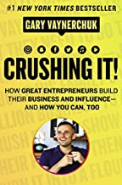**Crushing It!: How Great Entrepreneurs Build Their Business and Influence-and How You Can, Too**](https://www.amazon.com/Crushing-Great-Entrepreneurs-Business-Influence/dp/0062674676/ref=sr_1_1?dchild=1&keywords=crushing+it&qid=1619721409&sr=8-1)

by [Gary Vaynerchuk](https://www.amazon.com/Gary-Vaynerchuk/e/B001JP7NBE?ref=sr_ntt_srch_lnk_1&qid=1619721409&sr=8-1)

[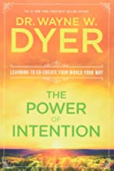**The Power of Intention**](https://www.amazon.com/Power-Intention-Dr-Wayne-Dyer/dp/1401902162/ref=sr_1_1?dchild=1&keywords=the+power+of+intention&qid=1619723041&sr=8-1)

by Wayne W. Dr. Dyer

[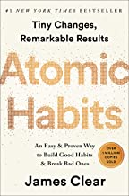**Atomic Habits: An Easy & Proven Way to Build Good Habits & Break Bad Ones**](https://www.amazon.com/Atomic-Habits-Proven-Build-Break/dp/0735211299/ref=sr_1_1?dchild=1&keywords=atomic+habits&qid=1619723113&sr=8-1)

by [James Clear](https://www.amazon.com/James-Clear/e/B07DJTJC3X?ref=sr_ntt_srch_lnk_1&qid=1619723113&sr=8-1)

[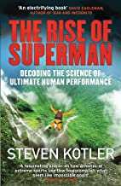](https://www.amazon.com/Rise-Superman-Decoding-Ultimate-Performance/dp/1784291226/ref=sr_1_1?dchild=1&keywords=the+rise+of+superman&qid=1619723192&sr=8-1)

[**Rise Of Superman**](https://www.amazon.com/Rise-Superman-Decoding-Ultimate-Performance/dp/1784291226/ref=sr_1_1?dchild=1&keywords=the+rise+of+superman&qid=1619723192&sr=8-1)

by [Steven Kotler](https://www.amazon.com/Steven-Kotler/e/B001JP87B4?ref=sr_ntt_srch_lnk_1&qid=1619723192&sr=8-1)

[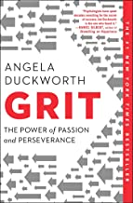**Grit: The Power of Passion and Perseverance**](https://www.amazon.com/Grit-Passion-Perseverance-Angela-Duckworth/dp/1501111116/ref=sr_1_1?dchild=1&keywords=grit&qid=1619723269&sr=8-1)

by [Angela Duckworth](https://www.amazon.com/Angela-Duckworth/e/B019S711S0?ref=sr_ntt_srch_lnk_1&qid=1619723269&sr=8-1)

[**12 Rules for Life: An Antidote to Chaos**](https://www.amazon.com/12-Rules-Life-Antidote-Chaos/dp/0345816021/ref=sr_1_3?dchild=1&keywords=12+rules+for+life&qid=1619724018&sr=8-3)

[Book 1 of 2: 12 Rules for Life](https://www.amazon.com/dp/B08XQMG9WB?searchxofy=true&binding=kindle_edition&ref_=dbs_s_aps_series_rwt_tkin&qid=1619724018&sr=8-3) | by [Jordan B. Peterson](https://www.amazon.com/Jordan-B-Peterson/e/B001HMLIKQ?ref=sr_ntt_srch_lnk_3&qid=1619724018&sr=8-3)

[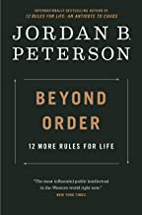**Beyond Order: 12 More Rules for Life**](https://www.amazon.com/Beyond-Order-More-Rules-Life/dp/0593084640/ref=sr_1_4?dchild=1&keywords=12+rules+for+life&qid=1619724018&sr=8-4)

[Book 2 of 2: 12 Rules for Life](https://www.amazon.com/dp/B08XQMG9WB?searchxofy=true&binding=kindle_edition&ref_=dbs_s_aps_series_rwt_tkin&qid=1619724018&sr=8-4) | by [Jordan B. Peterson](https://www.amazon.com/Jordan-B-Peterson/e/B001HMLIKQ?ref=sr_ntt_srch_lnk_4&qid=1619724018&sr=8-4)

[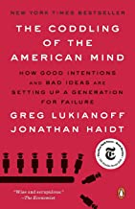**The Coddling of the American Mind: How Good Intentions and Bad Ideas Are Setting Up a Generation for Failure**](https://www.amazon.com/Coddling-American-Mind-Intentions-Generation/dp/0735224919/ref=sr_1_1?crid=1BD1SI999H7XT&dchild=1&keywords=the+coddling+of+the+american+mind&qid=1619724355&sprefix=the+codd%2Caps%2C201&sr=8-1)

by [Greg Lukianoff](https://www.amazon.com/Greg-Lukianoff/e/B008VFY3M2?ref=sr_ntt_srch_lnk_1&qid=1619724355&sr=8-1) and [Jonathan Haidt](https://www.amazon.com/Jonathan-Haidt/e/B001H6GAXW?ref=sr_ntt_srch_lnk_1&qid=1619724355&sr=8-1)

[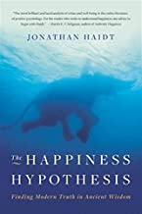](https://www.amazon.com/Happiness-Hypothesis-Finding-Modern-Ancient/dp/0465028020/ref=sr_1_1?crid=1B2V9C5QCM9CY&dchild=1&keywords=the+happiness+hypothesis&qid=1619724489&sprefix=the+happiness+%2Caps%2C235&sr=8-1)

[**The Happiness Hypothesis: Finding Modern Truth in Ancient Wisdom**](https://www.amazon.com/Happiness-Hypothesis-Finding-Modern-Ancient/dp/0465028020/ref=sr_1_1?crid=1B2V9C5QCM9CY&dchild=1&keywords=the+happiness+hypothesis&qid=1619724489&sprefix=the+happiness+%2Caps%2C235&sr=8-1)

by [Jonathan Haidt](https://www.amazon.com/Jonathan-Haidt/e/B001H6GAXW?ref=sr_ntt_srch_lnk_1&qid=1619724489&sr=8-1)

[](https://www.amazon.com/Love-Languages-Secret-that-Lasts/dp/080241270X/ref=sr_1_3?crid=2NNWO1K42H5XW&dchild=1&keywords=the+5+love+languages+gary+chapman&qid=1619721463&sprefix=the+5+love+lang%2Caps%2C203&sr=8-3)

[**The 5 Love Languages: The Secret to Love that Lasts**](https://www.amazon.com/Love-Languages-Secret-that-Lasts/dp/080241270X/ref=sr_1_3?crid=2NNWO1K42H5XW&dchild=1&keywords=the+5+love+languages+gary+chapman&qid=1619721463&sprefix=the+5+love+lang%2Caps%2C203&sr=8-3)

[Part of: The 5 Love Languages Series (11 Books)](https://www.amazon.com/dp/B07VVJPJ5Z?searchxofy=true&binding=kindle_edition&ref_=dbs_s_aps_series_rwt_tkin&qid=1619721463&sr=8-3) | by [Gary Chapman](https://www.amazon.com/Gary-Chapman/e/B01IAEQ73Q?ref=sr_ntt_srch_lnk_3&qid=1619721463&sr=8-3)

[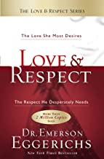](https://www.amazon.com/Love-Respect-Desires-Desperately-Needs/dp/1591451876/ref=sr_1_1?dchild=1&keywords=love+and+respect&qid=1619721522&sr=8-1)

[**Love & Respect: The Love She Most Desires; The Respect He Desperately Needs**](https://www.amazon.com/Love-Respect-Desires-Desperately-Needs/dp/1591451876/ref=sr_1_1?dchild=1&keywords=love+and+respect&qid=1619721522&sr=8-1)

by Emerson Eggerichs