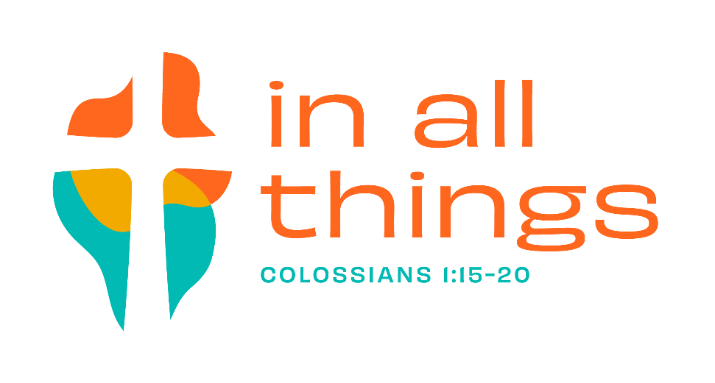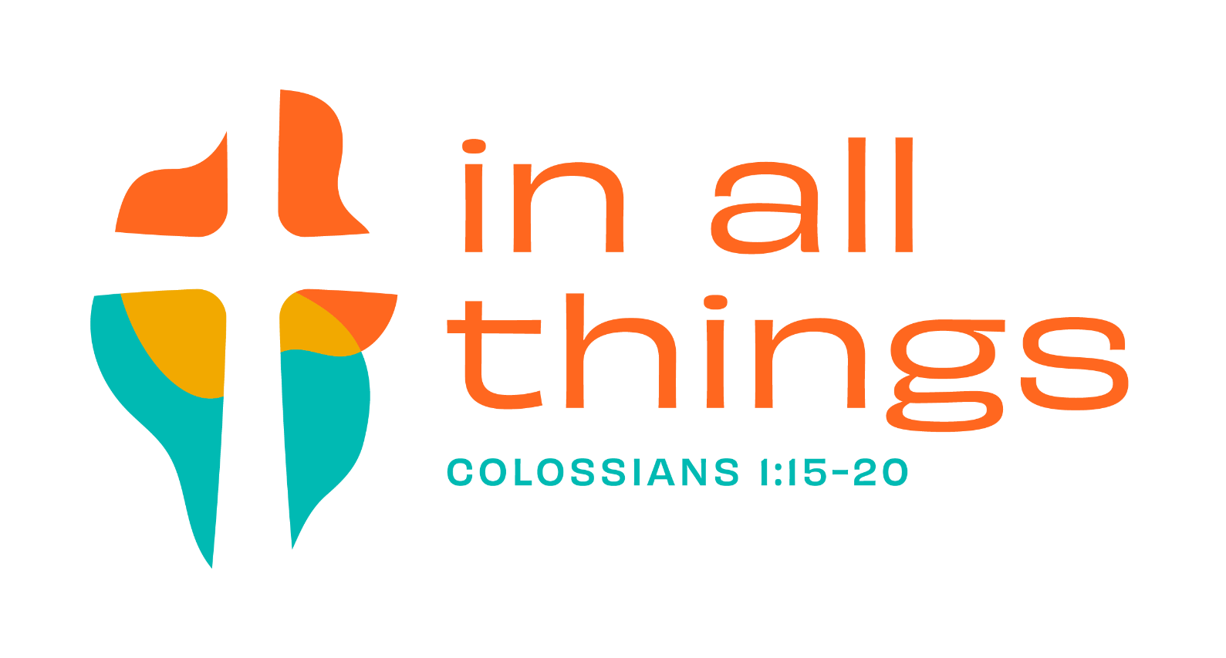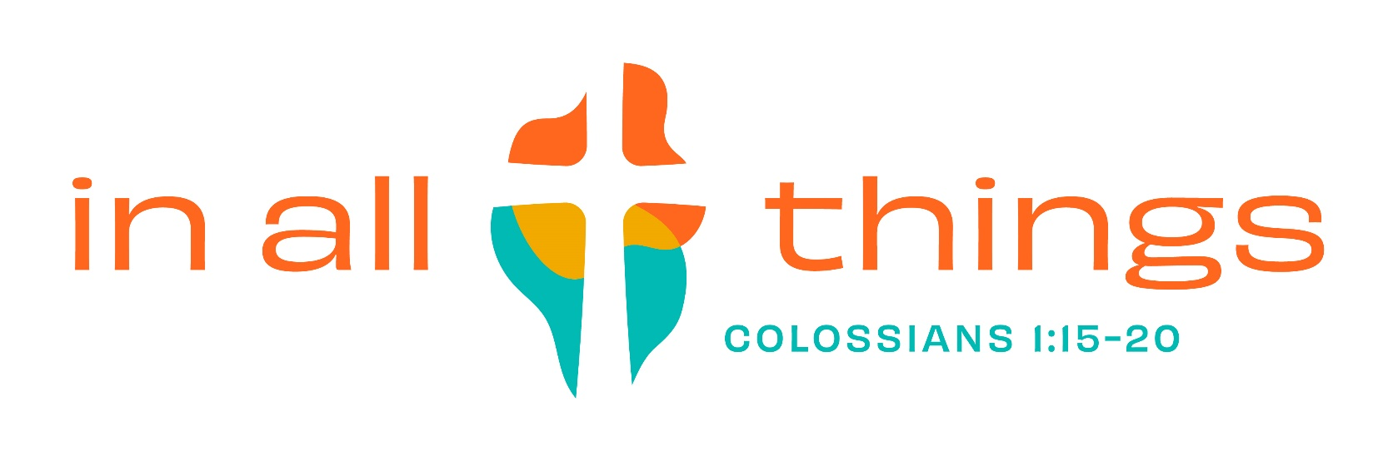

**LCMS Youth Gathering**

**July 9-13, 2022**

***In All Things is a reminder that the Christian story encompasses all things. Nothing, and no one, is left out. In baptism, all things in our lives are brought under the gracious rule and reign of Jesus Christ. The story includes all of each of us. Christ is the single “big idea” in Paul’s letter to the Colossians, and he will be the single big idea at the Y2022 LCMS Youth Gathering. ~ lmcsgathering.com/about***

The LCMS Youth Gathering provides youth and adults the opportunity to come together as a

community of God’s people to

* be affirmed in their lives as God's people
* nurture their relationship with others in the church
* celebrate their salvation in Jesus Christ through Word and Sacrament
* recognize that youth ministry happens in a variety of settings in their parish, community, and world

LCMS Youth Gatherings provide young people an opportunity to learn more about Jesus Christ, the Christian faith, and their Lutheran identity. During the five-days of the Gathering youth spend time together in worship, God’s Word, prayer, song, and service.

This event is organized by LCMS Youth Ministry. LCMS Youth Gatherings are held every three years for and are intended for high school youth ages 14-19 at the time of the gathering. The NYG is an incredible way for you to grow in relationships with your peers and with God. In these five days several thousand youth and adults from across the nation will come together in worship, through service, and fellowship.

This event is July 9-13,2022, in Houston, TX. LCMS youth and adult leaders will visit the city under the theme ***In All Things.***

**Estimated Trip Cost $1500 to cover travel, food, registration, and activities.**

**A registration fee of $150 will be due by July 11th, 2021. It will be non-refundable after we register in the Fall of 2021.**

Motivated by God’s love for me, I, _, commit to exploring, sharing, and growing in my faith this year. As a part of the First Evangelical Lutheran Youth I plan to attend the Youth Gathering 2022 in Houston, TX.

Parent Youth

Initials Initials

I understand the spiritual, financial, and personal conduct expectations that are a part of this trip. I also understand this registration fee is non-refundable. If an unavoidable circumstance causes me to not attend the Gathering, I know that I will not be refunded any payments made toward the trip and will not be held responsible for any remaining payments.

Throughout this experience we will be intentional about sharing God’s love with others through both our actions and our words. I will build relationships with fellow youth, serve my peers, and strengthen our youth group by being actively involved in worship and Youth events before and after the trip. I will participate in at least 3 youth events before the Gathering.

I understand that there will be fundraisers available to help offset the costs associated with the 2022

Gathering. If I do not raise enough funds through the fundraisers, I understand that it is my responsibility to come up with the remainder amount of money due by June 1st, 2022.

With my signature affixed below, I hereby give permission for my child, , to attend Youth Gathering 2022 in Houston, TX. This signed agreement hereby absolves the volunteer sponsors, First Lutheran, the church staff, and any and all members of its governing boards of any responsibility for the safety, welfare, health, and well-being for my child beyond such matters as may be called reasonable care for youth in the care of a sponsor, and subject to the sponsor’s clear instructions. The undersigned also assumes, personally and exclusively, all responsibility and liability for accident, injury, or other misfortune which may occur to the above-named child during the time of this activity.

My child agrees to behave responsibly according to the laws of the State, the rules of First Evangelical Lutheran Church and the reasonable expectations of the adult sponsors.

**First Evangelical Lutheran Commitment Form is due at the time of registration. Registration due July 11th, 2021 along with $150 deposit. If you prefer to not fundraise, you may set up a payment plan. There will be periodic fundraisers to help with the cost. The remaining about will be due June 1st, 2022.**

Youth Signature Date



Parent Signature Date



