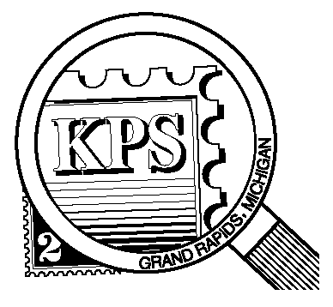

## 



NEWSLETTER OF THE KENT PHILATELIC SOCIETY

P.O. Box 1156, Grand Rapids, Michigan 49501-1156

Jerry Frye, President 616-538-6069

Louis Morel, Editor 269-420-3128

KentPhilatelicSociety.com

K.P.S. Philatelist

Volume 69 - No. 4 April 2025

KPS Club News

|  |  |
| --- | --- |
| The Kent Philatelic Society welcomes three new members to its ranks. Henry Barry, Bob Drnek, and Joe Stocchero have joined us. We look forward to hearing about their philatelic journeys at an upcoming Club meeting.  🟋🟋🟋  Did you remember to mark your calendar? The Spring Dealer Bourse will take place on Saturday, May 3 at the Neal Fonger American Legion Post in Walker. There will be six dealers at the event: KPS members Chuck Avery, Chris Daly (Grand Rapids Stamps), Jim Jeffery (Itty Bitty Stamp Company), Harry Thomasma (Schneider & Company), as well as the Kazoo Crew (led by Paul Matyas), and Mouse and Such (Paul Stanton).  🟋🟋🟋  Setup for the Bourse will take place on Friday, May 2 starting at 6 PM. There is a need for members to help at the registration desk during the Bourse on Saturday. Volunteering one hour or more for either would help tremendously in making this a successful event. Please give Bill Sobotka a call (616.531.3295) to volunteer.  🟋🟋🟋  The second annual June Stamp Social is coming up fast. We are looking for a member to step up and volunteer to *oversee its organization*. The Chairperson will receive plenty of assistance to ensure that all the necessary tasks (purchase of food, plates and plastic ware, setup and tear-down, etc.) are fulfilled to | make this a successful event. Please give Bill Sobotka a call to volunteer.  🟋🟋🟋  **KPS Archives**: The March 13, 1958 issue of The KPS Philatelist reported a meeting between member Orson Grant and the past President of the Society of Philatelic Americans, Ben Reeves. Mr. Reeves specialized in the 3¢ purple 1942 “Win the War” issue featuring an eagle (United States, Scott 905). At a Club meeting, Mr. Grant shared more than two dozen slides prepared by Mr. Reeves. They depicted varieties of the stamp that he called the “happy” eagle, the “sad” eagle, the twin eagles, the “hungry” eagle with the thin tongue, as well as the “fatso” eagle. There was no further explanation given about the appellation of these stamps.  The stamp was issued without a watermark. Yet, Mr. Reeves had an example of the eagle with a watermark. Other varieties on view were a double transfer, a double inverted transfer, and one printed on a cracked plate. There was an example of a recut (repair to a printing plate by an engraver’s tool) eagle. An eagle with a grill and one with a quadruple grill. Eagles on thin paper, thick paper, double paper, soft paper, and hard paper. And a rarity: a pair of eagle stamps with only two perforations between them. Mr. Reeves called it the “two-holer”. We learned from Mr. Reeves that so many details can define a perfect stamp. |

The KPS Board will enhance our monthly auctions by holding a drawing for a **FREE** $10 certificate toward the winning purchases of one lucky member. You need to be present to participate in the drawing.

**MONTHLY PROGRAM SCHEDULE**

The Kent Philatelic Society meets on the 4th **Tuesday** of the month at the Byron Center Baptist Church, 7343 Byron Center Ave SW, Byron Center.

|  |  |
| --- | --- |
| April 22, 2025: **KPS CLUB MEETING**  5:30 PM Board Meeting  6:30 PM Lot Viewing  7:00 PM Floor Auction | May 27, 2025: **KPS CLUB MEETING**  5:30 PM Board Meeting  6:30 PM Lot Viewing  7:00 PM Floor Auction |
|  |  |

*Members are invited to share their philatelic experiences in this space. Perhaps you made a special acquisition, or thrive on an uncommon collecting topic, or saw a remarkable exhibit. Share it with your fellow collectors. Contact the Editor with your stories.*

**What’s In That Lot?**

Some collectors are familiar with the term “kiloware”. Linn’s Stamp News offers the following definition in its glossary of philatelic stamps: a stamp mixture consisting of miscellaneous postally used stamps on envelope corner paper from various sources. Kiloware is sometimes sold by the kilogram (about 2.2 pounds), hence the name. Stamps on paper are sold in various weight increments in the USA. Examples can be seen in videos prepared by the authors of the “Postal Pleasures” and “Ted Talks Stamps” channels on YouTube as they search for treasures in these random lots.

Long-time KPS member, Carol Ligda-Wong, shares a recent experience after acquiring such a lot at a Club meeting.

“I purchased a bulging one-gallon Ziplok bag containing used US stamps on paper from Bernie Jager’s estate at the February meeting. There was nothing in the lot that every KPS member does not already have in their collection, which was A-OK with me. It took me nine days to soak, dry, tear off selvages, sort, bundle and file the hoard as I went about the responsibilities and routines of my daily life.”

“With sorting came new ideas. For example, I decided to start collecting the portion of the cancellation that is a circle identifying the post office of origin and the date the cover began its journey to its destination.”

“Another idea came to mind as I sorted the A-B-C-D rate change stamps. They could be used, along with other alphabet stamps, to create a collage.”

Carol is referring to the rate change stamps that were issued between 1978 and 1981. They were not the first non-denominated USA stamps to be issued. Postage rates for late 1975 were uncertain. This prompted the USPS to issue both Christmas stamps (Scott 1579 and 1580) without denominations, the first in the history of the US postal service.

Following the approval of a rate change from 10¢ to 13¢, the USPS printed a new non-denominated stamp so it would be ready for the next rate change. The decision was based undoubtedly on the historical action of the Postal Rate Commission (PRC). Rate increases had to be approved by the PRC. Often, the PRC would take as much as a year conducting studies and compiling data before accepting or rejecting the proposed increases. If the rate increase was approved, the Postal Service then had to rush to design and produce the new stamps.

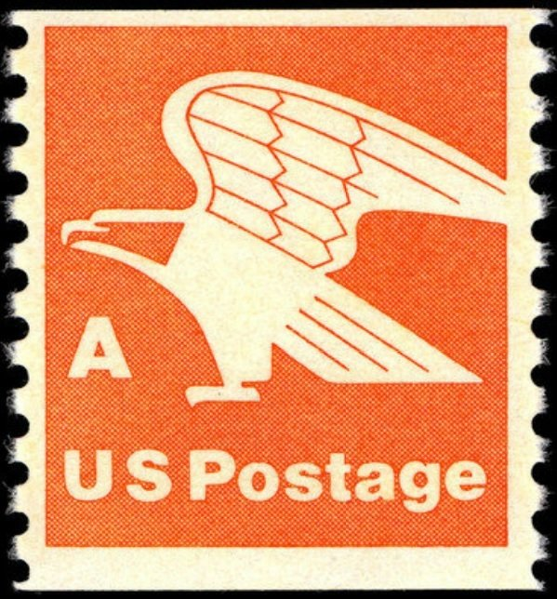The letter ‘A’ was used to represent the unknown rate so the stamps could meet customer demand until new definitives bearing the actual rate were printed. When the rate increased in 1978 from 13¢ to 15¢, the first of the letter rate change stamps (Scott 1735 (regular issue), 1736 (booklet), and 1743 (coil, shown at right)) went into use.

The “B” stamps were printed shortly after and put in storage until they were needed. Two postal increases occurred in 1981– one in March and another in November! The same stylized eagle was used on the “B” issue. The only difference was the background color: violet instead of orange. It sold at the new rate of 18¢ (Scott 1818 (regular issue), 1819 (booklet), and 1820 (coil)). The ‘C’-lettered brown stamp was issued when the rate increased to 20¢ (Scott 1946 (regular issue), 1948 (booklet), and 1947 (coil)).

Late in 1981, the Bureau of Engraving and Printing printed the non-denominated “D” stamp in anticipation of the next change in rate. For nearly four years, some 6.6 billion stamps bearing the same eagle design but in green awaited distribution. They were printed in sheet, coil, and booklet form (Scott 2111, 2112, 2113, respectively). They were released in 1985 when the 22¢ rate was approved. Alphabet stamps ended at the letter ‘H’. “Forever” issues eliminated the need for such stamps.

Linda continues “As I did my preliminary sort by face value, I determined that the bulk of the lot consisted of 4¢ to 10¢ stamps. These stamps were issued between 1958 and 1975. They will be a nice addition to my “paint box” of duplicate stamps bundled by color. The less common stamps went into my topical file. I do not file my duplicates by Scott number.”

“Of course, I must not forget to send duplicates to my niece’s three kids, which I do on a monthly basis.” (Ed. note: See the December 2021 issue of The KPS Philatelist for an account of Carol’s philatelic mentoring of her niece’s children.)

“The lot amounted to approximately 2,000 stamps. It afforded me many days of entertainment. I wonder if I will ever again acquire another hoard of U.S. stamps on paper to soak and sort.”

Carol Ligda-Wong with a contribution from Louis Morel