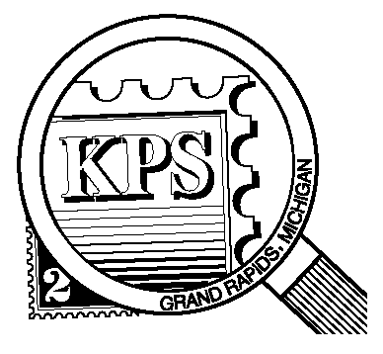

## 



NEWSLETTER OF THE KENT PHILATELIC SOCIETY

P.O. Box 1156, Grand Rapids, Michigan 49501-1156

Jerry Frye, President 616-538-6069

Louis Morel, Editor 269-420-3128

KentPhilatelicSociety.com

K.P.S. Philatelist

Volume 69 - No. 10 October 2025

KPS Club News

|  |  |
| --- | --- |
| **October is National Stamp Collecting Month!** Not only is it an opportunity to revel in our hobby but also an invitation to share our enthusiasm with those unfamiliar with the pastime and entice them to start a collection.  🟋🟋🟋  Accordingly, if it’s October it’s time for the 2025 edition of the KPS Stamp Exhibition & Dealer Bourse (Kentpex). It will be held on Saturday, October 25 (10 AM to 4 PM) and on Sunday, October 26 (10 AM to 3 PM) at the Neal Fonger American Legion Post #179 in Walker. Seven dealers will attempt to cater to our collecting needs.  This year’s theme focuses on the 250th anniversary of the appointment of the first American Postmaster General of the Post Office, Benjamin Franklin. The top three exhibitors at the Show will earn medals, ribbons, and plaques.  We are looking for volunteers to help out at the registration desk to greet members and other collectors. Can you offer an hour or two of your time to help the Club? Let Bill Sobotka (616.531.3295) know that you are interested.  🟋🟋🟋  The annual awards dinner will be held on Wednesday, November 12 at Brann’s Steakhouse & Grille on Division Street in Wyoming. Gathering will start at 6 PM. The meal will | be served at 6:30 PM followed by the distribution of the awards and prizes. Come meet your fellow Club members. The cost for dinner is $21 (ribs, chicken) or $28 (prime rib) based on your choice of entrée.  🟋🟋🟋  The Club’s October meeting will feature a donation auction. All proceeds of the sales will go to the Club.  🟋🟋🟋  It is time to renew your KPS membership for 2026. The dues remain unchanged for the upcoming year at $15. Many of the Club’s members drop off their payment at Kentpex. You may drop off your payment at the next Club meeting. Finally, you can send a check to the address found above in the masthead. Please do not delay.  🟋🟋🟋  There are vacancies on the KPS Board. Are you interested in contributing in a meaningful way to the Club? Contact Jerry Frye for more details (616-538-6069).  🟋🟋🟋  **KPS Archives**: The Club’s October 1961 issue of The Philatelist was sent in envelopes adorned by a cachet. It was member Harry Wietfeldt’s contribution to the Club as he designed and drew the illustration. |

The KPS Board will enhance our monthly auctions by holding a drawing for a **FREE** $10 certificate toward the winning purchases of one lucky member. You need to be present to participate in the drawing.

**MONTHLY PROGRAM SCHEDULE**

The Kent Philatelic Society meets on the 4th **Tuesday** of the month at the Byron Center Baptist Church, 7343 Byron Center Ave SW, Byron Center.

|  |  |
| --- | --- |
| October 28, 2025: **KPS CLUB MEETING**  5:30 PM Board Meeting  6:30 PM Lot Viewing  7:00 PM Donation Auction | November 25, 2025: **KPS CLUB MEETING**  5:30 PM Board Meeting  6:30 PM Lot Viewing  7:00 PM Trade Night and Presentation |
|  |  |

*Members are invited to share their philatelic experiences in this space. Perhaps you made a special acquisition, or thrive on an uncommon collecting topic, or saw a remarkable exhibit. Share it with your fellow collectors. Contact the Editor with your stories.*

**Benjamin Franklin: Man of Many Talents**

The USPS issued a stamp (Scott 6024) in July 2025 to celebrate the 250th anniversary of the establishment of the US Post Office. The stamp features Benjamin Franklin who was appointed Postmaster General at the time. The stamp design is based on the 5¢ stamp issued in 1847 (Scott 1). The new issue is only available by purchasing a prestige booklet or paying a premium to a dealer for the single stamp.

Franklin’s parents were members of the Puritan faith. They did not share the views of the Church of England. They chose to emigrate from England in 1683. Benjamin was born in Boston in 1706.

An intelligent youngster, Franklin attempted to learn his father’s candle making trade but found it unbearable. Instead, he took a job at his brother’s Boston newspaper. He was an avid reader. He became a vegetarian in order to save money to buy books. Continuing to learn the printer’s trade, Franklin moved to England in 1724 to gain more skill. Becoming a Master Printer, Franklin returned to the Colonies and opened two newspapers, the Pennsylvania Gazette and Poor Richard’s Almanac*.*

Franklin is known as one of the founding fathers who drafted and signed the Declaration of Independence and for shaping the Constitution. writing letters as a woman, chowing down on native foods and hosting an anatomy school in his house. He was also the first to chart the Gulf Stream which had been reported 255 years earlier by Ponce de Léon. He completed the first scientific study of the currents in 1775. He mapped them and made prints for the mail ships.

As a young man, Franklin developed an interest in invention and science. Most people are familiar with his experiments with electricity which resulted in the development of the lightning rod. He also devised a wood-burning stove, an odometer that attached to a carriage, bifocal glasses, a chair that converted into a stepladder, the glass armonica musical instrument, a new kind of street lamp (with a funnel dispersing the smoke), a rocking chair with a fan, swimming fins, a flexible urinary catheter and a “long arm” for removing objects from high shelves.

Amenities and services were required for settled regions that made up British North America. Colonists needed homes, transportation, and a method of conveying the important letters of homesteaders, politicians and the military. Expanding the postal system by adding to the number of offices already established along well-travelled routes became a priority. One of the men chosen (1753) for the extensive job was Benjamin Franklin who was appointed Deputy Postmaster.

In 1755 he organized the first regular monthly mail packet service between Falmouth, England and New York. He opened the first official post office in what would become Canada in Halifax, Nova Scotia.

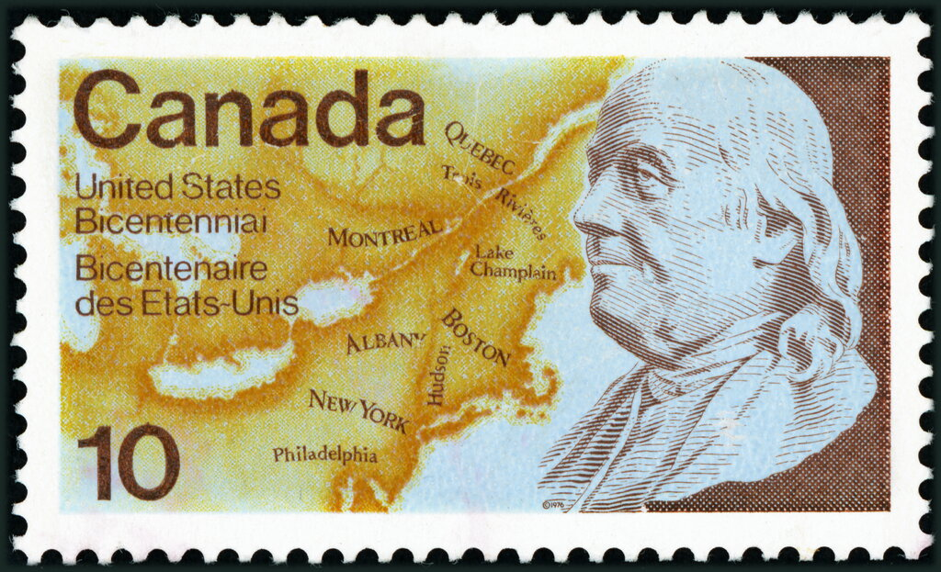Seeking to improve postal service, Franklin established post offices in Quebec City, then Montreal and Trois-Rivières in the 1760s. The map on the 1976 stamp at right (Canada, Scott 691; joint issue with US (Scott 1690)) shows these cities. Under UV light, the paper emits a moderate bluish-white glow. Its fluorescent bars glow yellowish-white.

The service used the existing road between Montreal and Quebec. Providing relatively easy access, the road was already dotted with postal service houses at nine-mile intervals. Developing his courier service, Franklin opened a twice-monthly summer run from Montreal to New York City using Lake Champlain and the Hudson River route (see map above). The service ran only once a month in the winter.

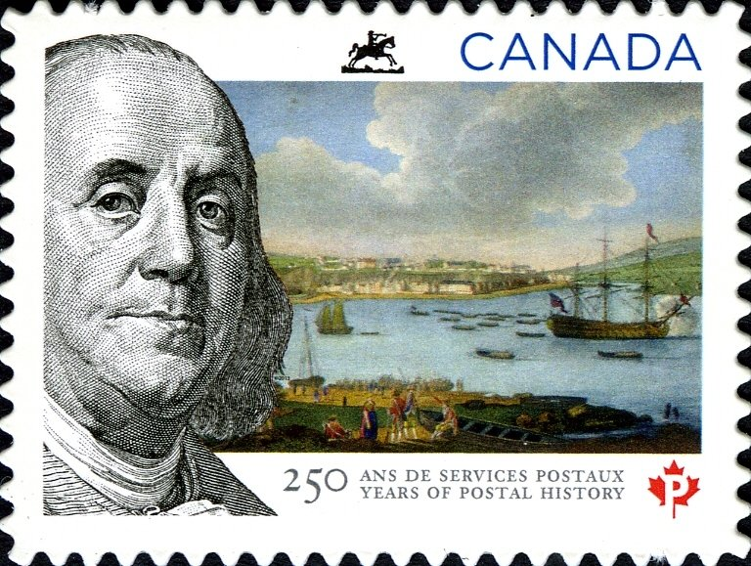To celebrate 250 years of postal service, Canada issued the stamp at left (Scott 2649) on June 10, 2013 reflecting Franklin’s role. This happens to be the date on which Hugh Findlay was made postmaster general at Quebec in 1763. This may explain why Quebec City is featured in the background.

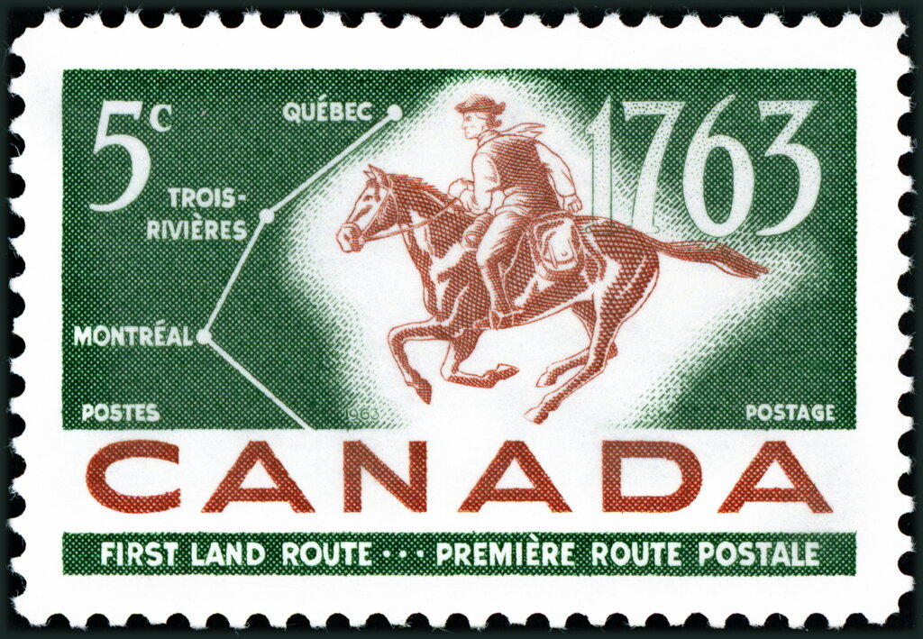Interestingly, Findlay is celebrated for having introduced a courier service from Montreal to New York to reach the monthly packet sailing to England, an ambitious innovation that put cash in the coffers of the British Post Office, which paid Findlay on the basis of his earnings. The stamp with the horseman (Canada, Scott 413) was issued in 1963 to commemorate the bicentenary of the first postal route by land from Quebec City to Montreal.

Louis Morel