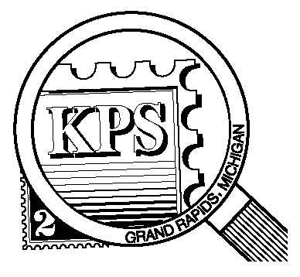

NEWSLETTER OF THE KENT PHILATELIC SOCIETY
P.O. Box 1156, Grand Rapids, Michigan 49501-1156
Jerry Frye, President 616-538-6069
Louis Morel, Editor 269-420-3128
KentPhilatelicSociety.com

K.P.S. Philatelist
Volume 69 - No. 12 December 2025

KPS Club News
The Club’s traditional annual pot luck Holiday dinner is just around the corner on December 9. It will be held in our usual meeting place. Bring a dish to share. Bring your philatelic thinking cap and participate in the quiz for stamp collectors. David Luke will be the quizmaster.  It’s not too late to consider serving on the KPS Board. A fresh approach to serve the needs of the membership is always welcome. Let a current Board member know that you are interested in contributing to the Club’s success or contact Jerry Frye for more details (616-538-6069). There are two vacancies on the Board. Elections will be held at the December meeting.  About two thirds of the KPS members have paid their dues for 2026. The amount remains unchanged for the upcoming year at $15. You can drop off your payment at the December Club meeting. You can also send a check to the address found above in the masthead. Please consider making your payment before the end of the year.  The Archives: Have you received a letter franked with a stamp that has not been canceled? This is not a new phenomenon. | Consider this report from May 1978. A Nebraska Senator’s aides acknowledged tearing uncanceled stamps off incoming mail and re-using them. They did it as a means of cutting down on mailing expenses. Recall that the rate of first-class postage at the time was 13 cents. It increased to 15 cents on May 29, 1978.  The administrative assistant to the Senator claimed that she could harvest between $5 and $10 worth of stamps on “a slow day”. She added “That’s like picking up money off the street.” She contended that many offices do this and that the postal cancellation machinery’s failure makes it legal to re-use those stamps.  The USPS claimed that it lost between $25 million and $75 million per year because of the widespread practice which happens to be a federal crime. Postal officials said that it would be impractical to try to find and prosecute those who re-use uncanceled stamps. Violations carry a maximum penalty of a $500 fine and a year in jail.  Senators can send letters for free using franked envelopes bearing their signature. The assistant explained that once the quota has been reached, they use uncanceled stamps. The Senator himself said that he was re-using a tax dollar as an uncancelled stamp is the same as using a mint stamp.

The KPS Board will enhance our monthly auctions by holding a drawing for a FREE $10 certificate toward the winning purchases of one lucky member. You need to be present to participate in the drawing.

MONTHLY PROGRAM SCHEDULE
The Kent Philatelic Society meets on the 4th Tuesday of the month at the Byron Center Baptist Church, 7343 Byron Center Ave SW, Byron Center.
December 9, 2025: KPS MEMBERS POT LUCK  6:00 PM Doors open  6:30 PM Bring a dish | January 27, 2026: KPS CLUB MEETING  6:00 PM Board Meeting  6:30 PM Lot Viewing  7:00 PM Floor Auction

Members are invited to share their philatelic experiences in this space. Perhaps you made a special acquisition, or thrive on an uncommon collecting topic, or saw a remarkable exhibit. Share it with your fellow collectors. Contact the Editor with your stories.
Fruits, Vegetables and Much More
México supplied 11.4 million tons (that’s 22.8 billion pounds!) of fresh fruits and vegetables to the USA in 2023. That accounted for one half of the imported produce that year. Guatemala, Costa Rica and Canada follow for a combined 6.4 million tons (12.8 billion pounds). Together they represented 78% of the total of fresh produce imports. This leads quite naturally to the expansive set of Mexican stamps featuring that country’s exports.

The Exporta issue of México was introduced in 1975 and continued until 1993. It is one modern set of issues that is colorful, inexpensive and comes in an array of varieties that will occupy a collector for quite some time. The designs featured a variety of exports from citrus fruit to pistons to cinema. There are reportedly fourteen different paper weights and grades. Have you ever used a paper micrometer? This might be an opportunity to start. Was the paper made in México or elsewhere in North America? Or even in England? The gums used during that twelve-year period included glossy synthetic gum, dull (matte) synthetic gum, dull polyvinyl acetate (PVA) gum, semi-gloss PVA gum, and dry dextrin gum. Others may have been used as well.

The first Exporta stamp to be printed was the 1.60-peso Bicycle stamp in 1975. It paid the air mail rate within México and to the United States and Canada. The backdrop of how the idea for the stamps came about is noteworthy. Back in the 1970s the Mexican Postal and Commercial Trade officials came up with the idea of promoting Mexican exports with postage stamps. Once the concept was approved it was decided to hold a contest among leading artists and designers. The winner of the export issues competition was Rafael Davidson, who at the time of the competition was working in México in advertising and product design.

Davidson received most of his training in art in the US and later, when the Exporta issues were finished, he returned to the Art Center in Pasadena where he taught design as well as at the Academy of Art College in San Francisco. Upon winning the Exporta competition, one of the first things Davidson did was to meet with the TIEV (Talleres de Impression de Estampillas y Valores), the government printing plant responsible for printing Mexican postage stamps. A number of design considerations were established.
Each design would be easily readable without a magnifying glass since the primary purpose of the stamps was communication. Each design would include the “México Exporta” logo and a single typeface would be used for all inscriptions. In all, 28 different designs were produced. All together there are at least 260 clearly defined variations of the stamps. Of course, this can be disputed whenever another printing flaw is discovered by a collector.

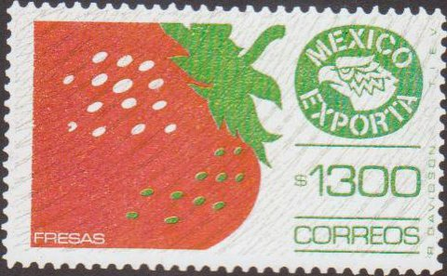
The first year saw six issues: the 50-c Auto Parts; 80-c Beef Cattle; 1.60-peso Bicycle; 1.90-peso Petroleum Valve, 3-peso Shoes; and the 4.30-peso Strawberry. Davidson tried to exert control over the printing quality and especially the ink colors. He rejected a number of color shades and impressions, but was distressed when he discovered the “pink” 4.30-peso Strawberry (1975, Scott C496, lower left) had escaped his oversight. It is described as “bright pink and olive”. The issue on the right (1988, Scott 1592) is described as “red and green”.
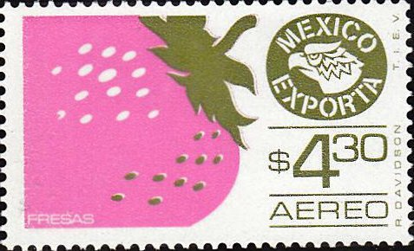
Did you notice the burelage on the right-hand stamp? The burelage is a deliberately applied pattern printed onto some of the Exporta stamps to discourage counterfeiting. It is found mostly on high values, but not all of them. Accordingly, the 1300-peso issue has burelage lines running from the lower left to the upper right and arching towards the lower right. Four issues released between 1983 and 1992 had the grey burelage lines arching towards the upper left. A 1920 issue from Danzig (Scott 25-30) was among the first to incorporate the technique.

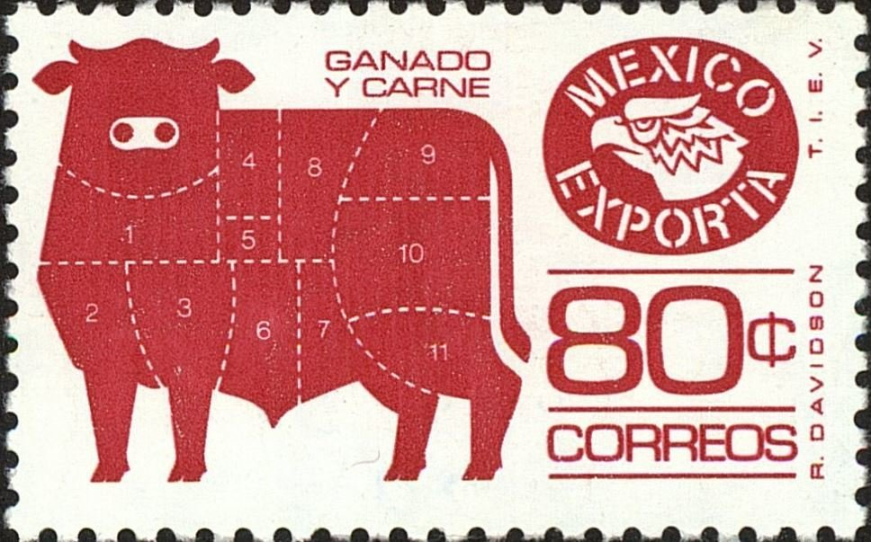
Perforations? Yes, there are many variations to find. Consider the issues and their variants (nine in total issued over the course of 17 years) showing the meat cuts marked on a steer (Scott 1113, 1168 (shown above, issued in 1979), 1491, and 1763). Their perforations vary from 11 X 11 (with large and small holes) to 11 ½ X 11 to 14 X 14 ¼. Two variants were made with “thin” paper. The issue and its variant released in 1979 had different perforations but both had a watermark featuring a circumscribed eagle and the letters MEX.

All in all, quite an interesting endeavor to undertake.

Louis Morel

